

Ar Kar

14377336

Coding assignment

CP2406

Contents

Task 1 Compile and Run UserInterface.cpp 2

Task 2 Add A Debug Option 7

Task 3 Add Option “7) Generate new database” 14

Task 4 Add Option “8) Save database to file” 21

Task 5 Add Option “9) Load database from file” 25

Task 6 Add Option “10) Edit Employee” 29

Task 7 Add Option “11) Search Employee” 34

Task 8 HD-level 39

Commit Record 51

GitHub Repo Link 52

# Task 1 Compile and Run UserInterface.cpp

Before compiling UserInterface.cpp, configure .vscode/task.json to compile all ‘.cpp’ files inside the directory.

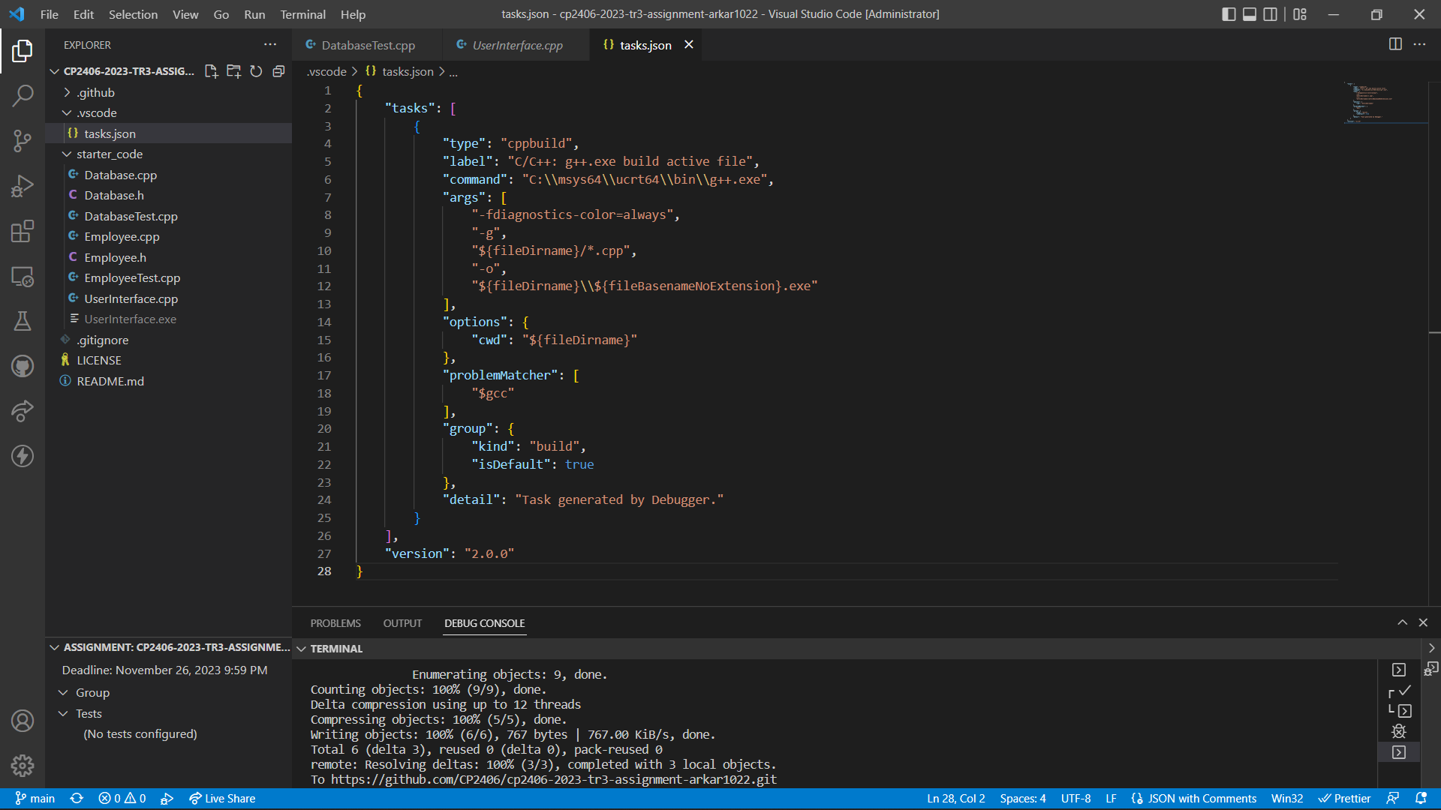

After that, compile and run UserInterface.cpp and following are the results.

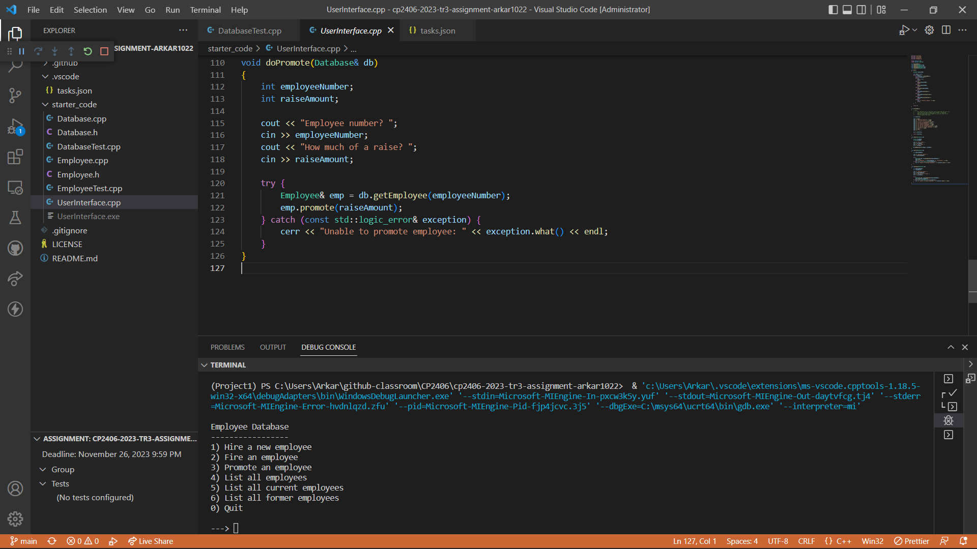

Hire a new employee

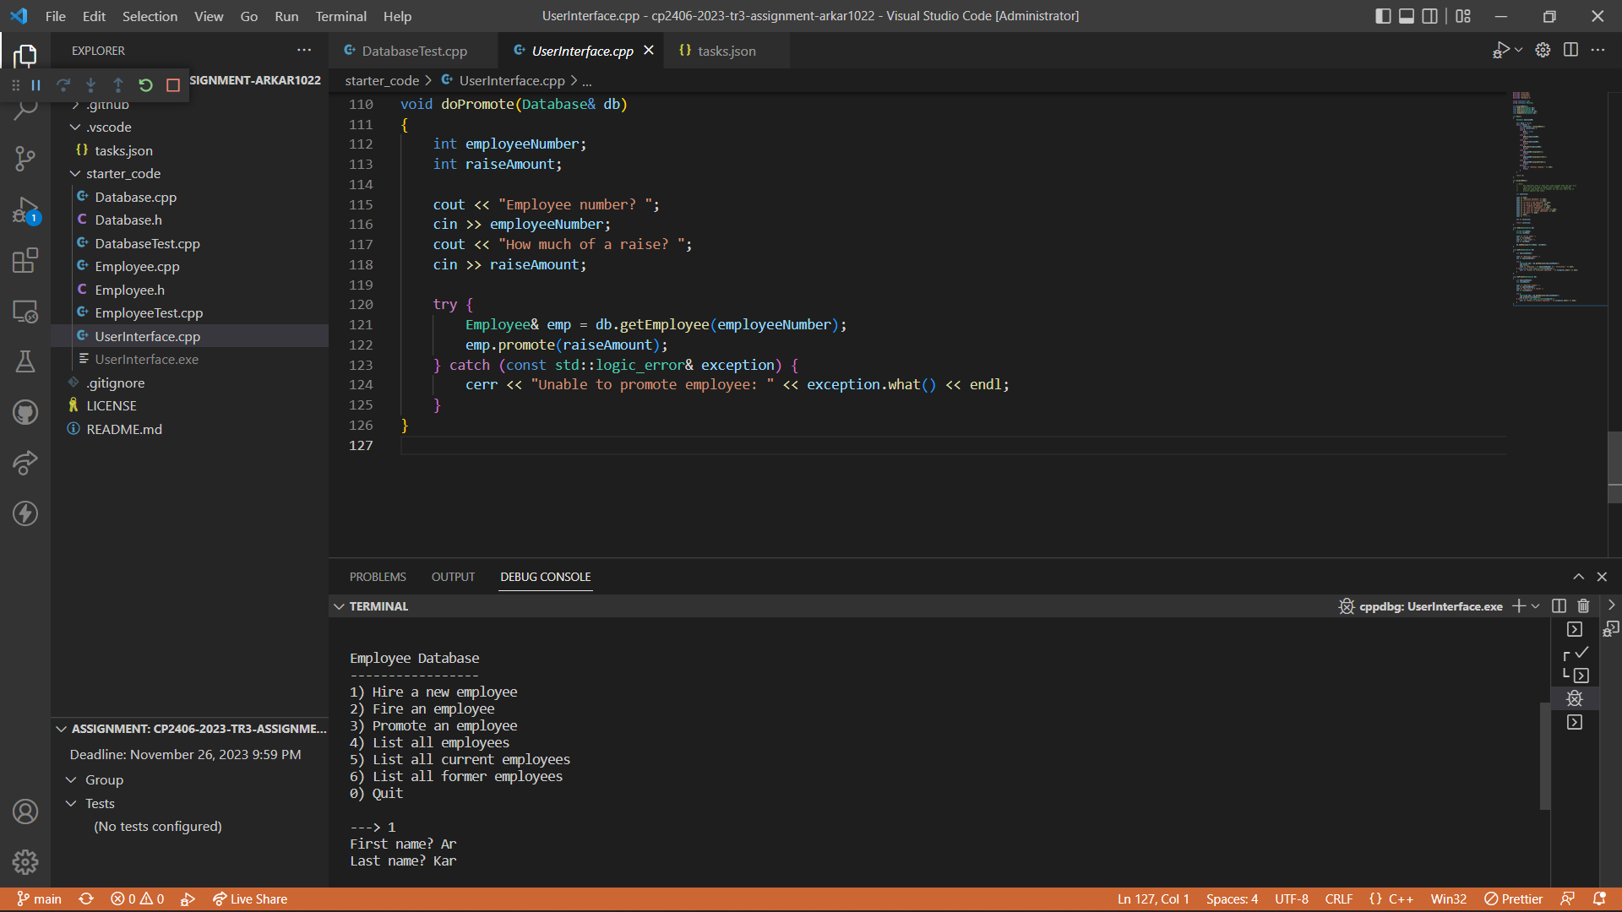

List all employees.

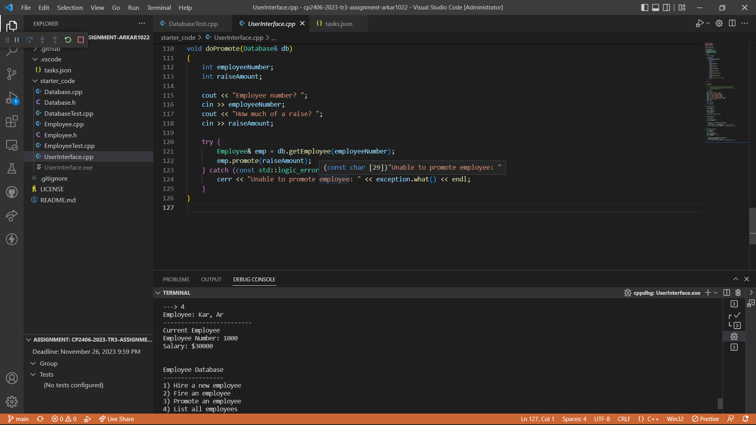

Promote Employee and raise salary to $5000.

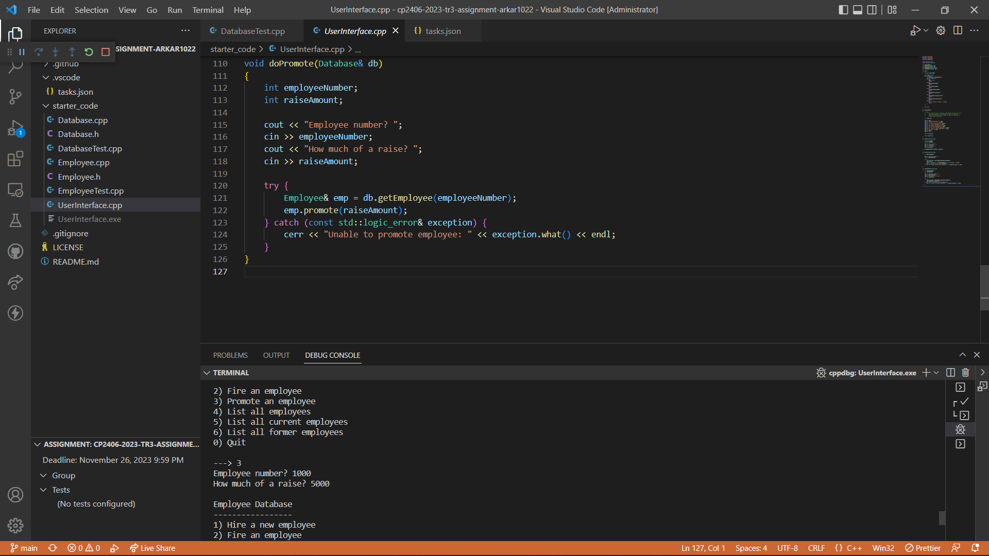

Fire an essmployee

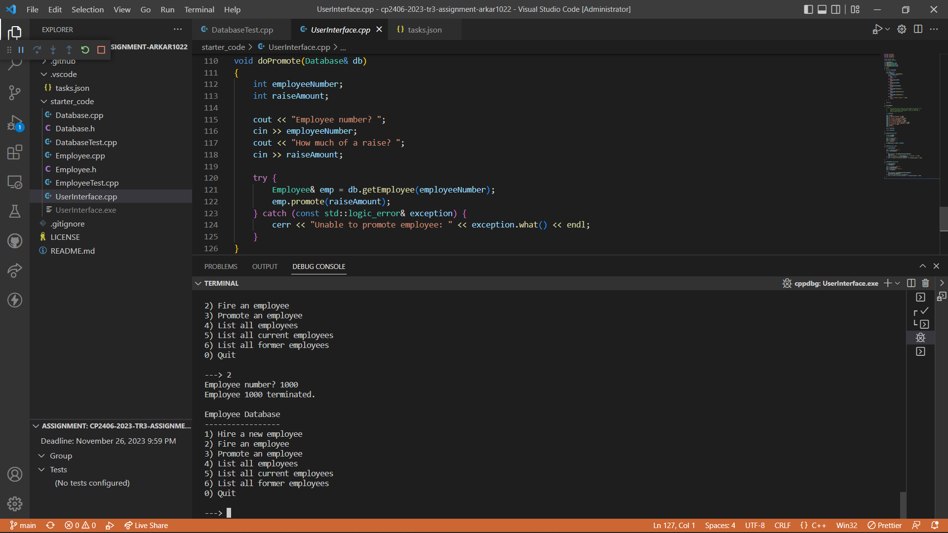

List all current employees.

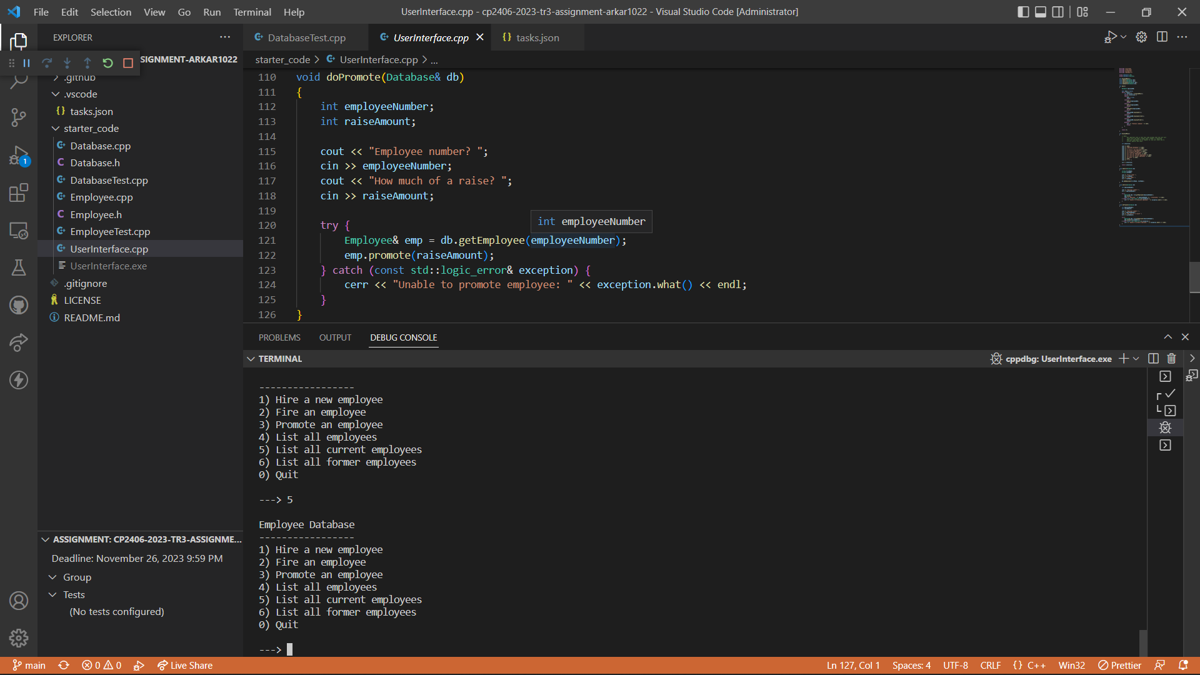

List all former employees.

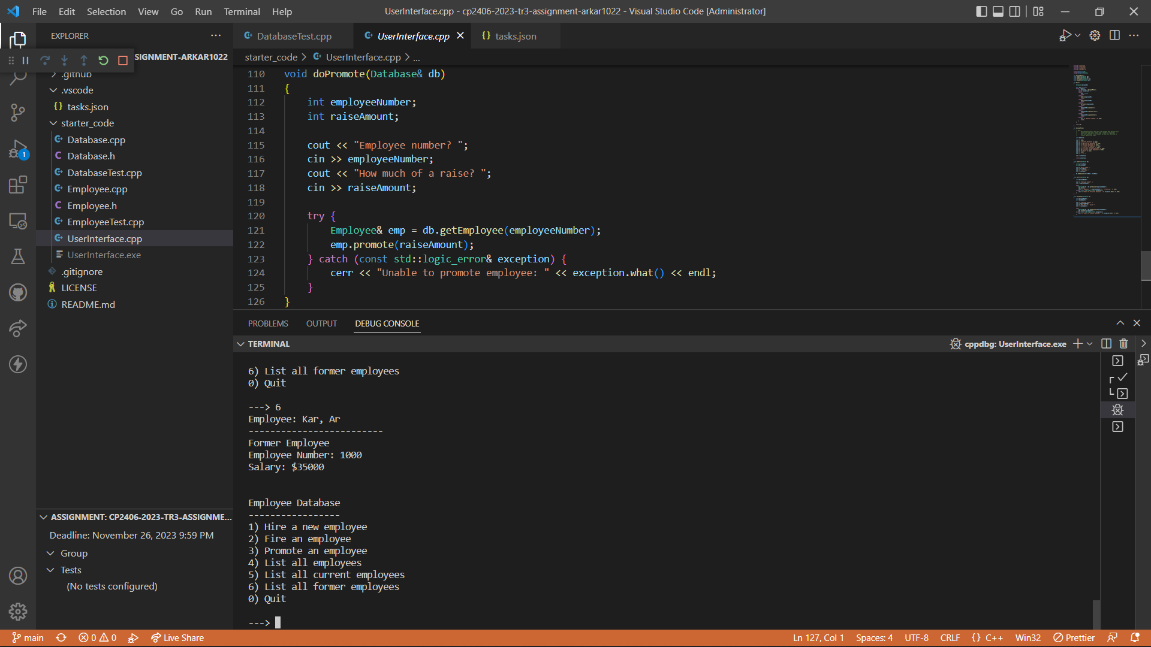

Quit the Program

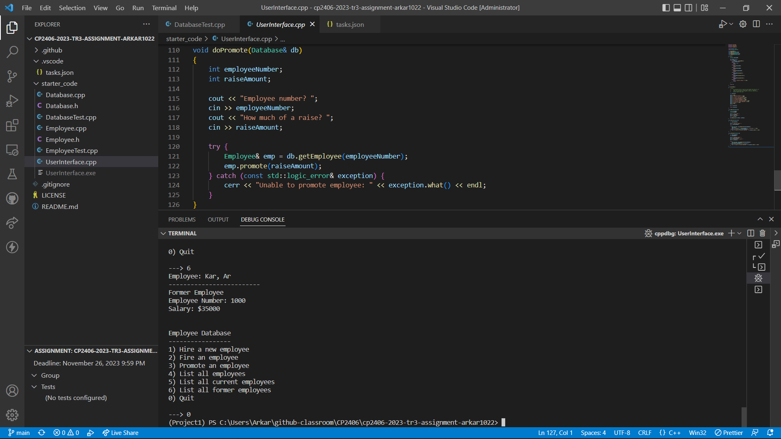

# Task 2 Add A Debug Option

Create a file called ‘my_debugger.h’ which include code to debug and trace the program and include the debugger header in “Employer.h”.

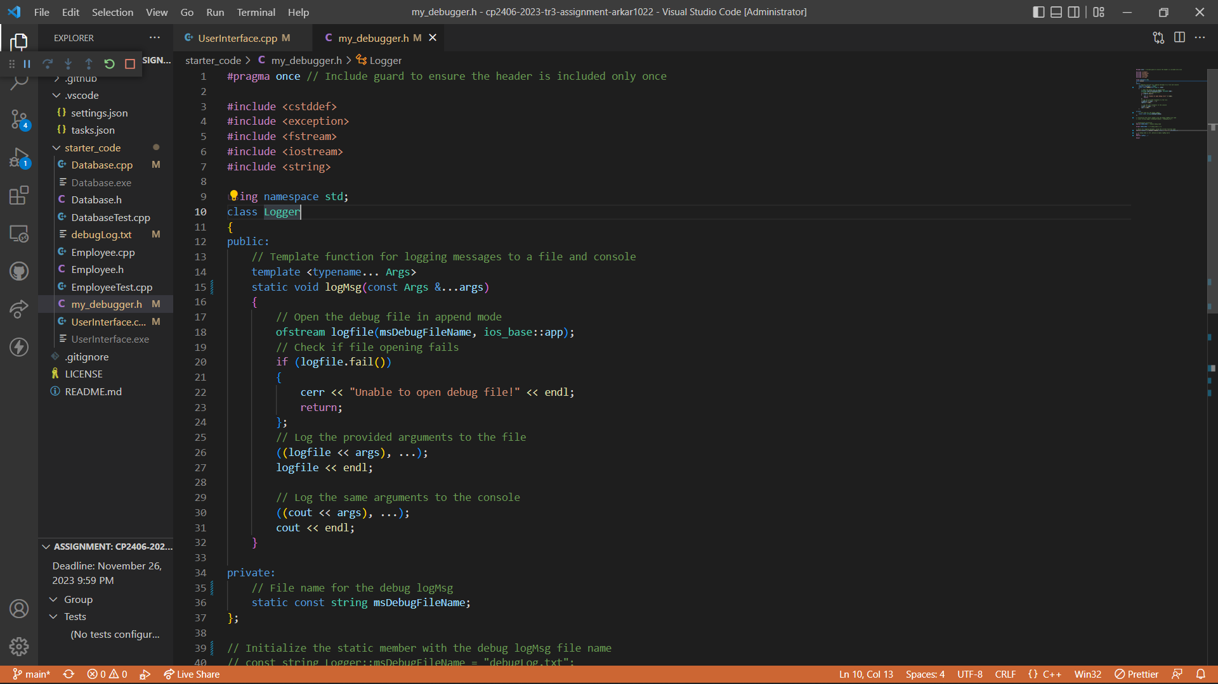

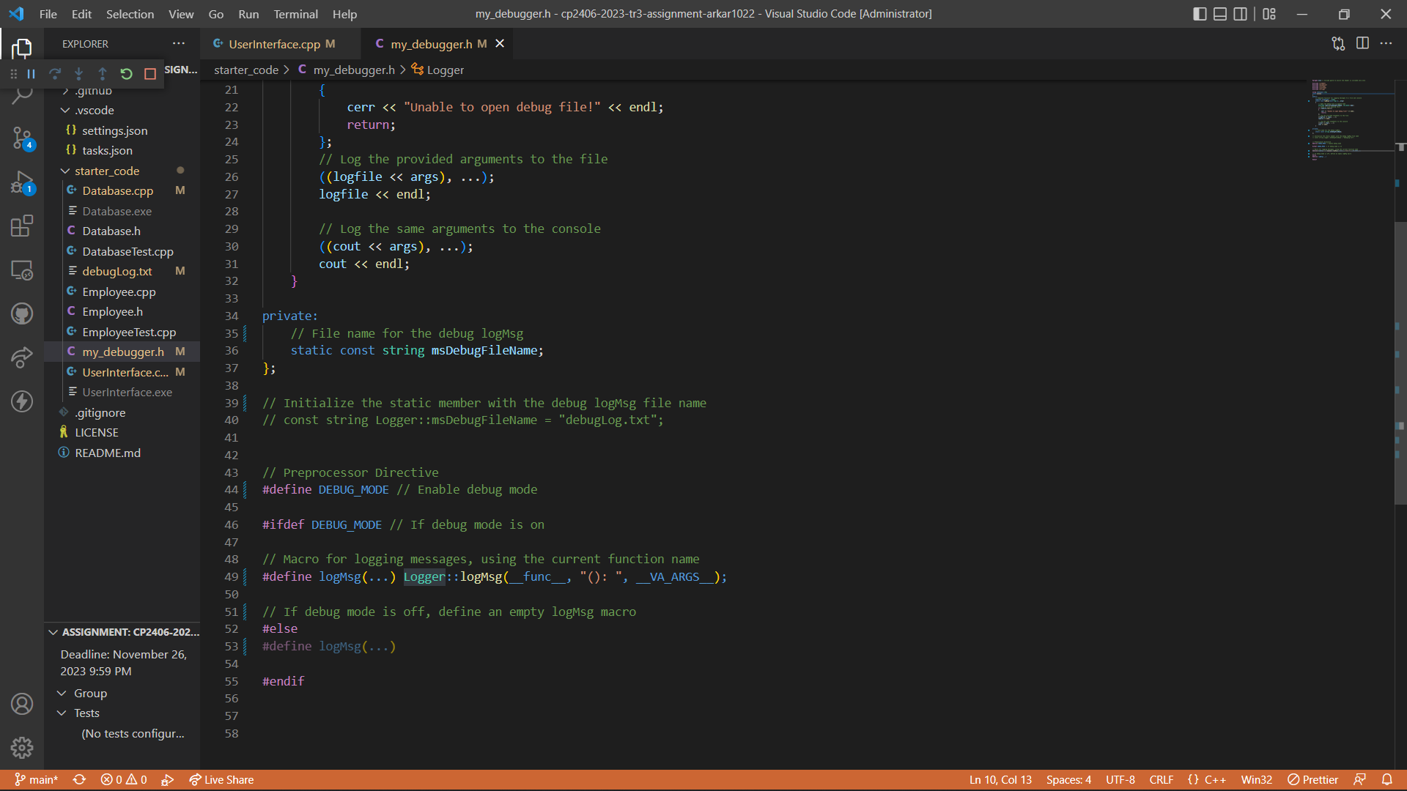

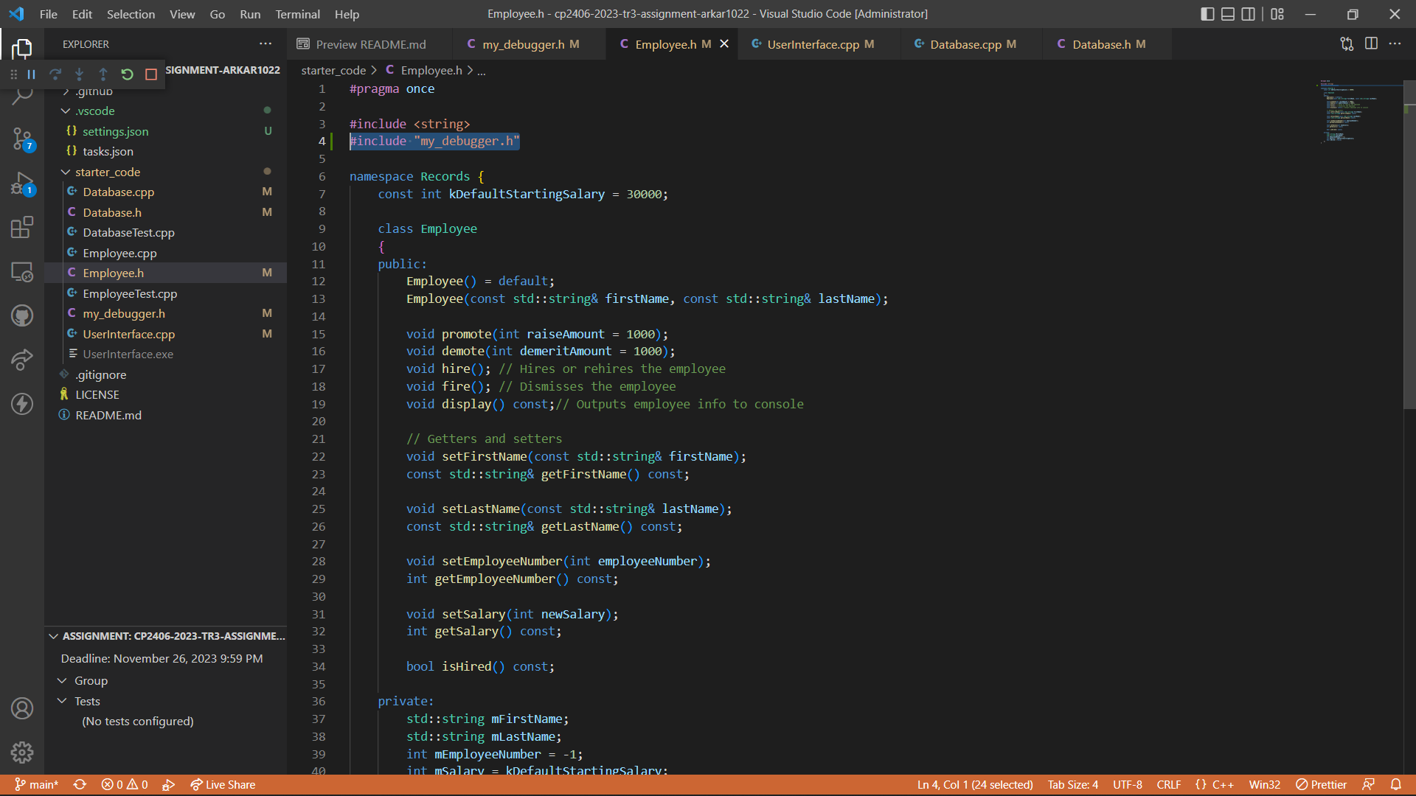

Adding log messages for specific functions to trace and debug.

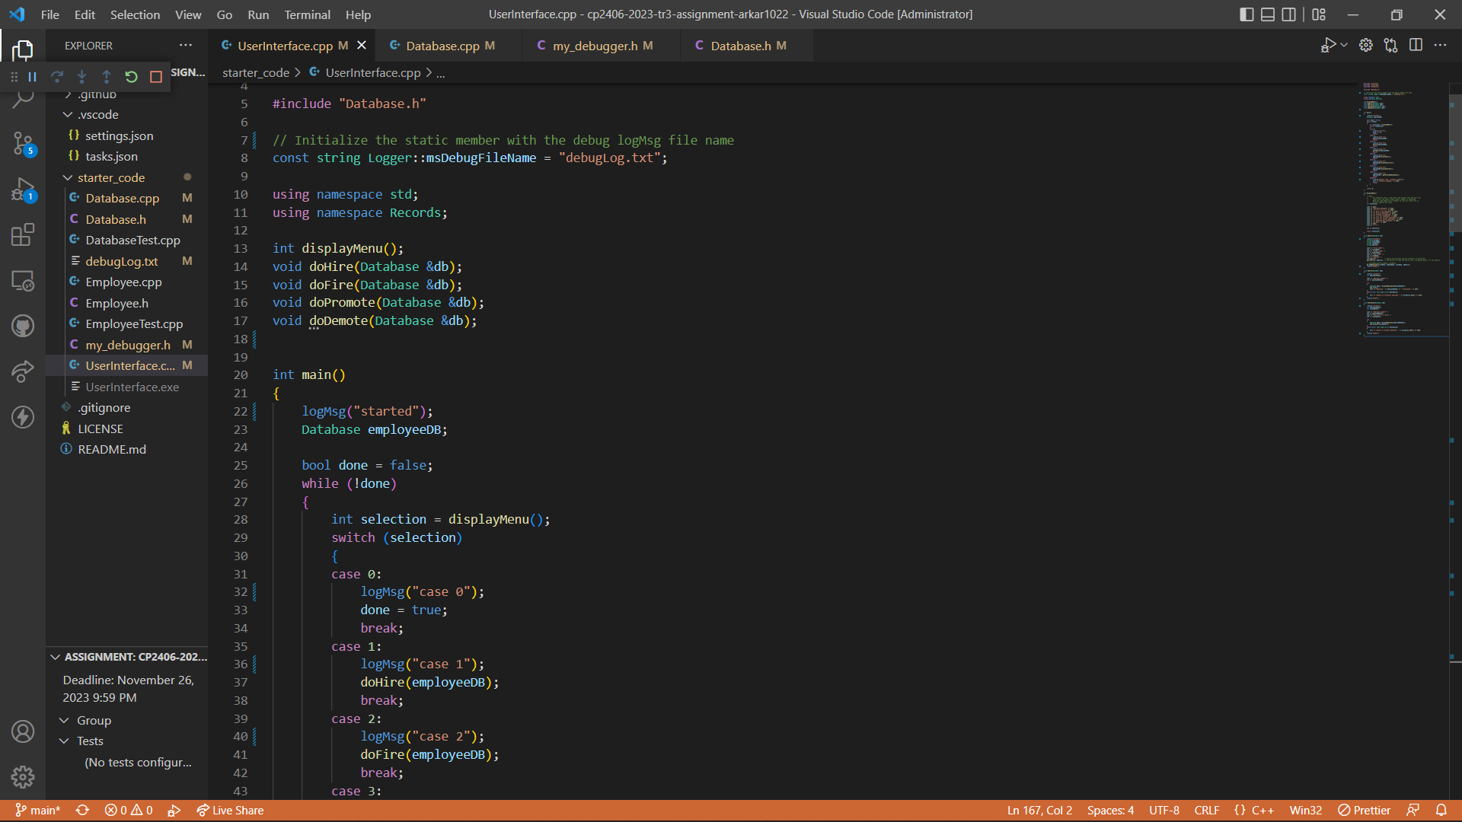

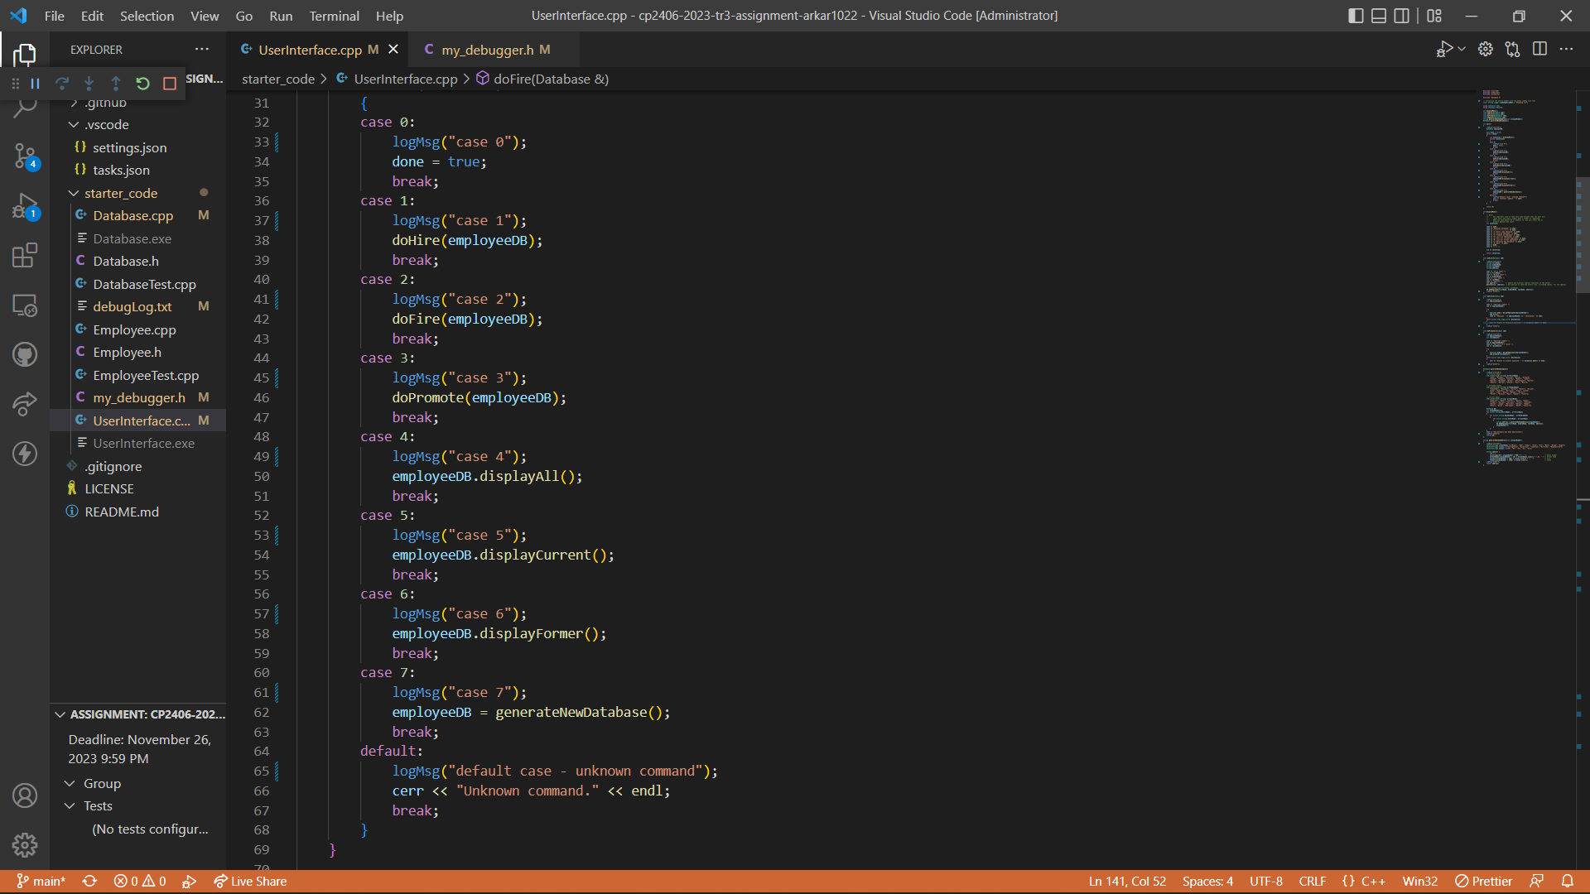

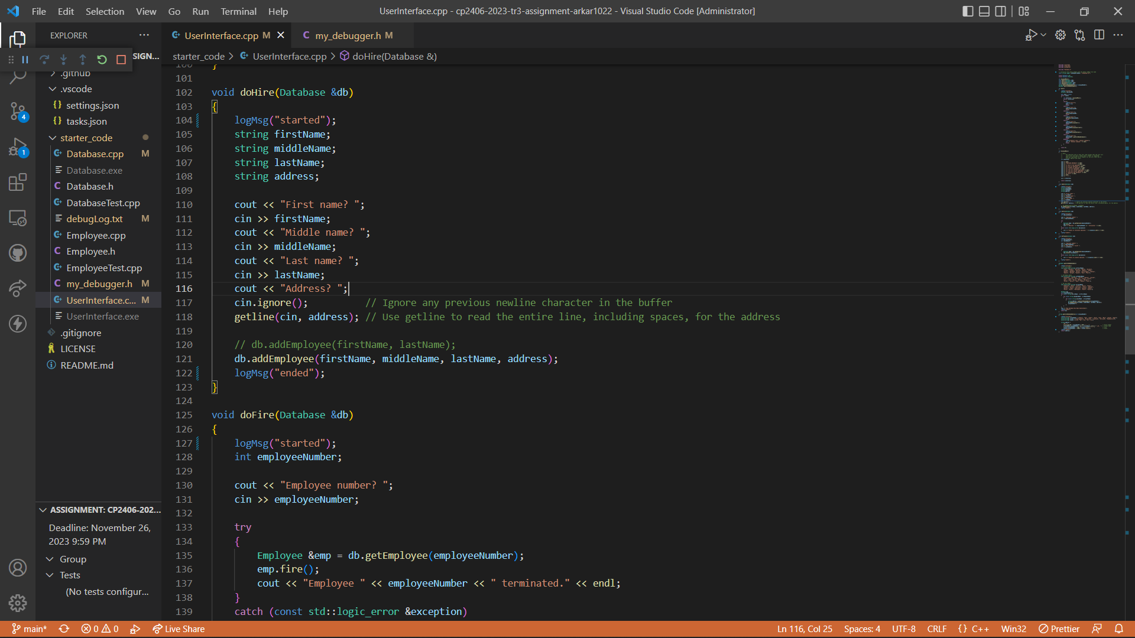

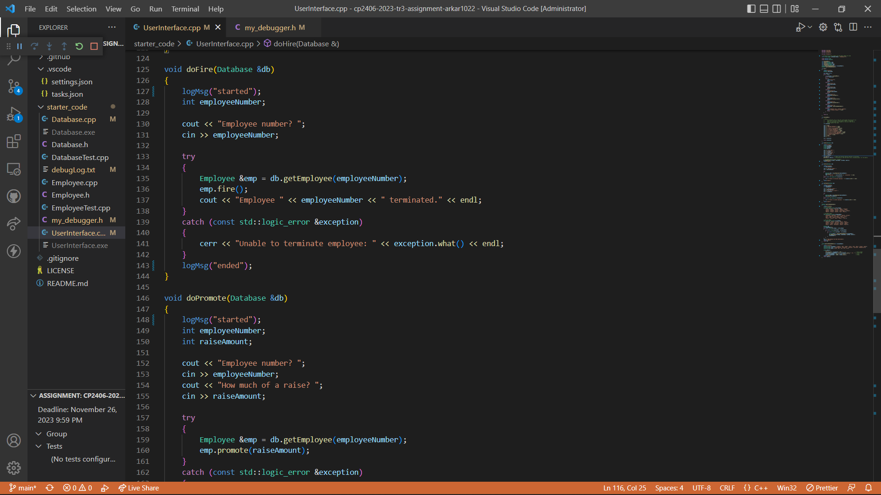

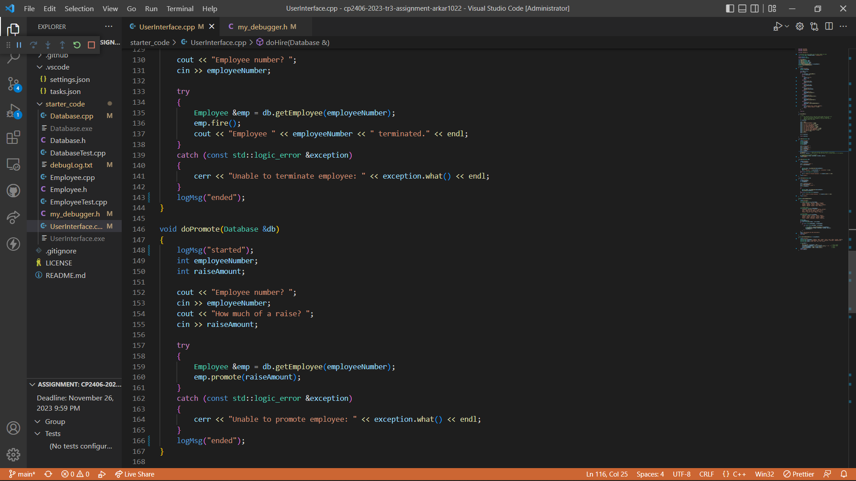

Print Tracing to the screen (console).

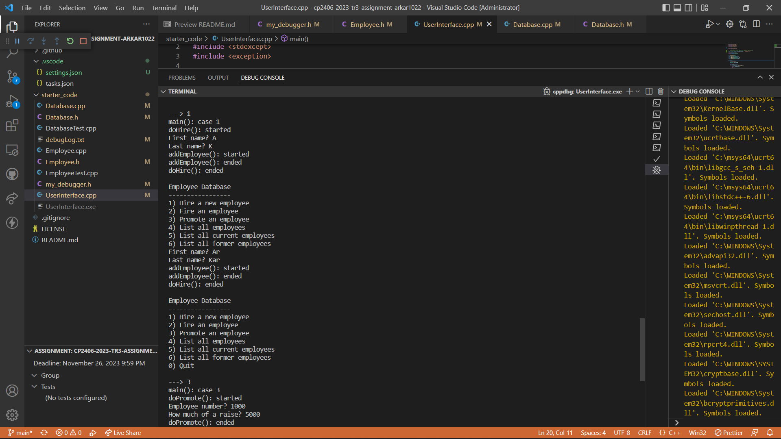

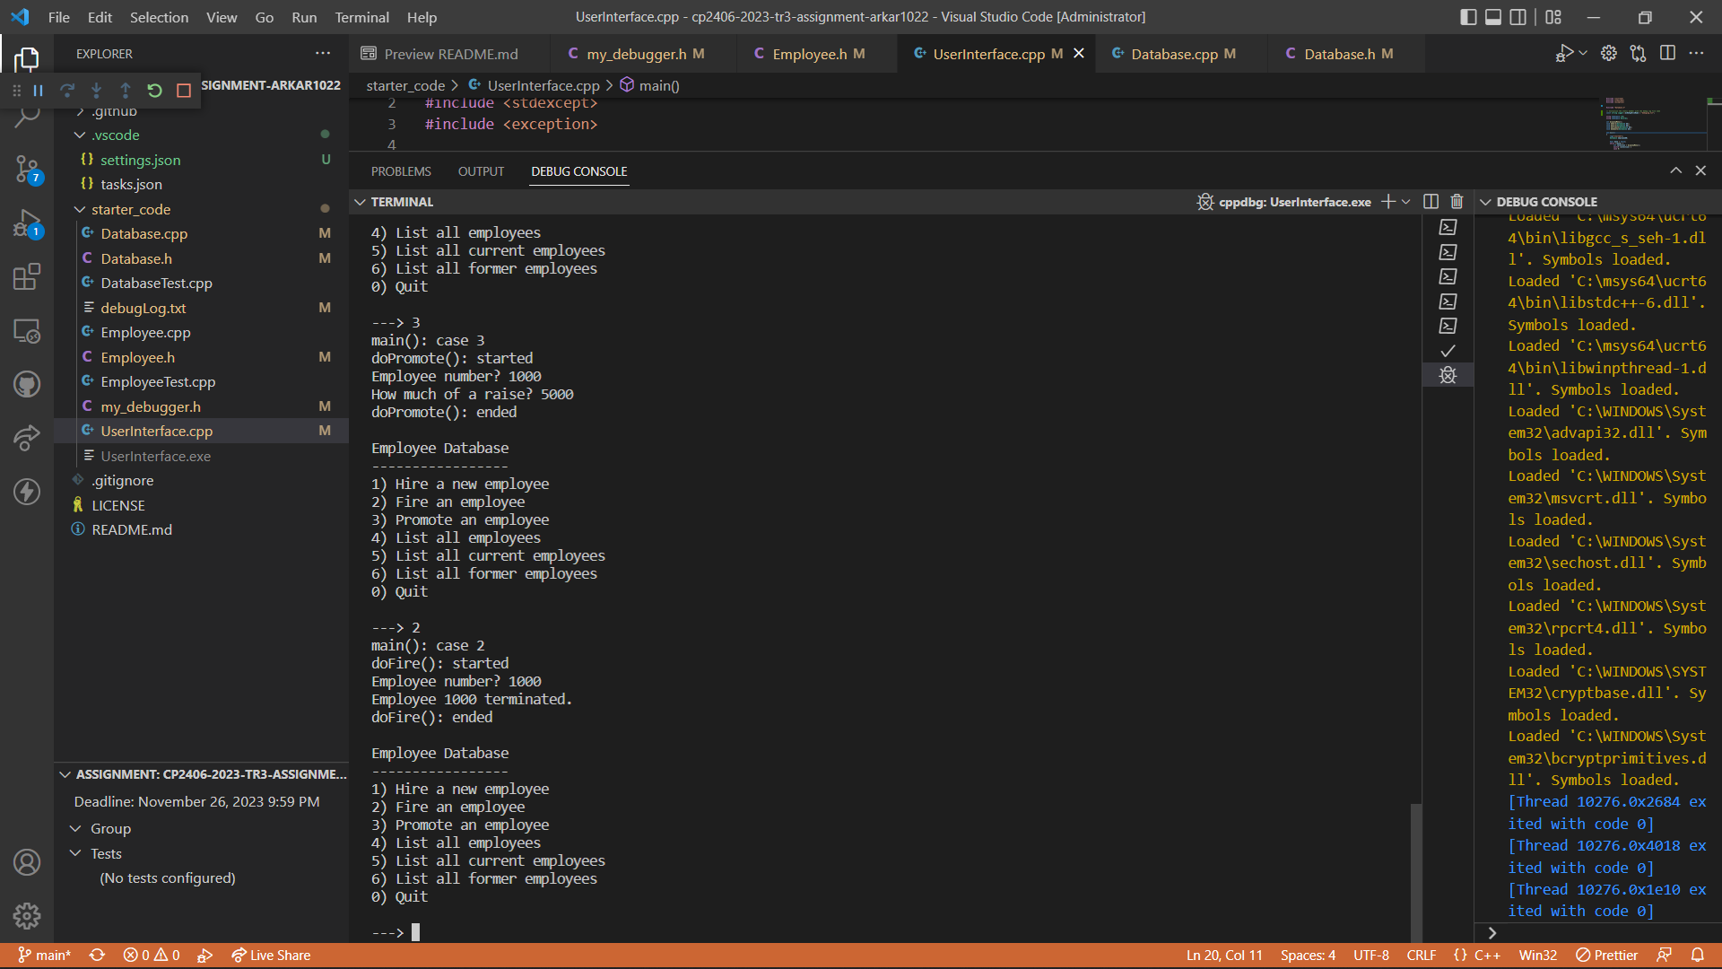

Results from debugLog.txt

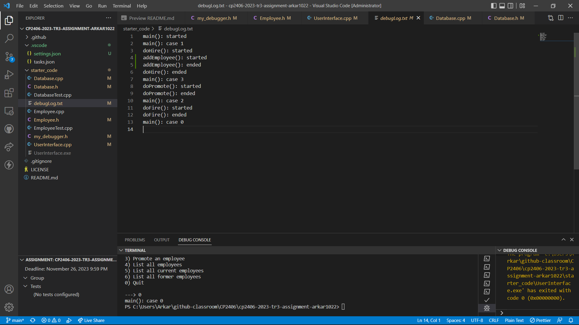

# Task 3 Add Option “7) Generate new database”

Adding new data members and getters and setters for “middle name” and “address” in “Employee.h” and updating constructor to accept middle name and address as new parameters.

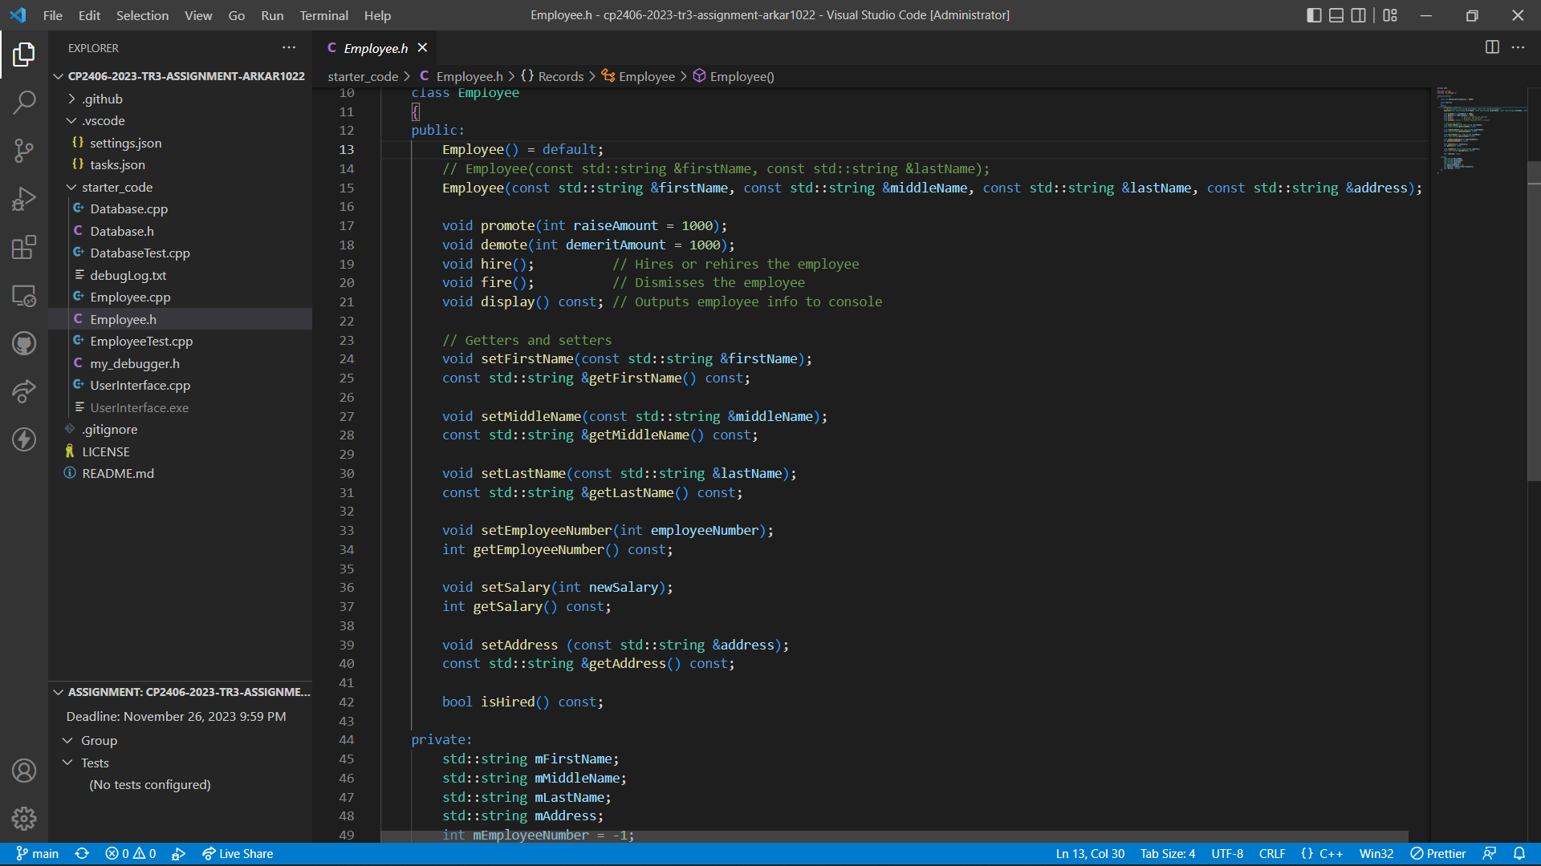

Define functions for specific getters and setters of middle name, address and updated constructor in “Employee.cpp”

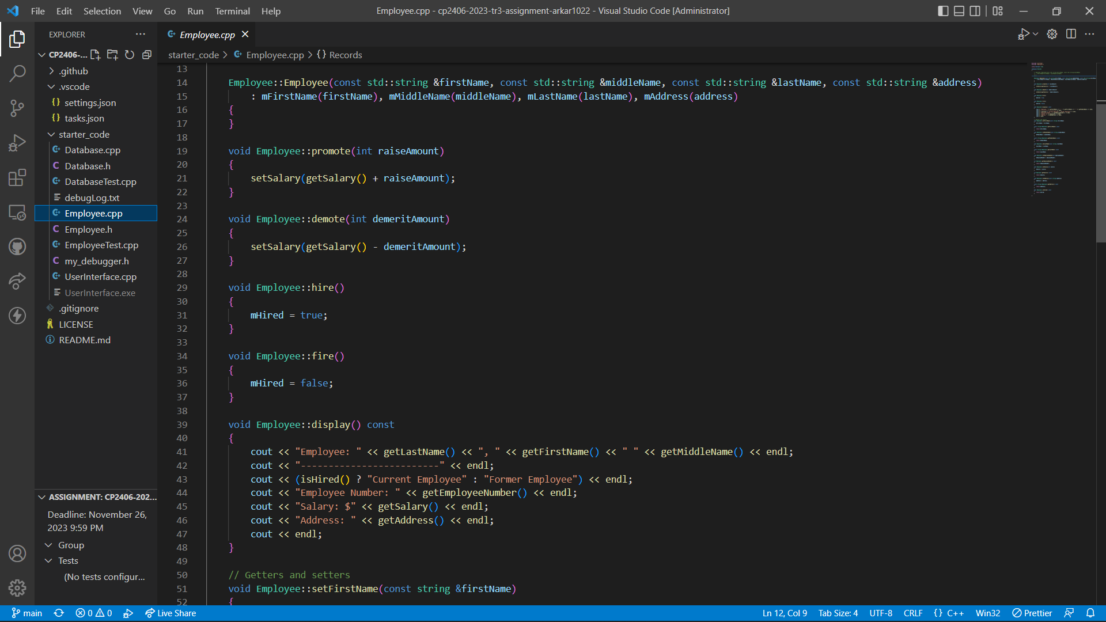

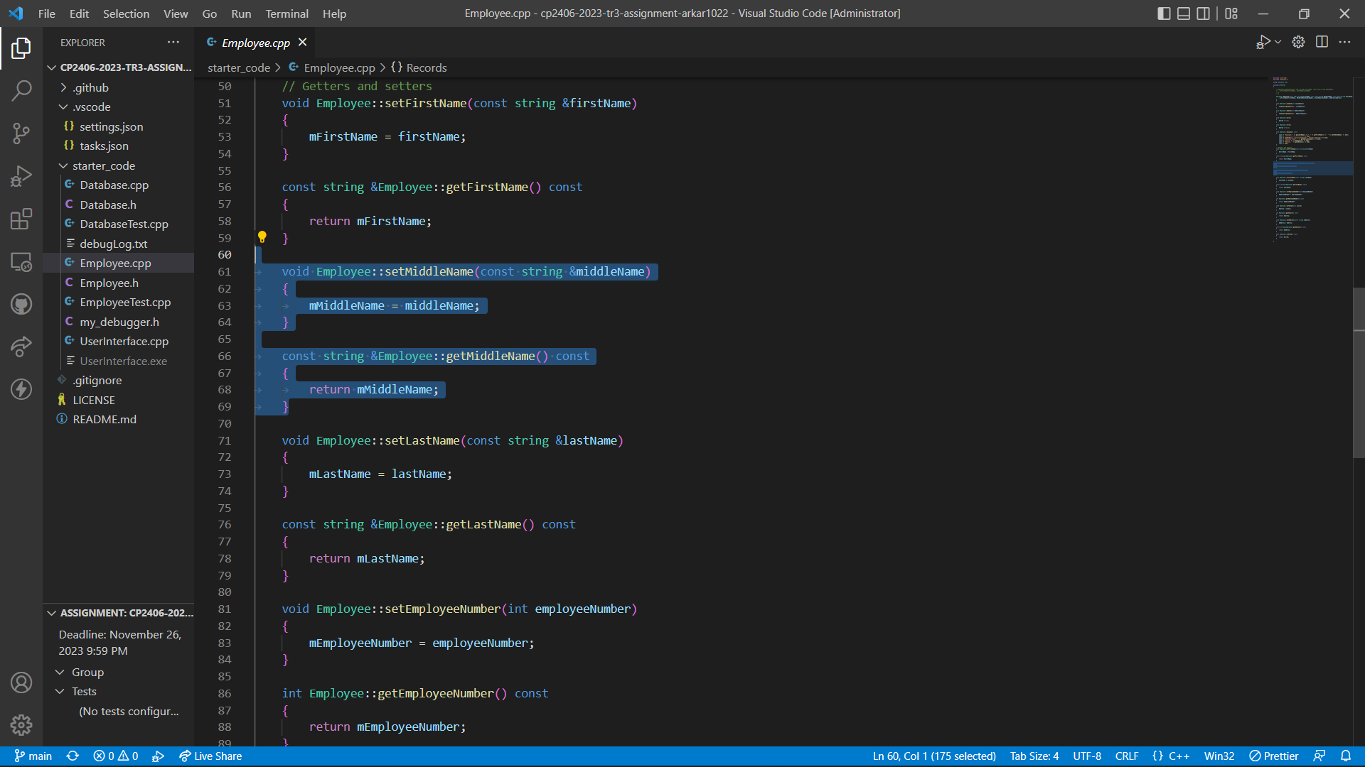

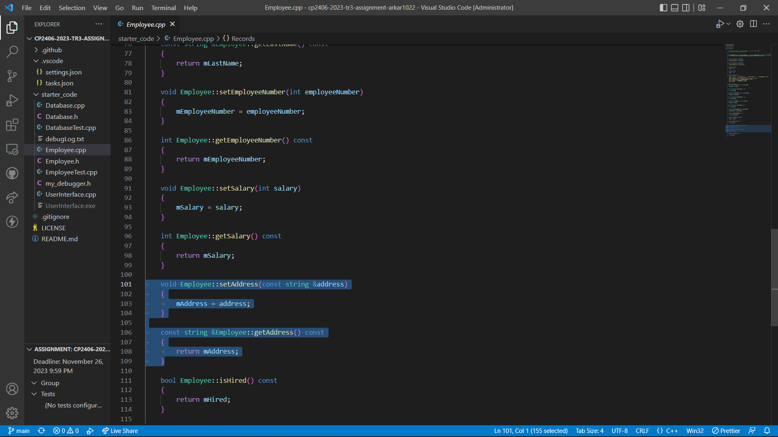

Declare and define updated “addEmployee” function which will accept middle name and address as new parameters in “Database.h” and “Database.cpp”.

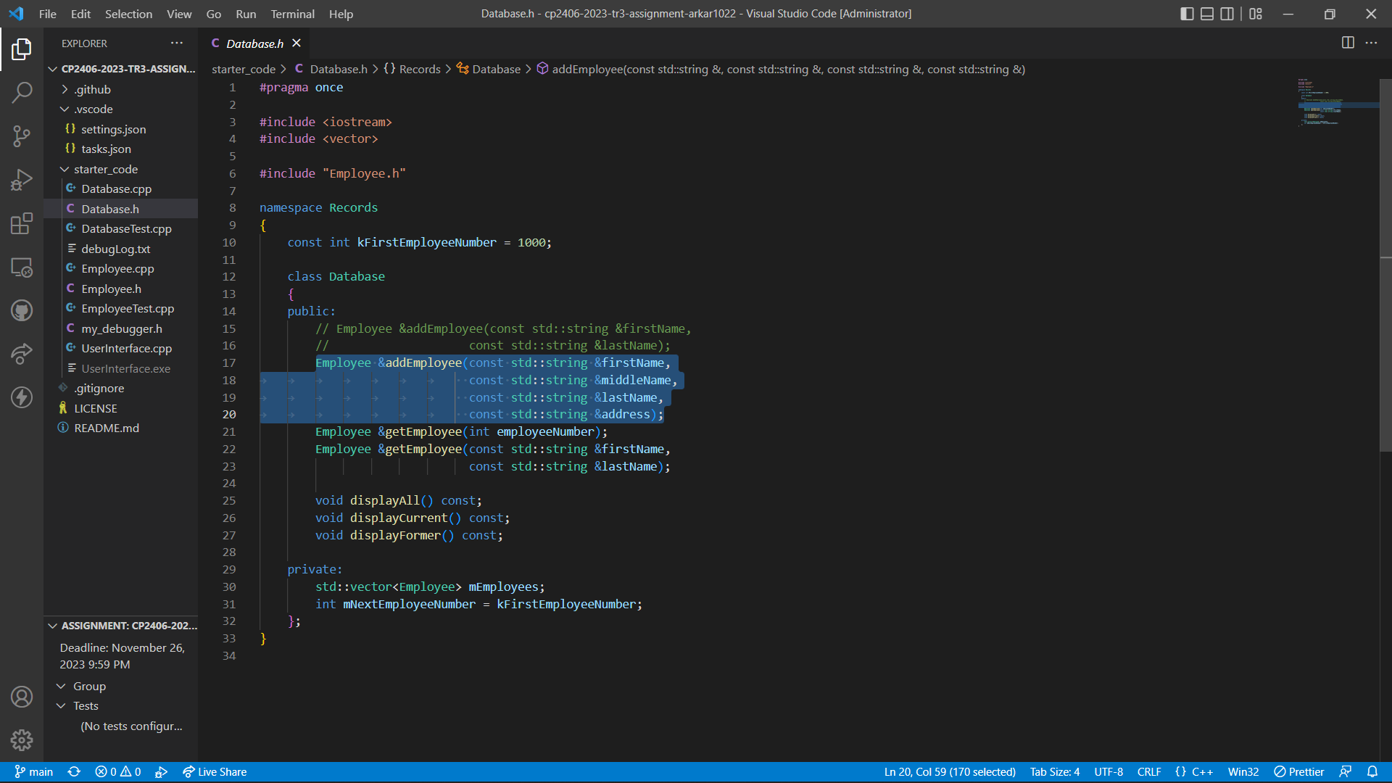

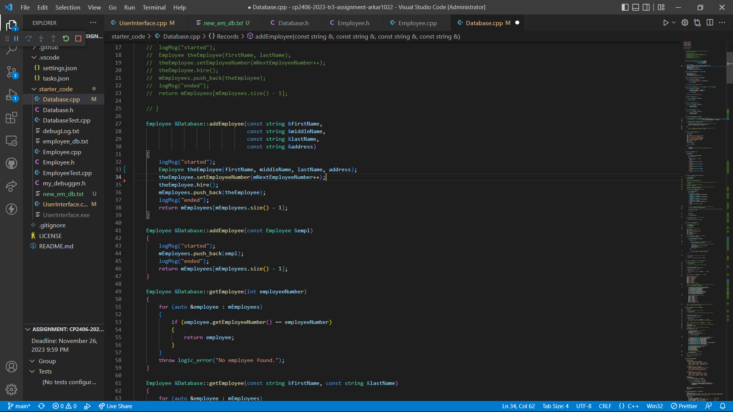

Modified “doHire()” function in “UserInterface.cpp”, so that user will be asked to input first name, middle name, last name and address.

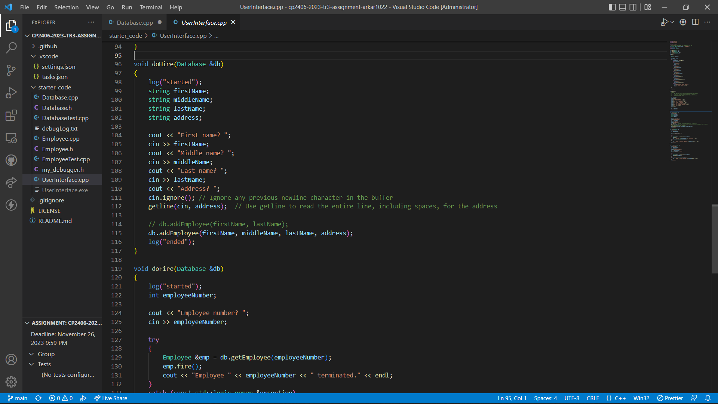

Define and declare “generateRandomAddress()” function and “generateNewDatabase()” function in “Database.h” and “Database.cpp”.

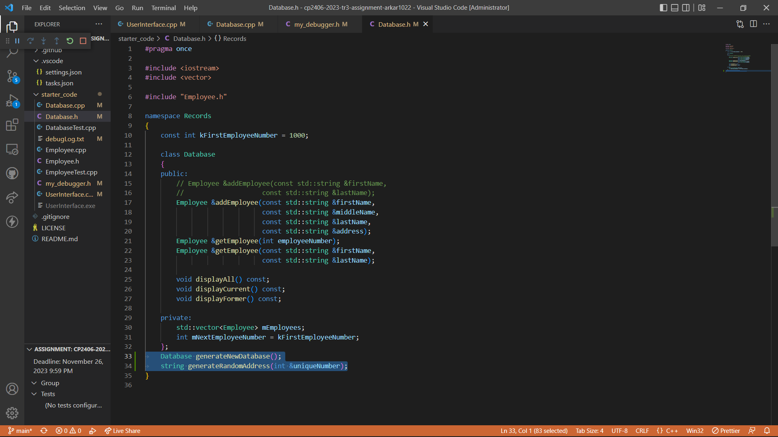

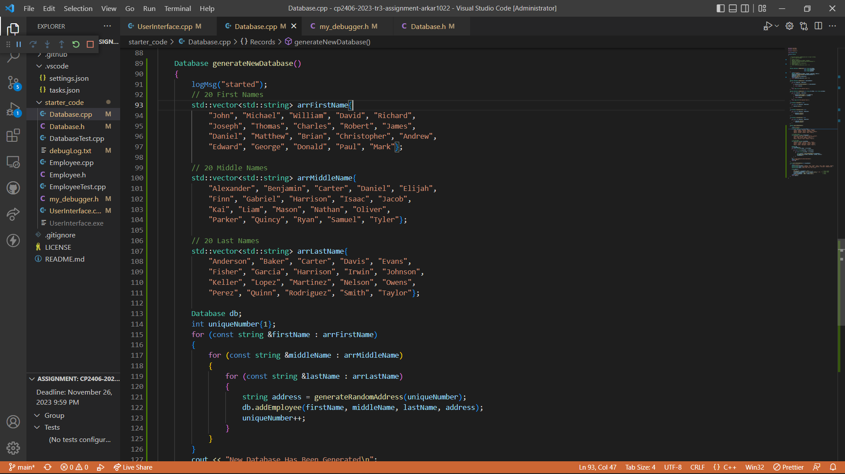

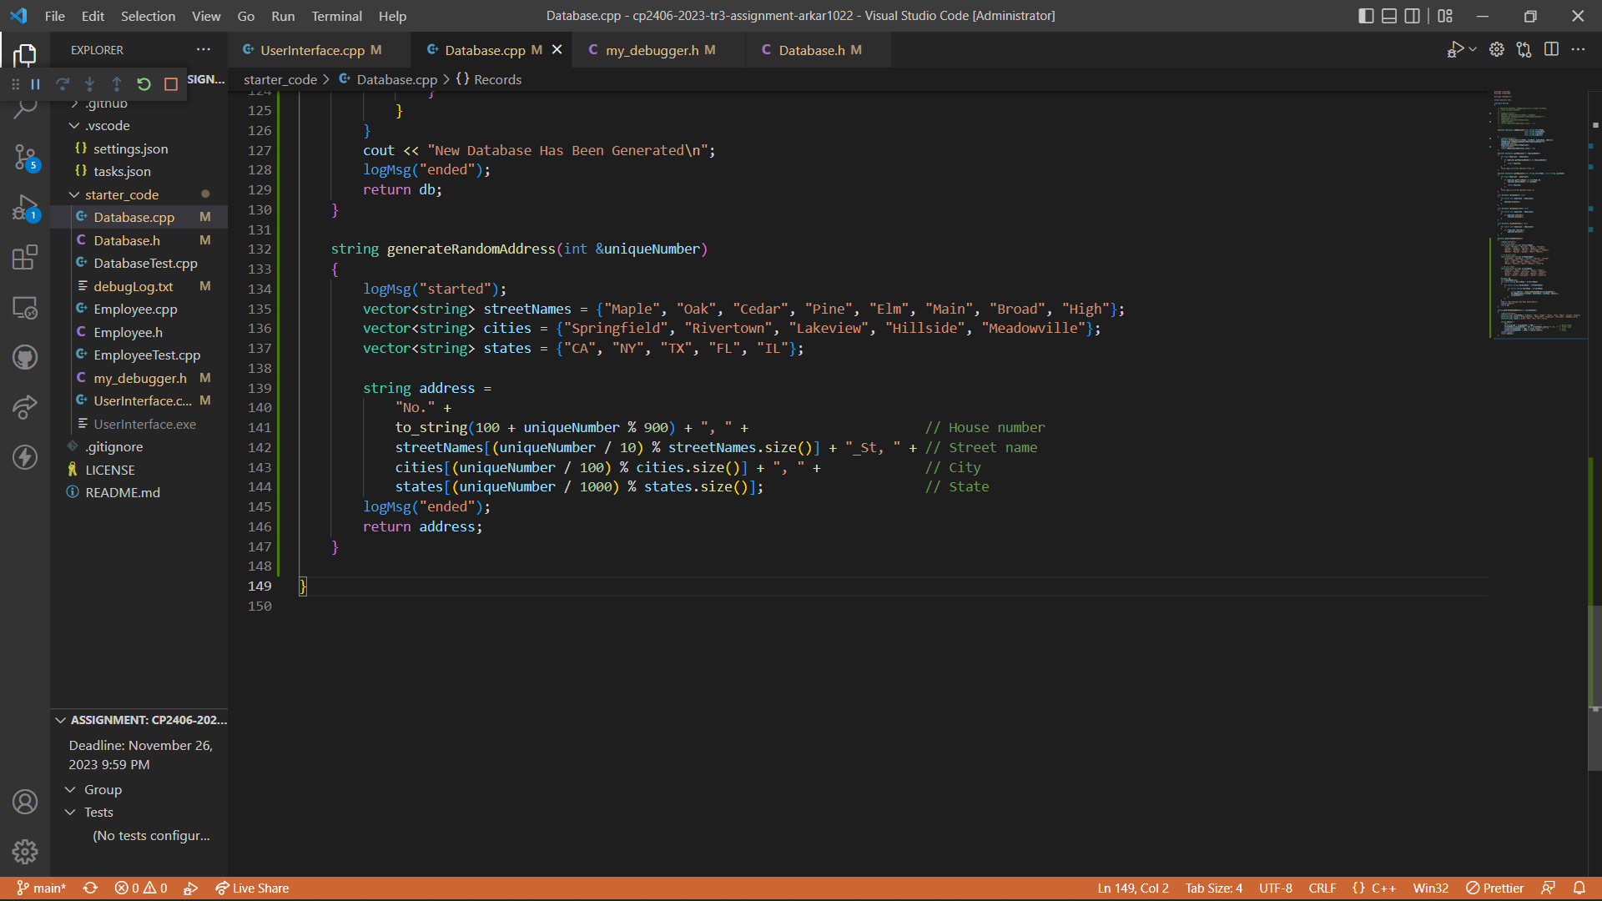

Call the function in main().

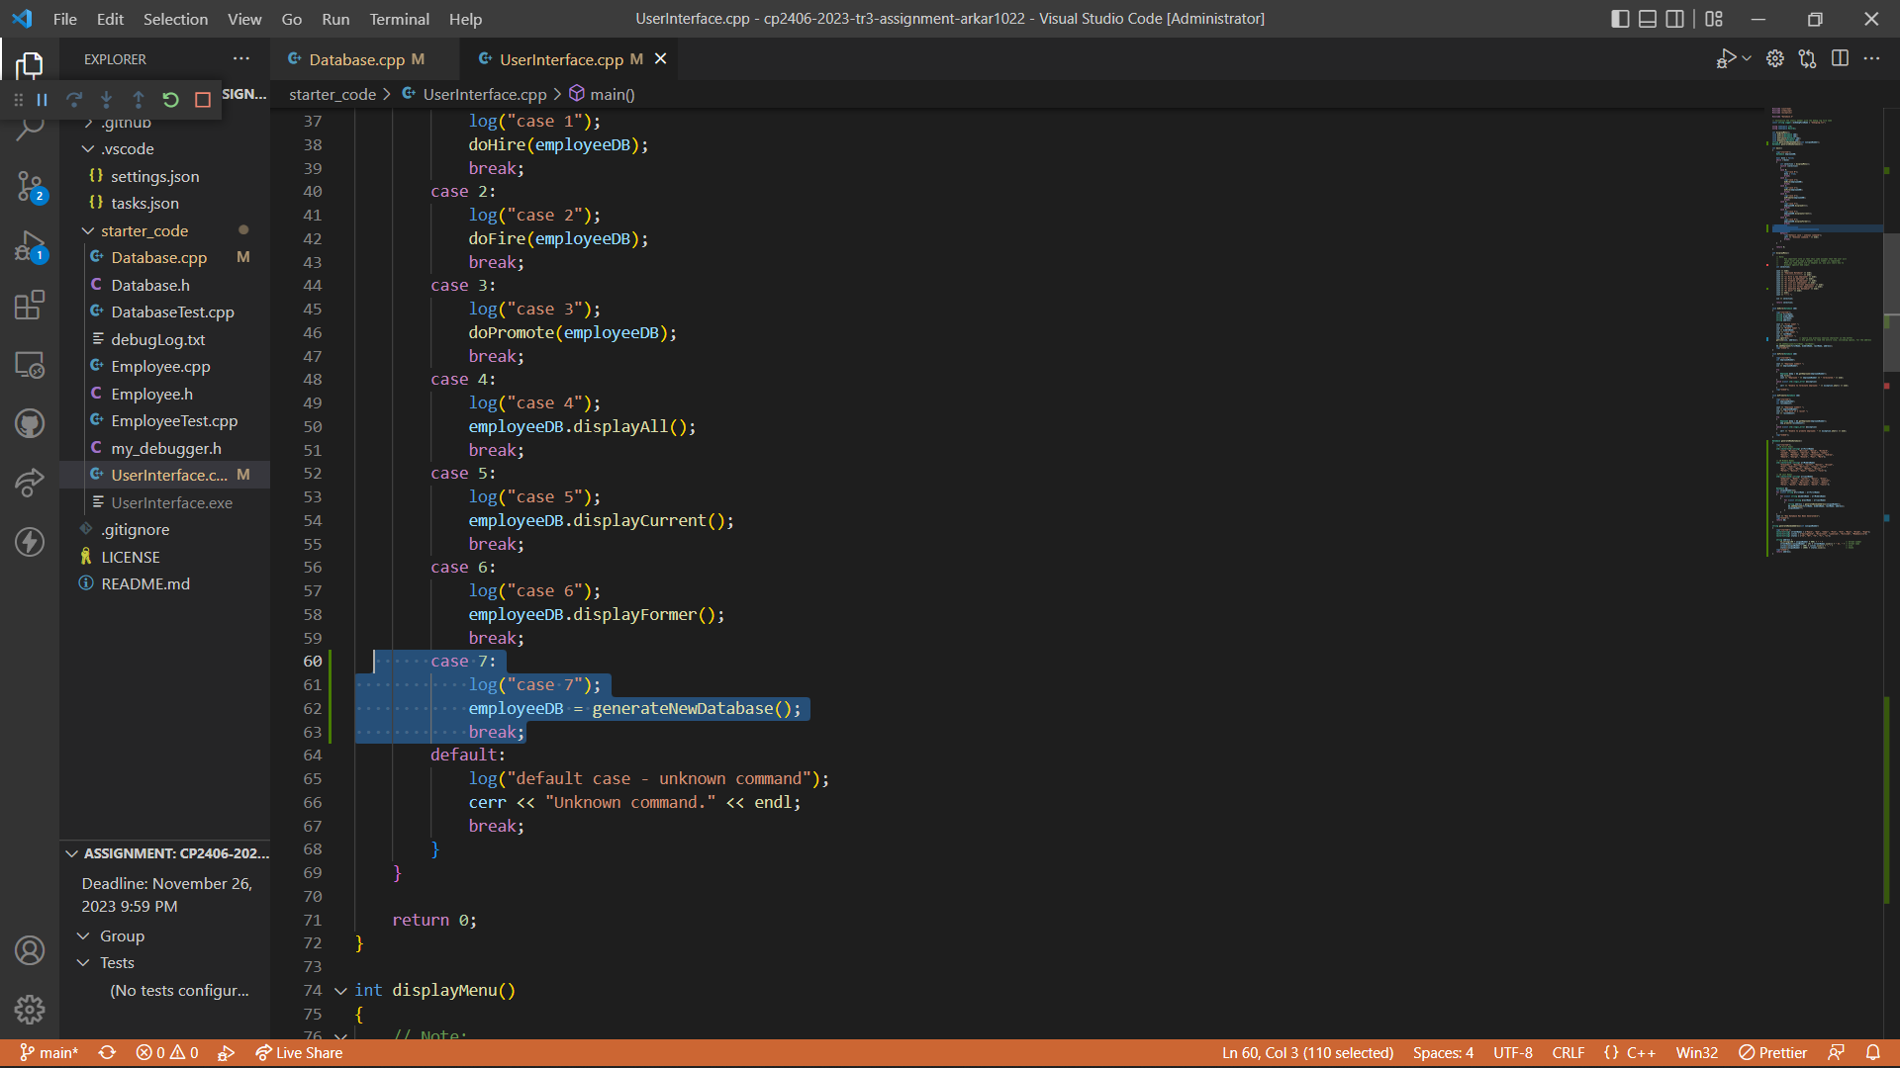

Output Results:

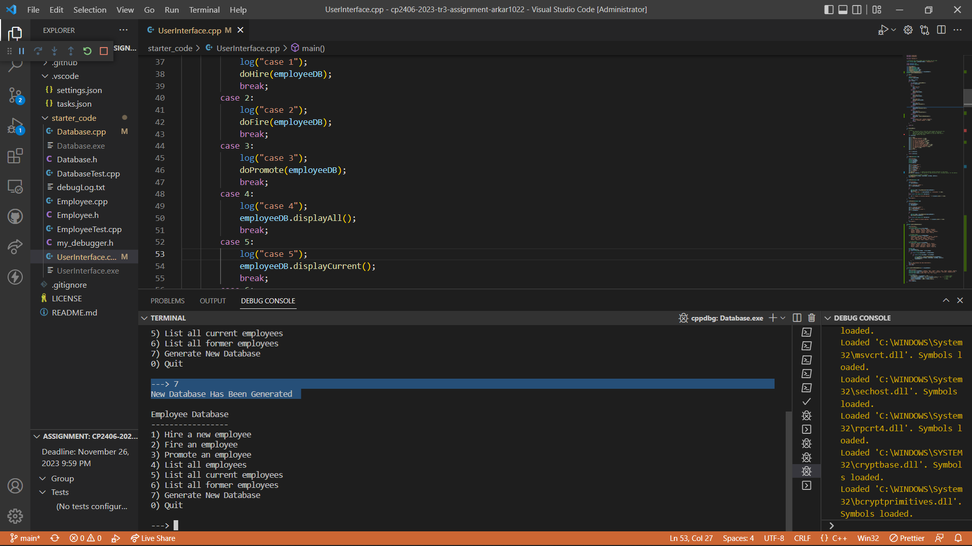

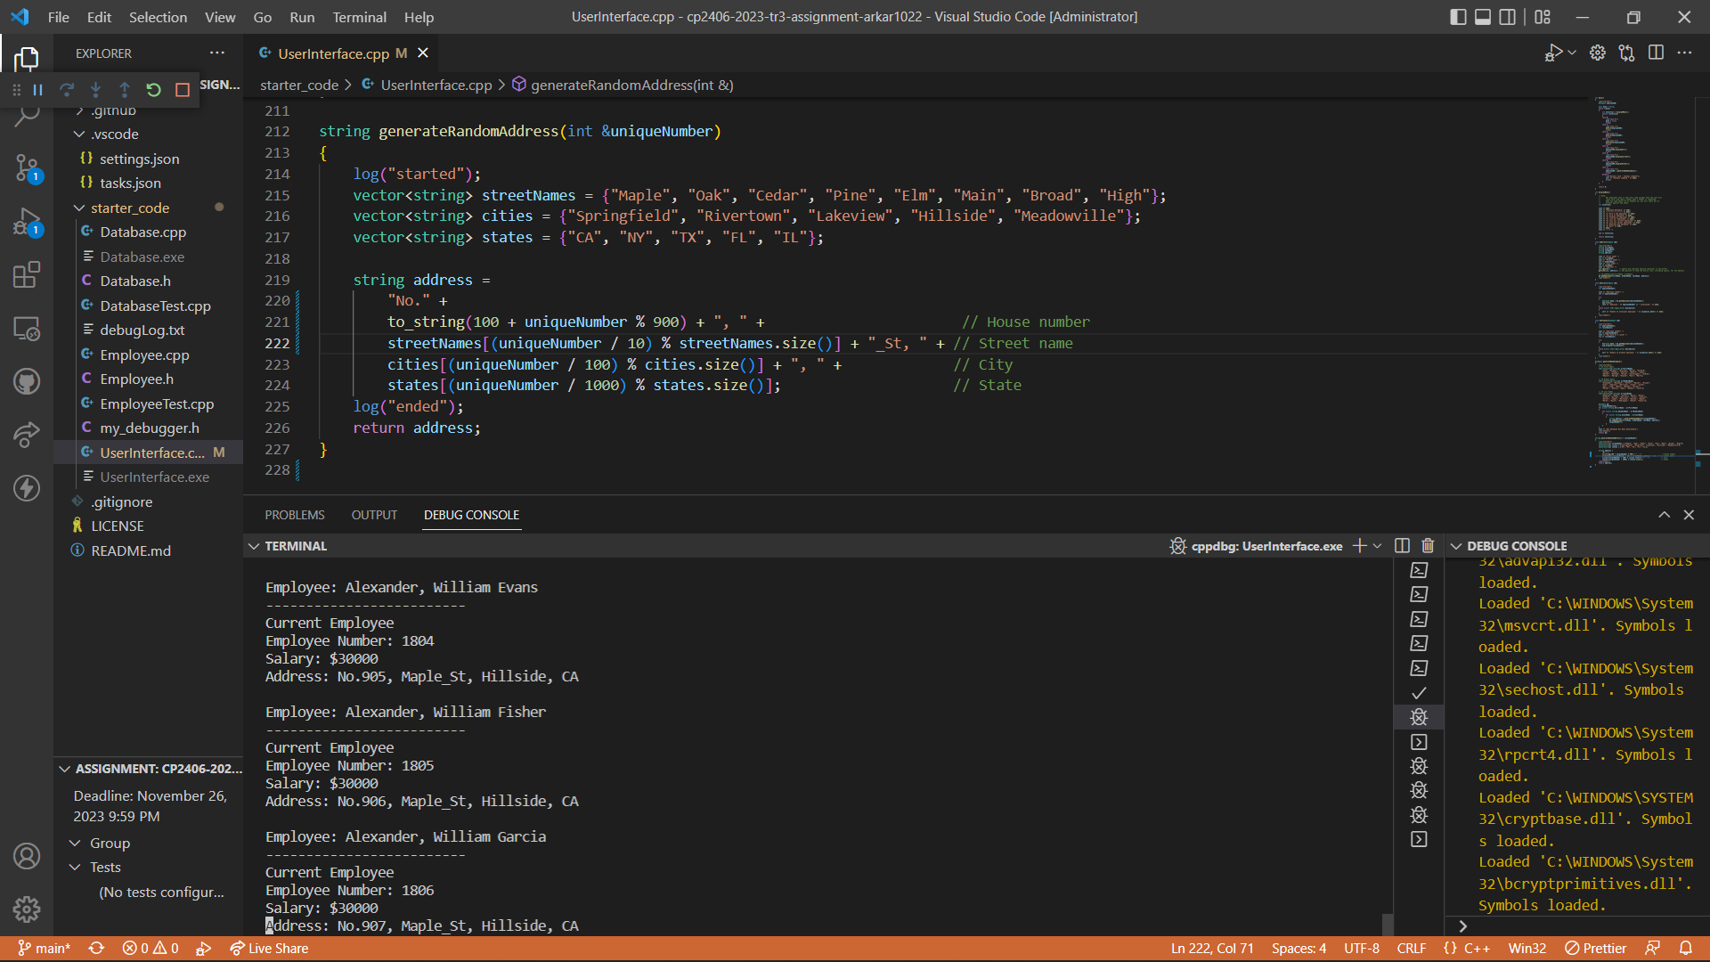

# Task 4 Add Option “8) Save database to file”

Add “selectOutputFileName()” function in “UserInteface.cpp” which will check whether file already exist or not and if exist, confirm user to overwrite it.

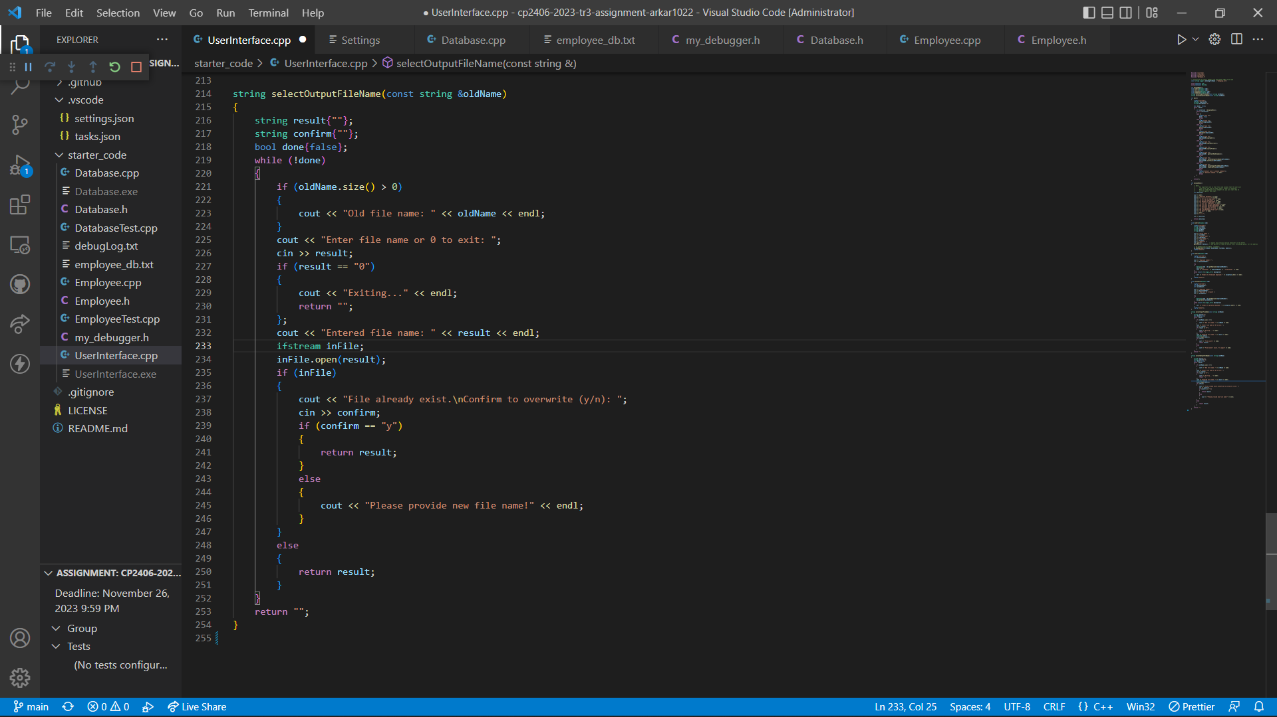

Declare and define “saveToFile()” in “Database.h” and “Dtabase.cpp” which will save current database to a file, named by the user.

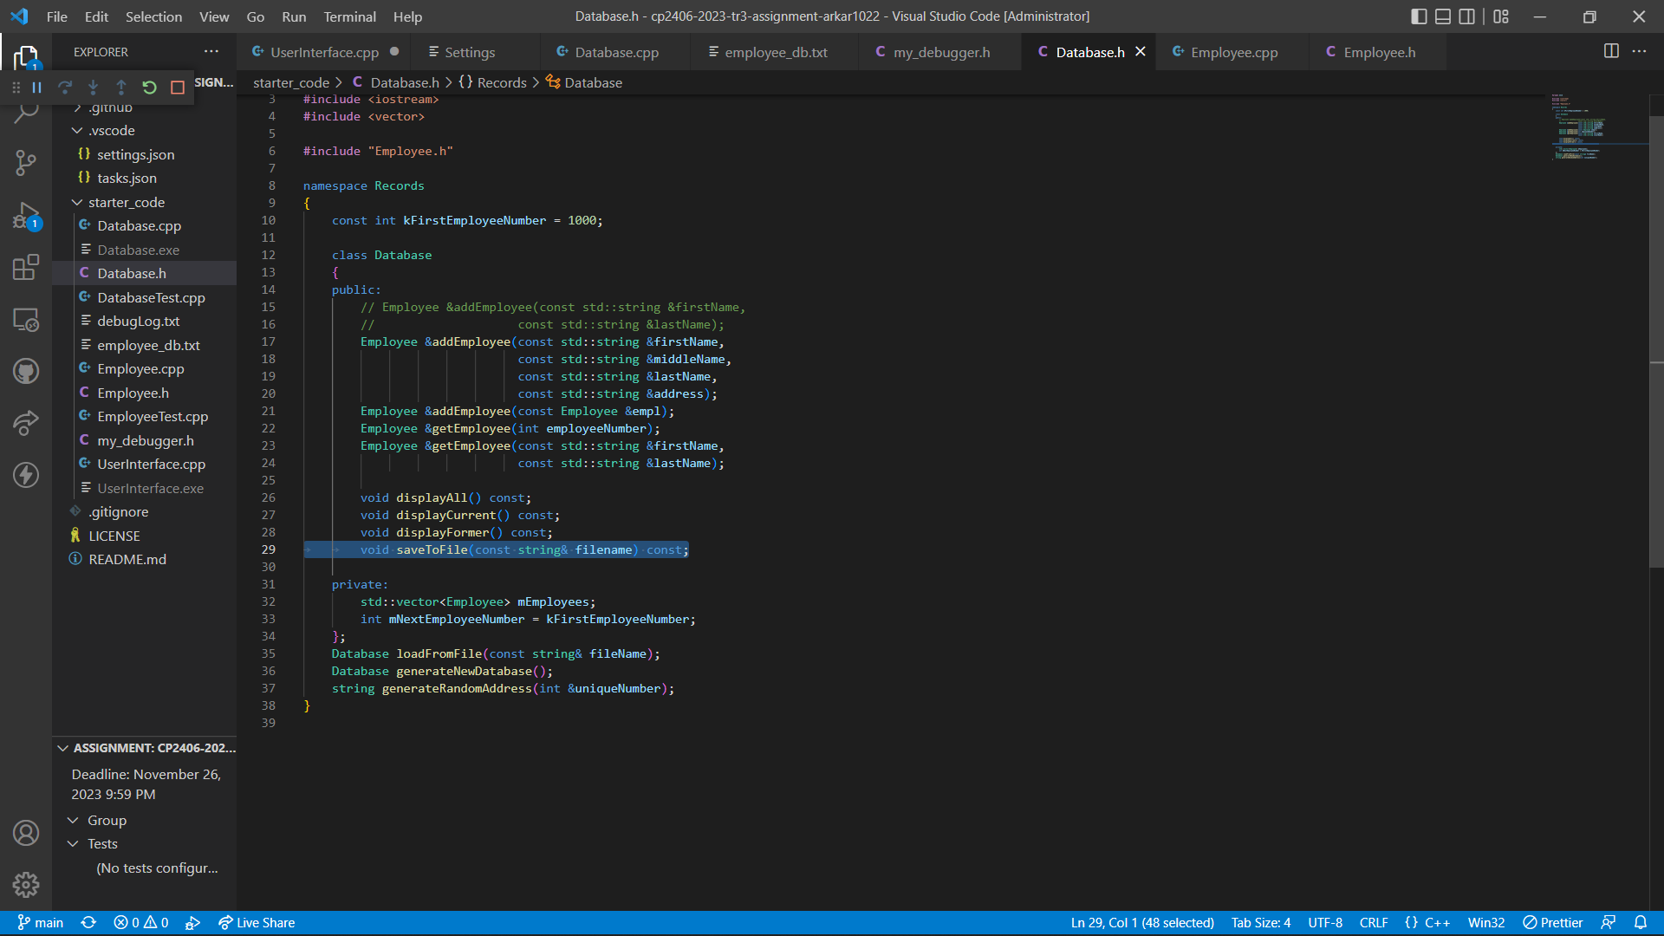

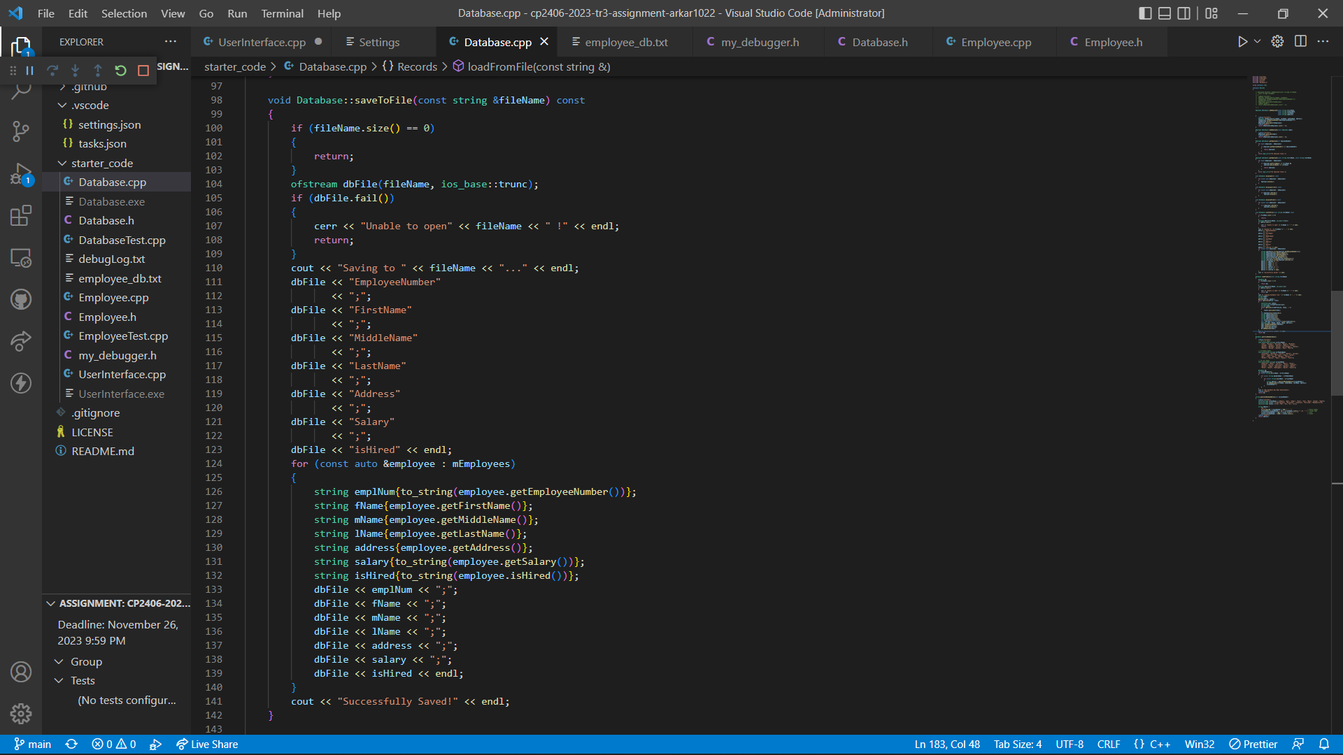

Call the function in “Case: 8”.

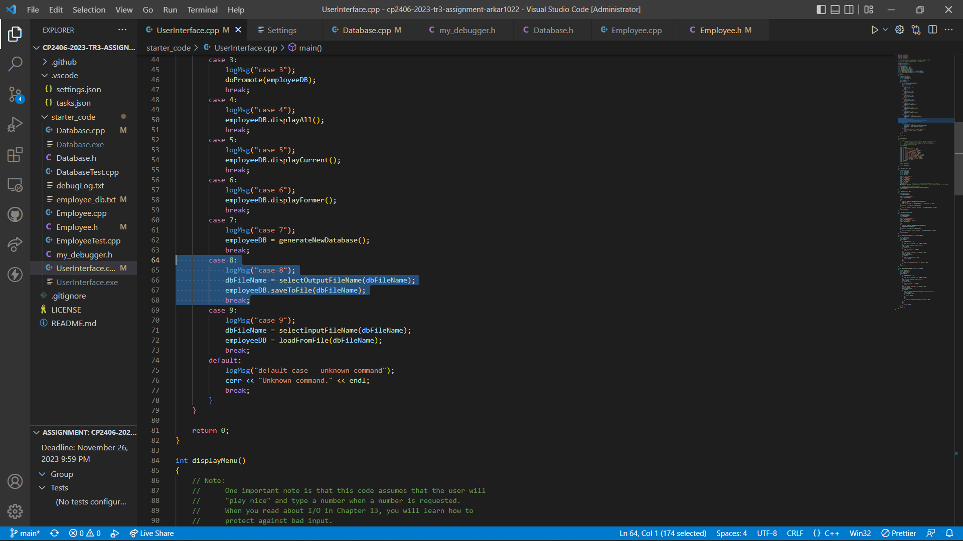

Output Result:

Generate Database first

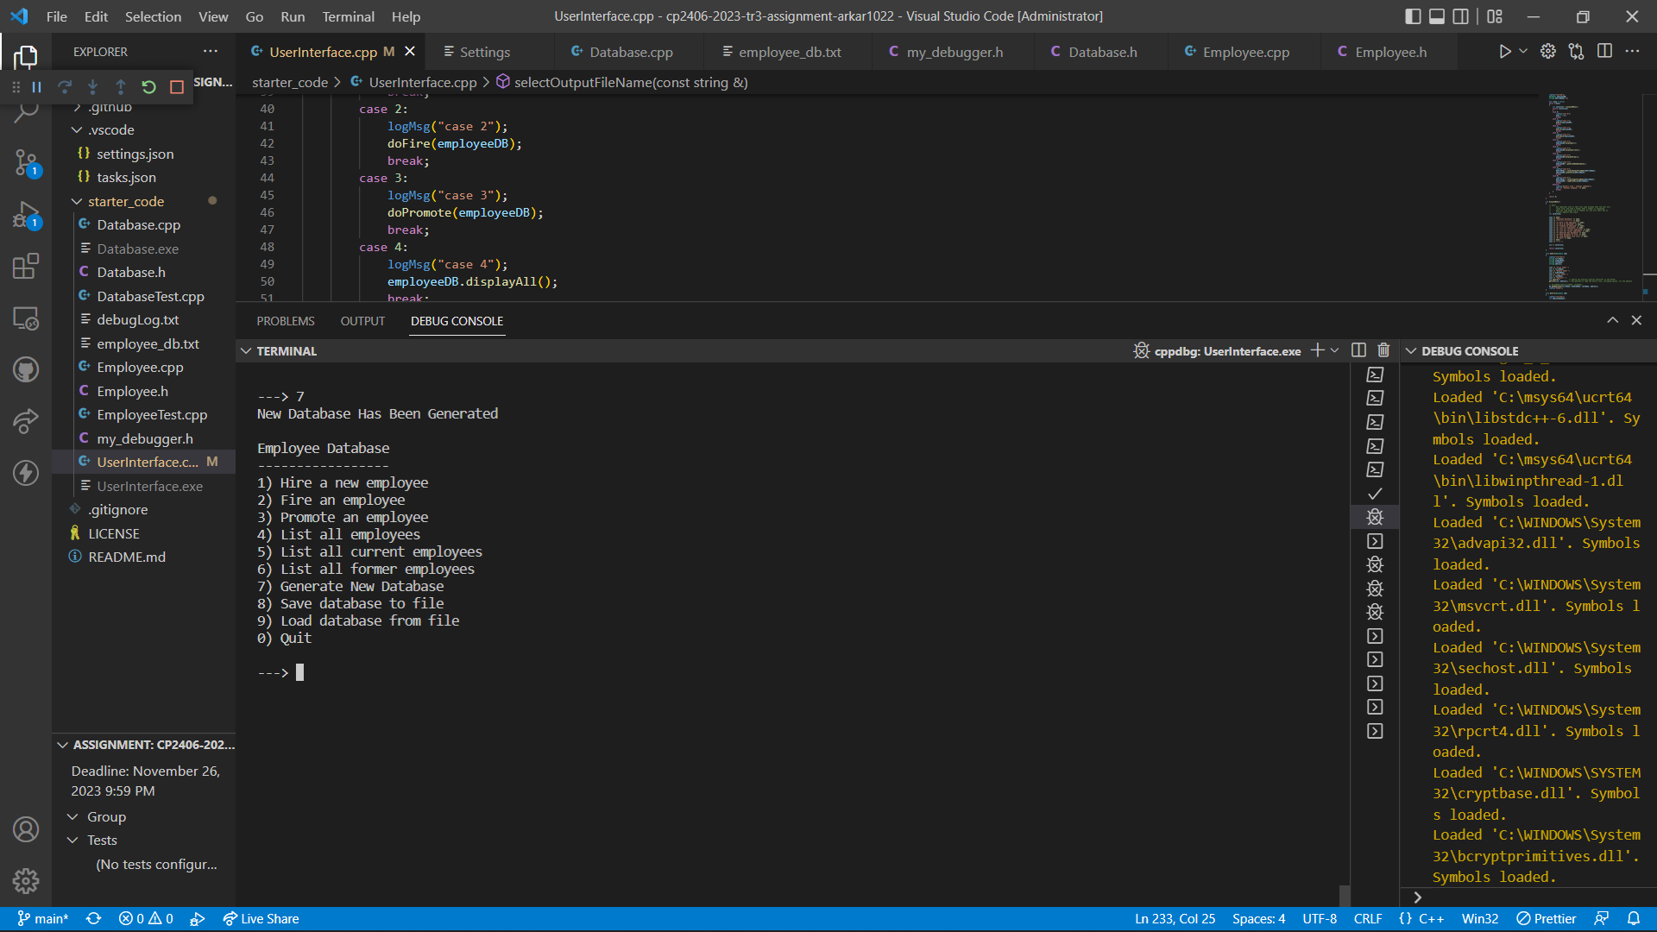

Choose Option 8 to save to a file and confirm user to overwrite it when the file is already existed. Input ‘0’ to exit the function.

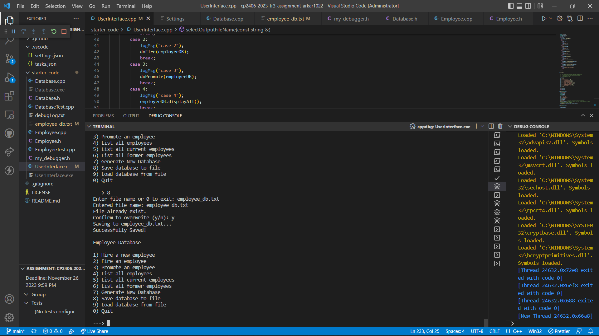

employee_db.txt

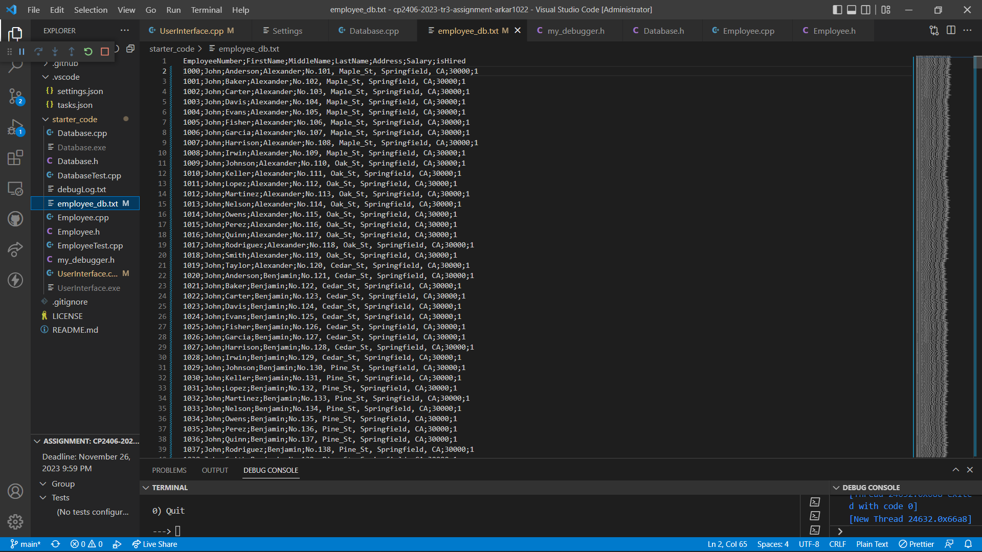

# Task 5 Add Option “9) Load database from file”

Add “selectInputFileName()” function in “UserInteface.cpp” which will check whether file already exist or not and if not exist, alert message will be displayed and asked file name again.

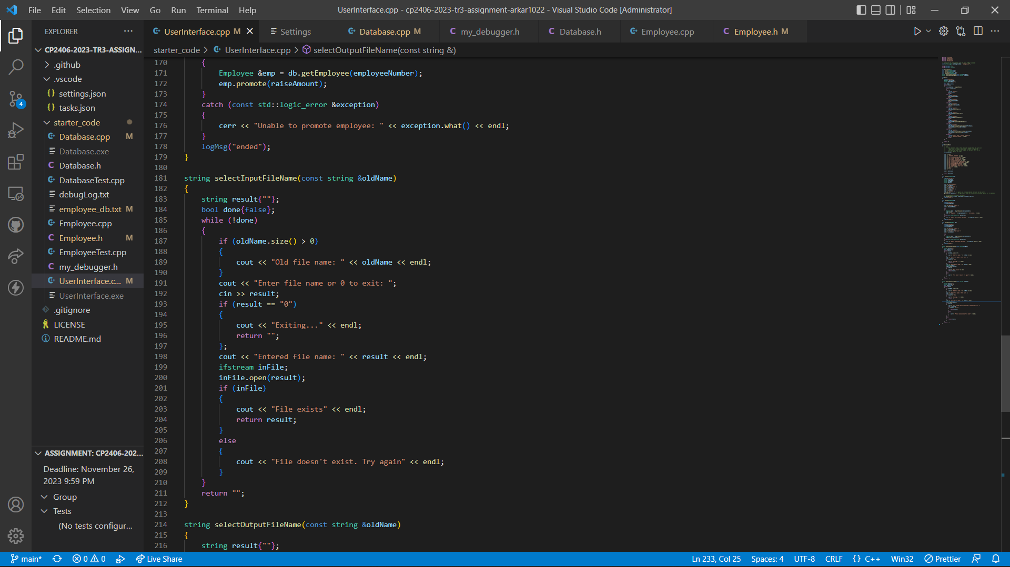

Define constant variables to store each index number in “Employee.h” which will be applied during tokenization.

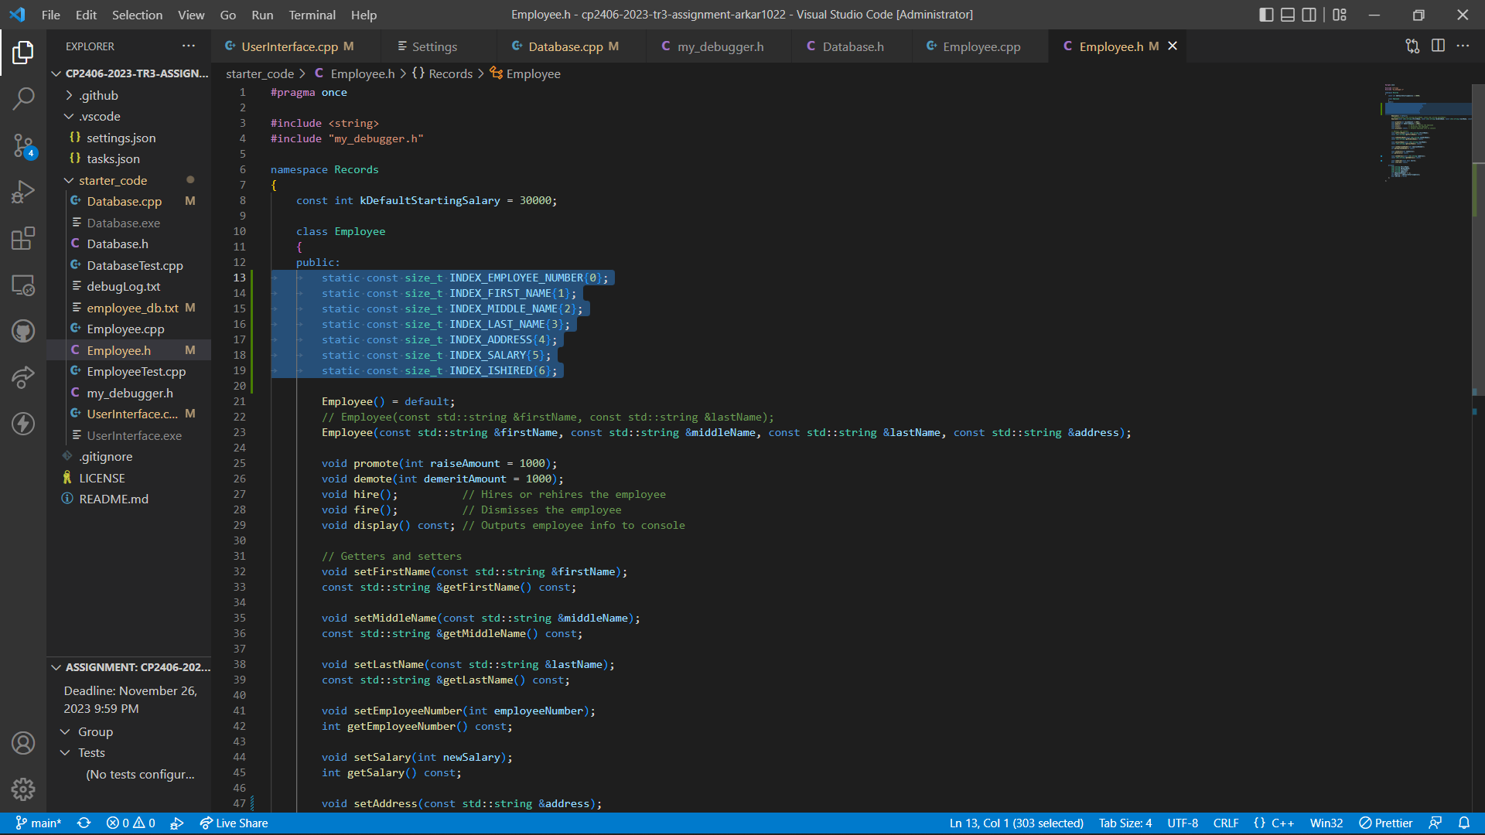

Declare and define “loadFromFile()” function in “Database.h” and “Database.cpp”.

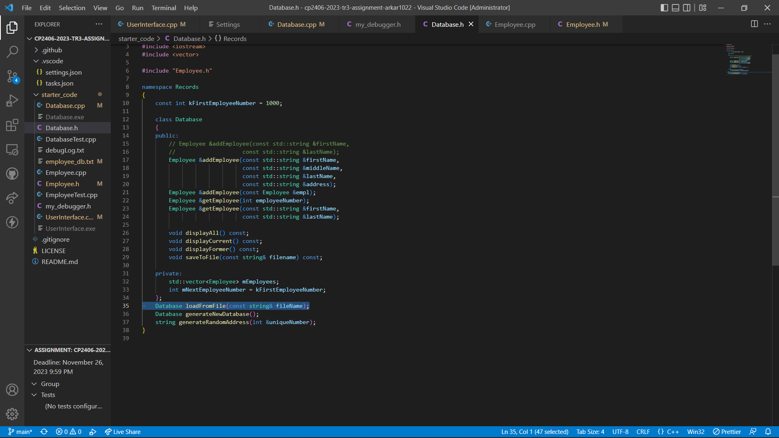

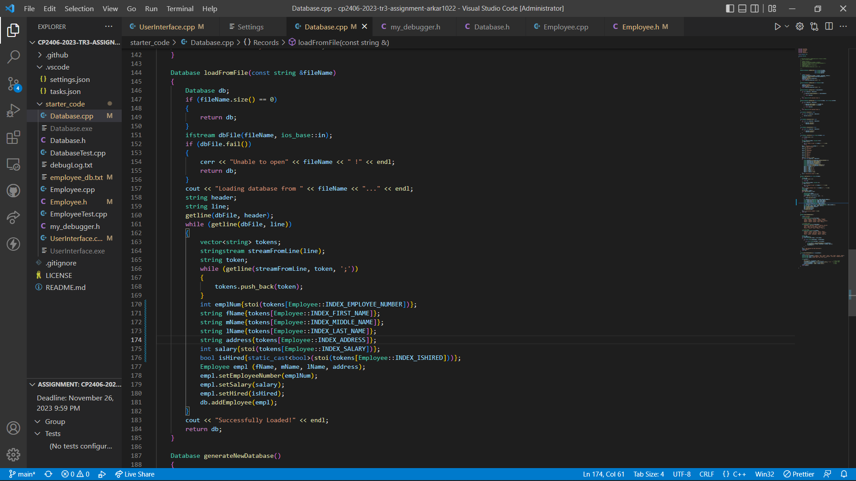

Call the function in “Case: 9”.

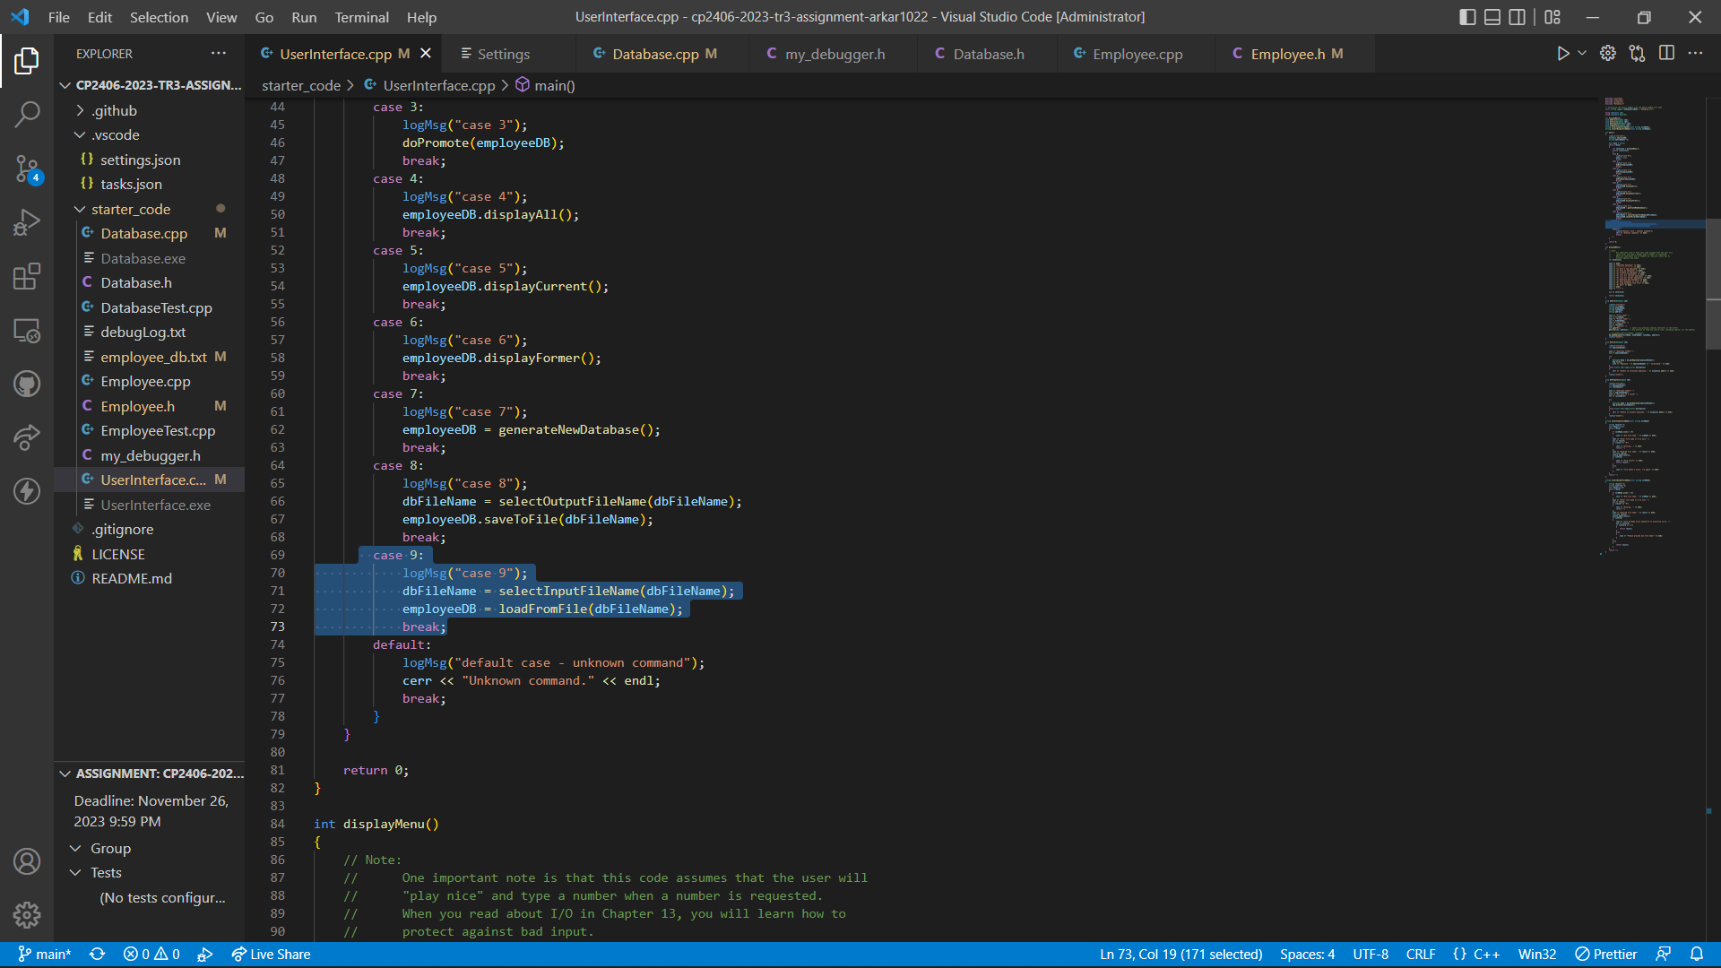

Output Result:

Choose Option 9 and load database from previous saved file. Alert message will be displayed if t}”  
he file does not exist.

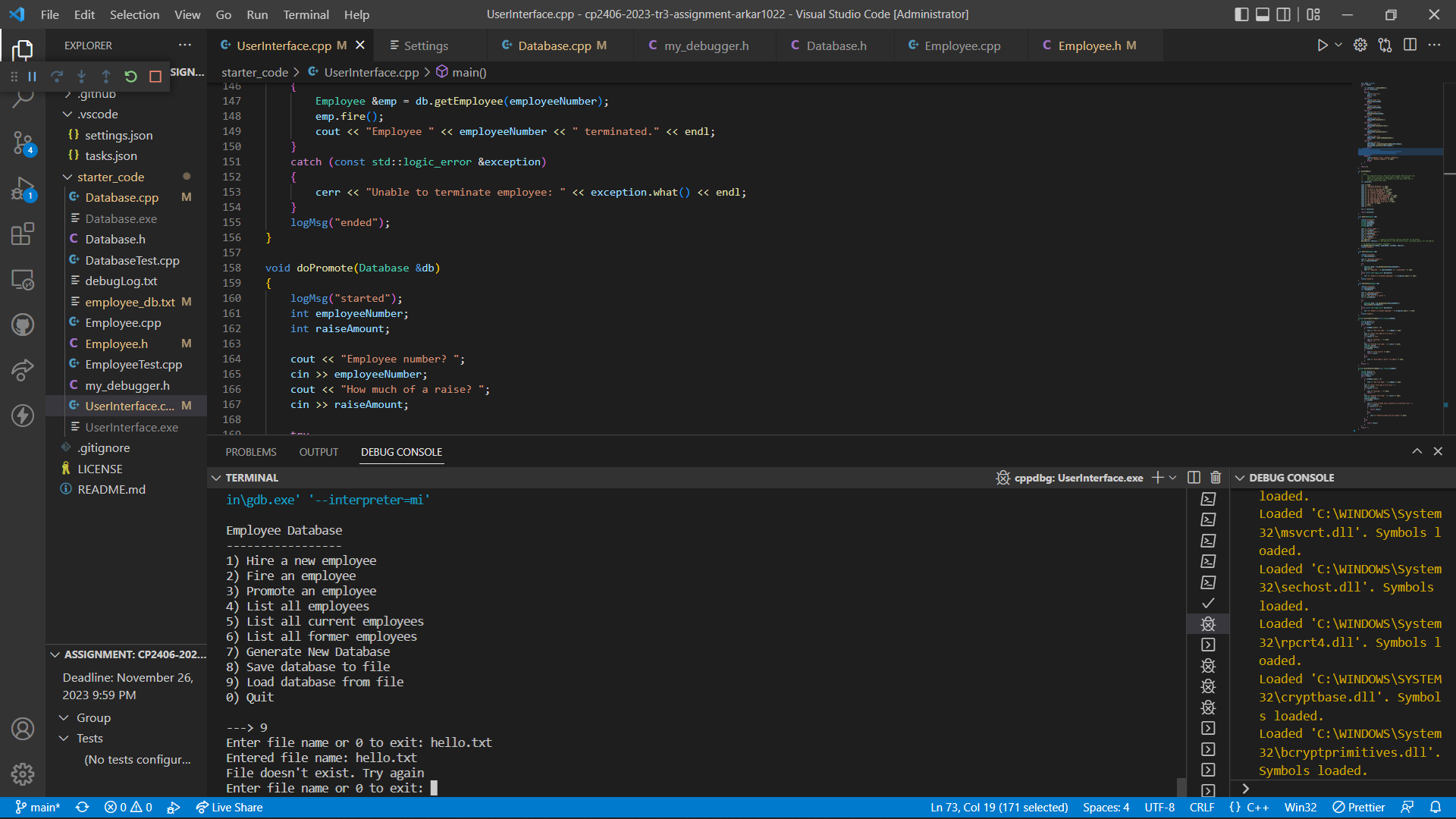

Load database from ‘employee_db.txt’.

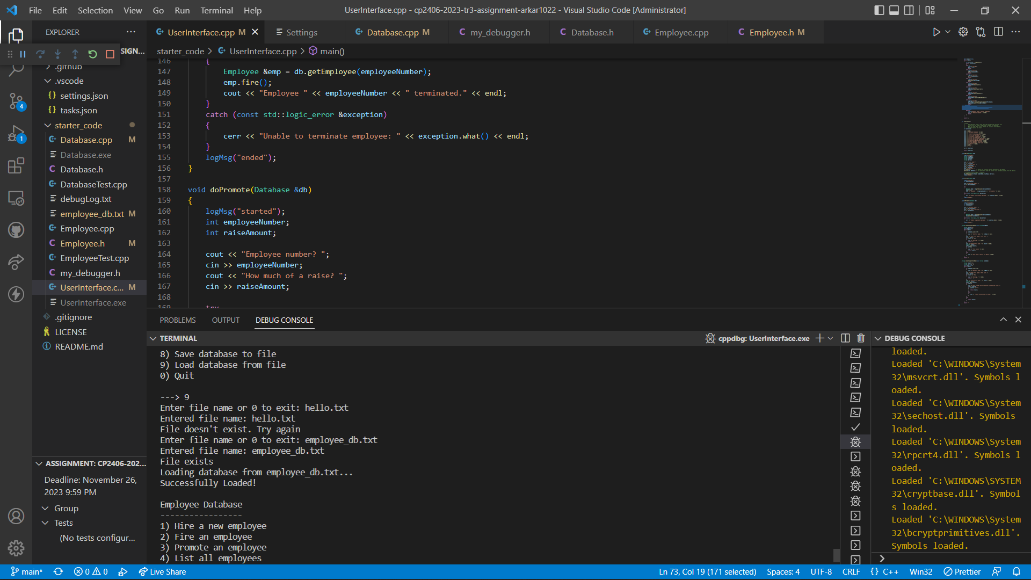

Display all the employees in current database.

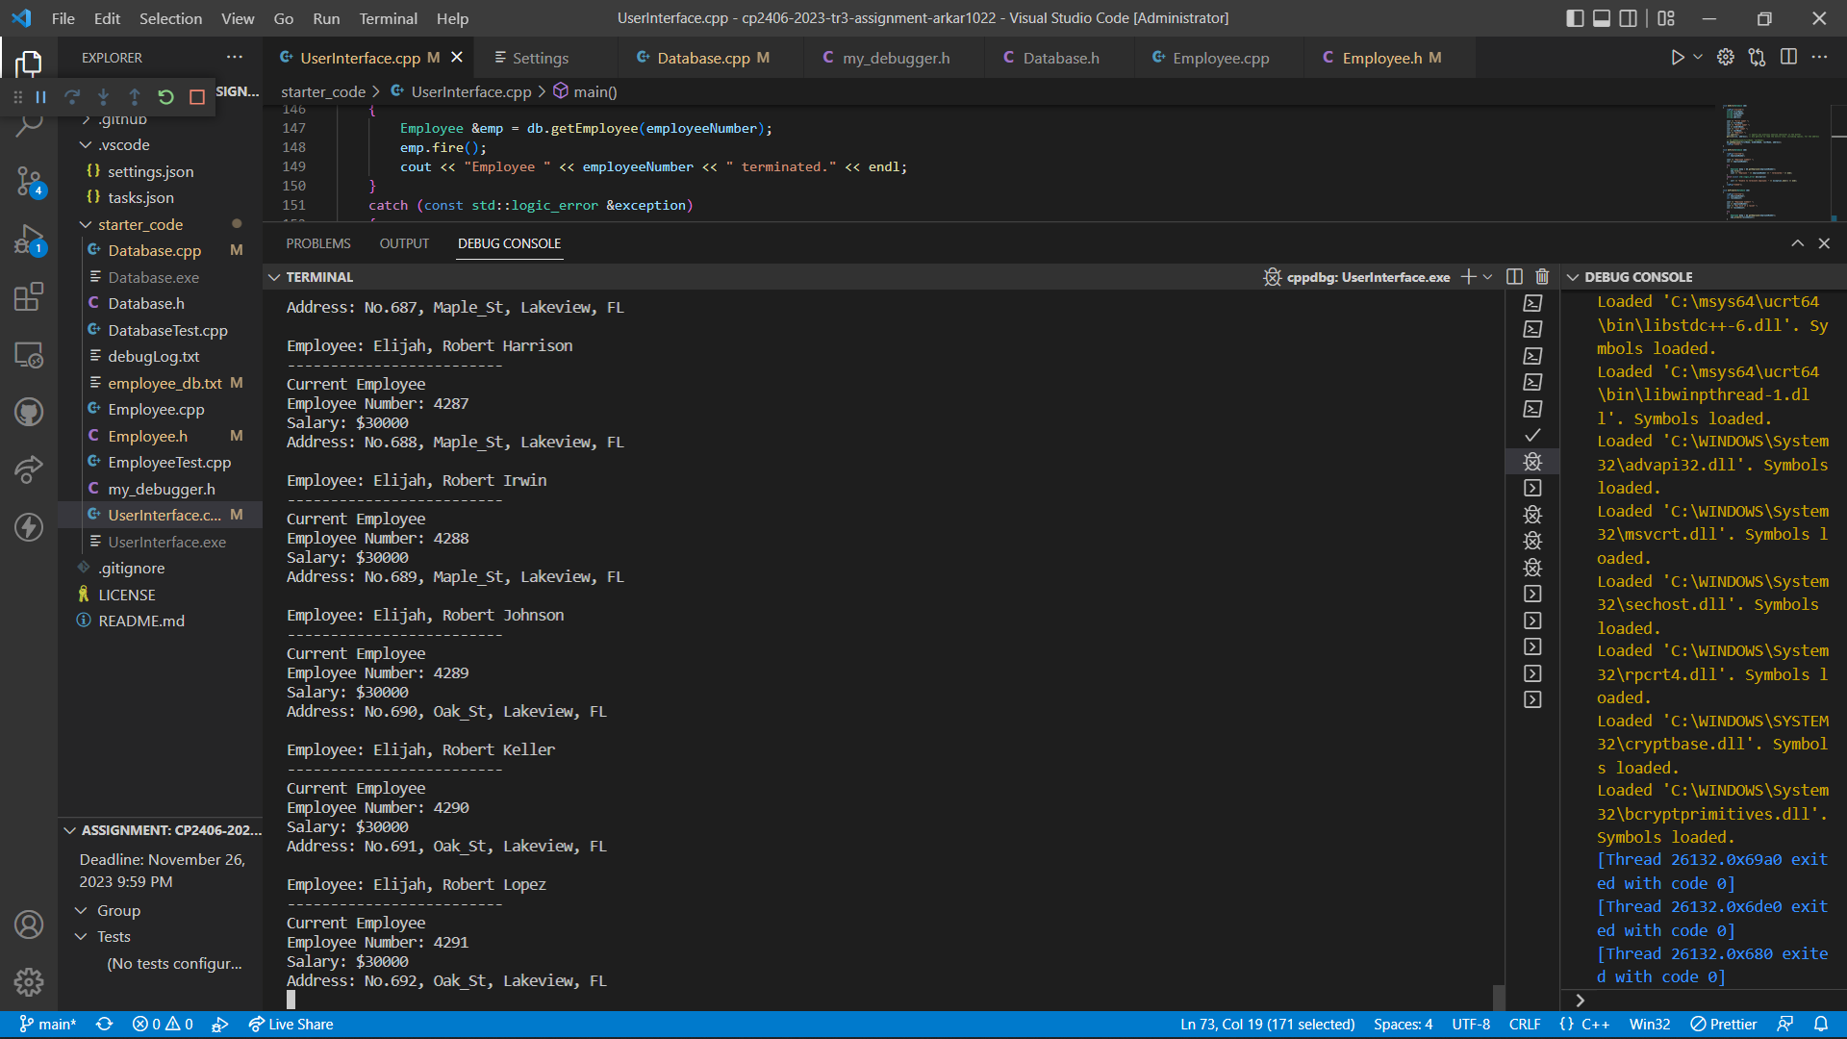

# Task 6 Add Option “10) Edit Employee”

Declare and define “doEdit()” function in “UserInterface.cpp”.

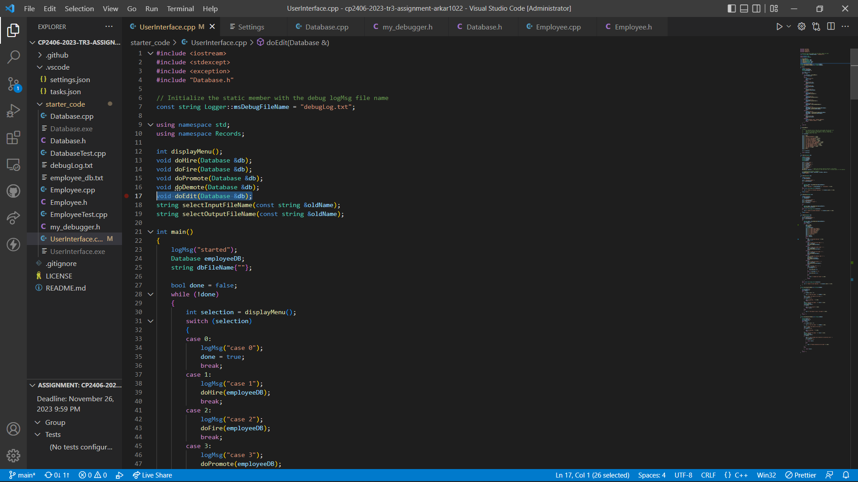

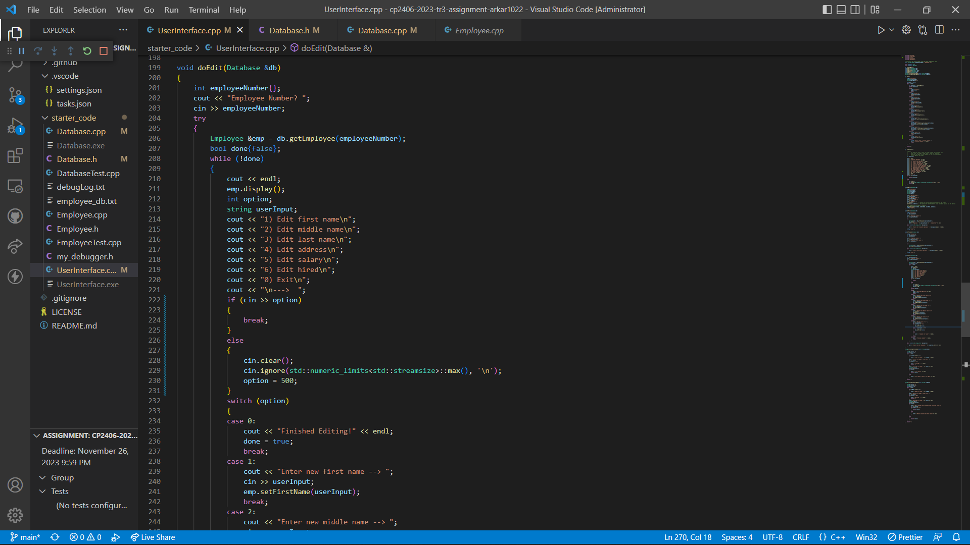

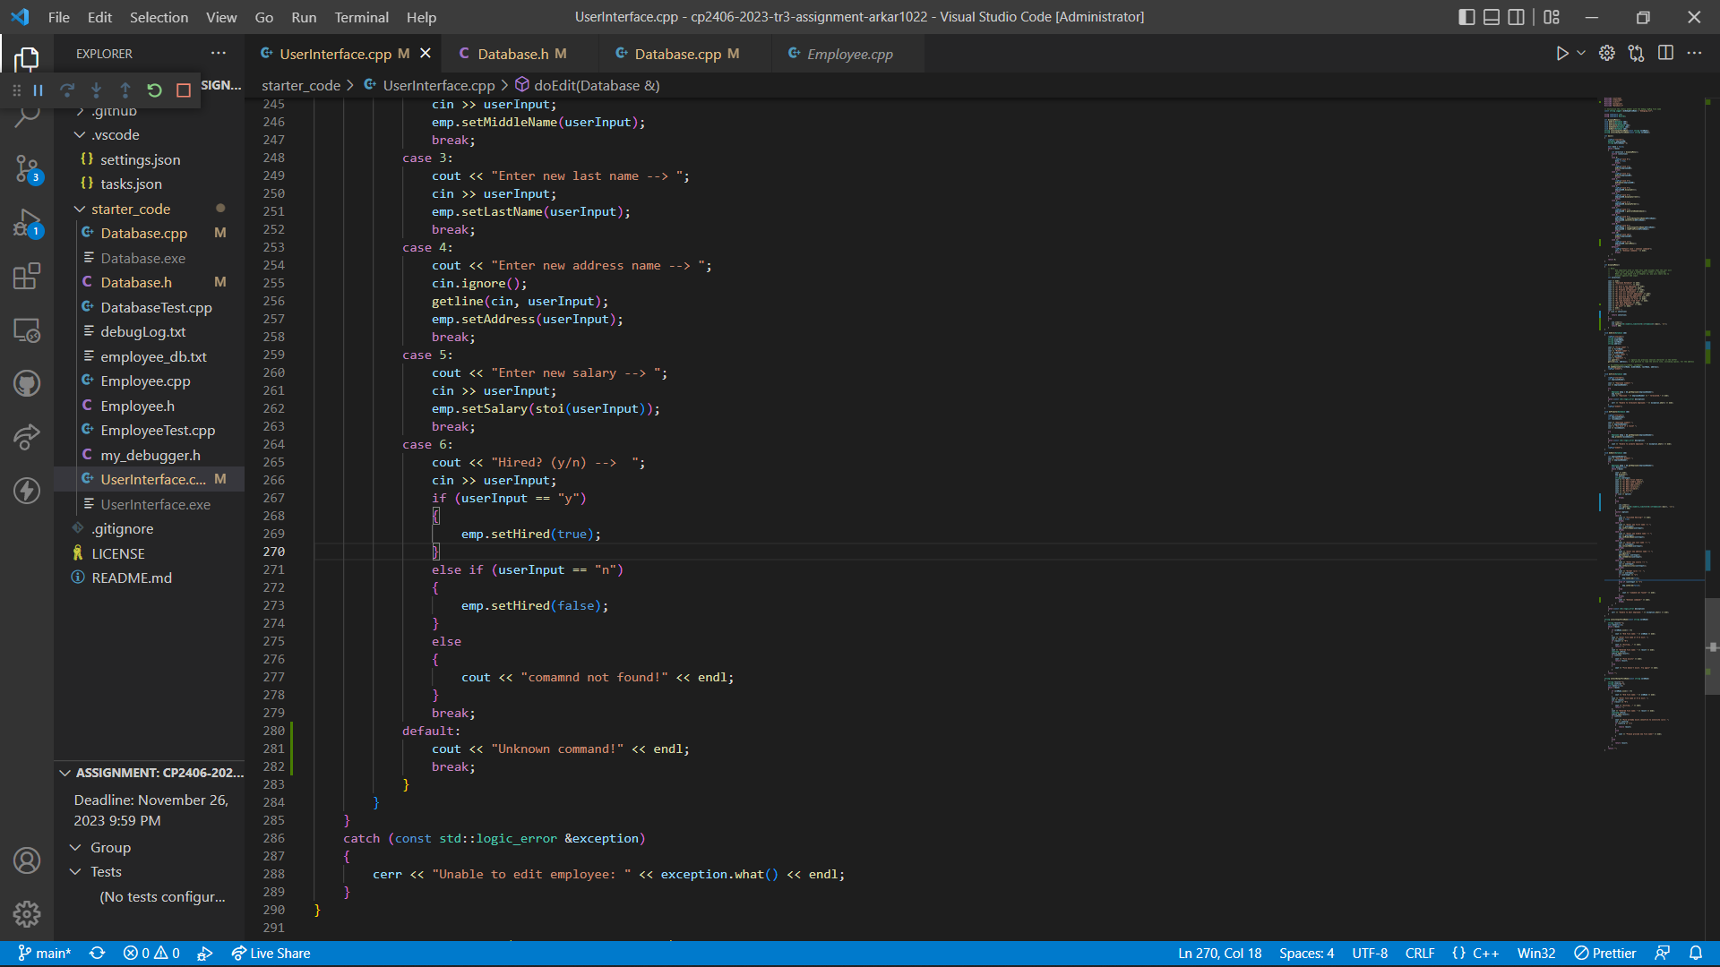

Output Result:

Choose option 10 and edit employee in database using employee number. Invalid employee number will result in alert message.

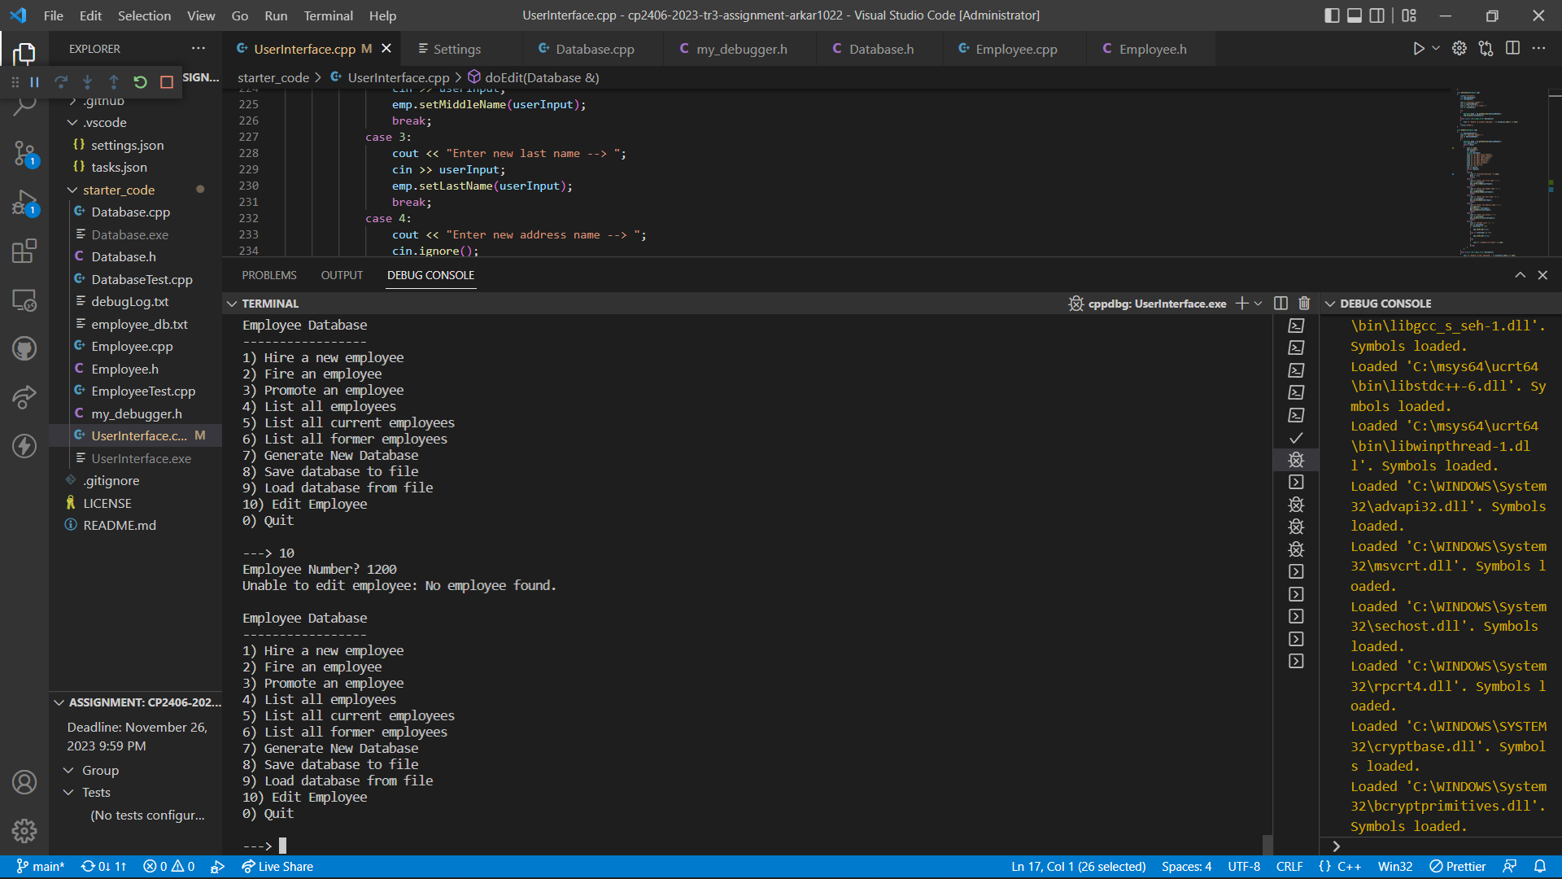

Editing first name:

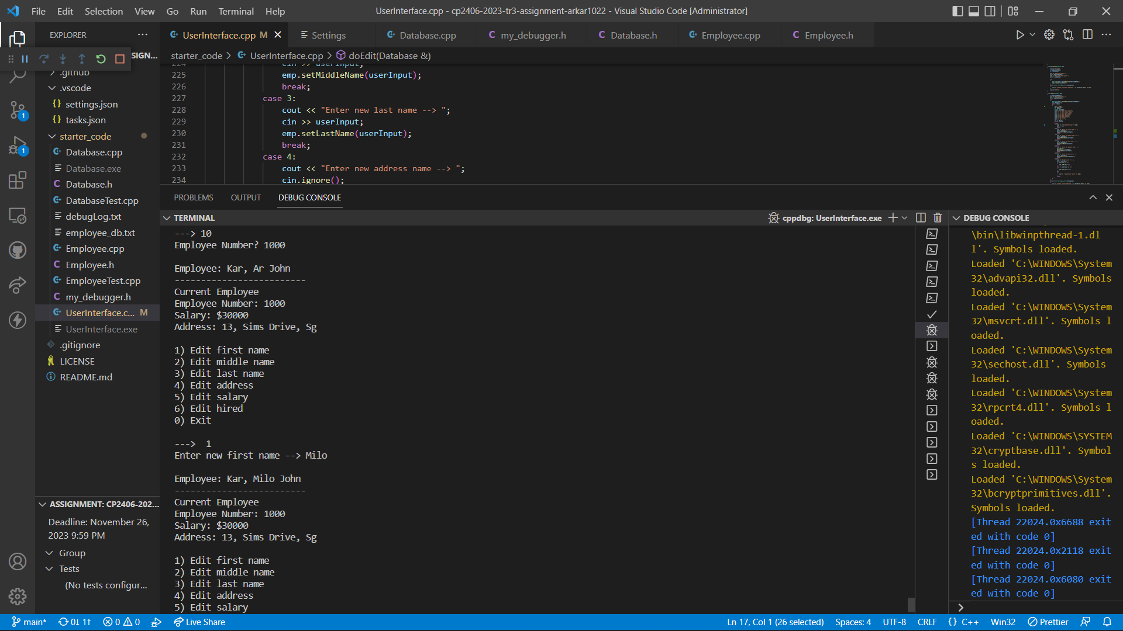

Editing middle name:

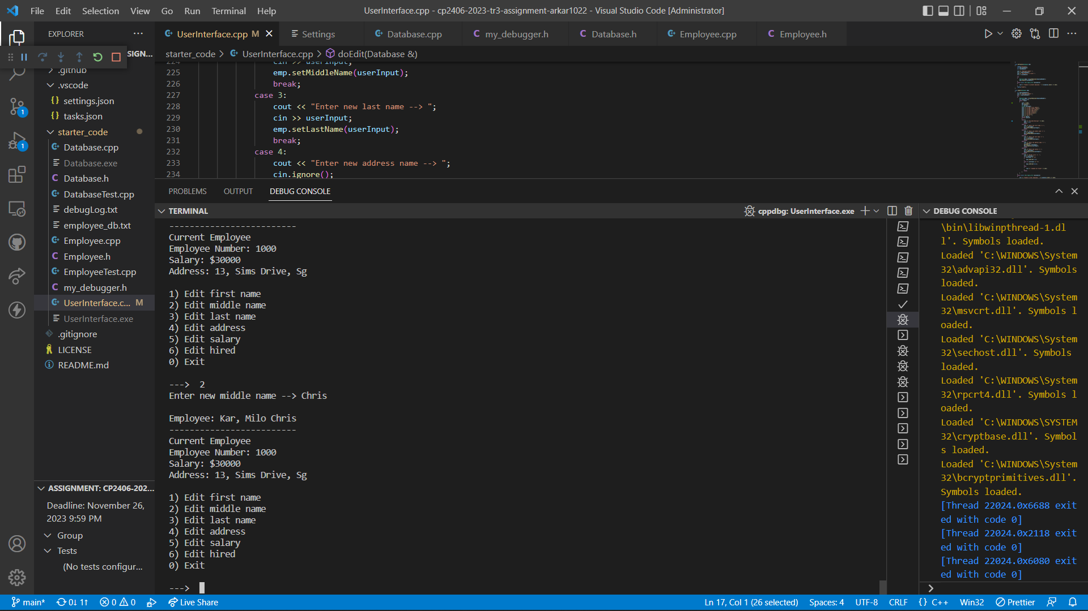

Editing last name:

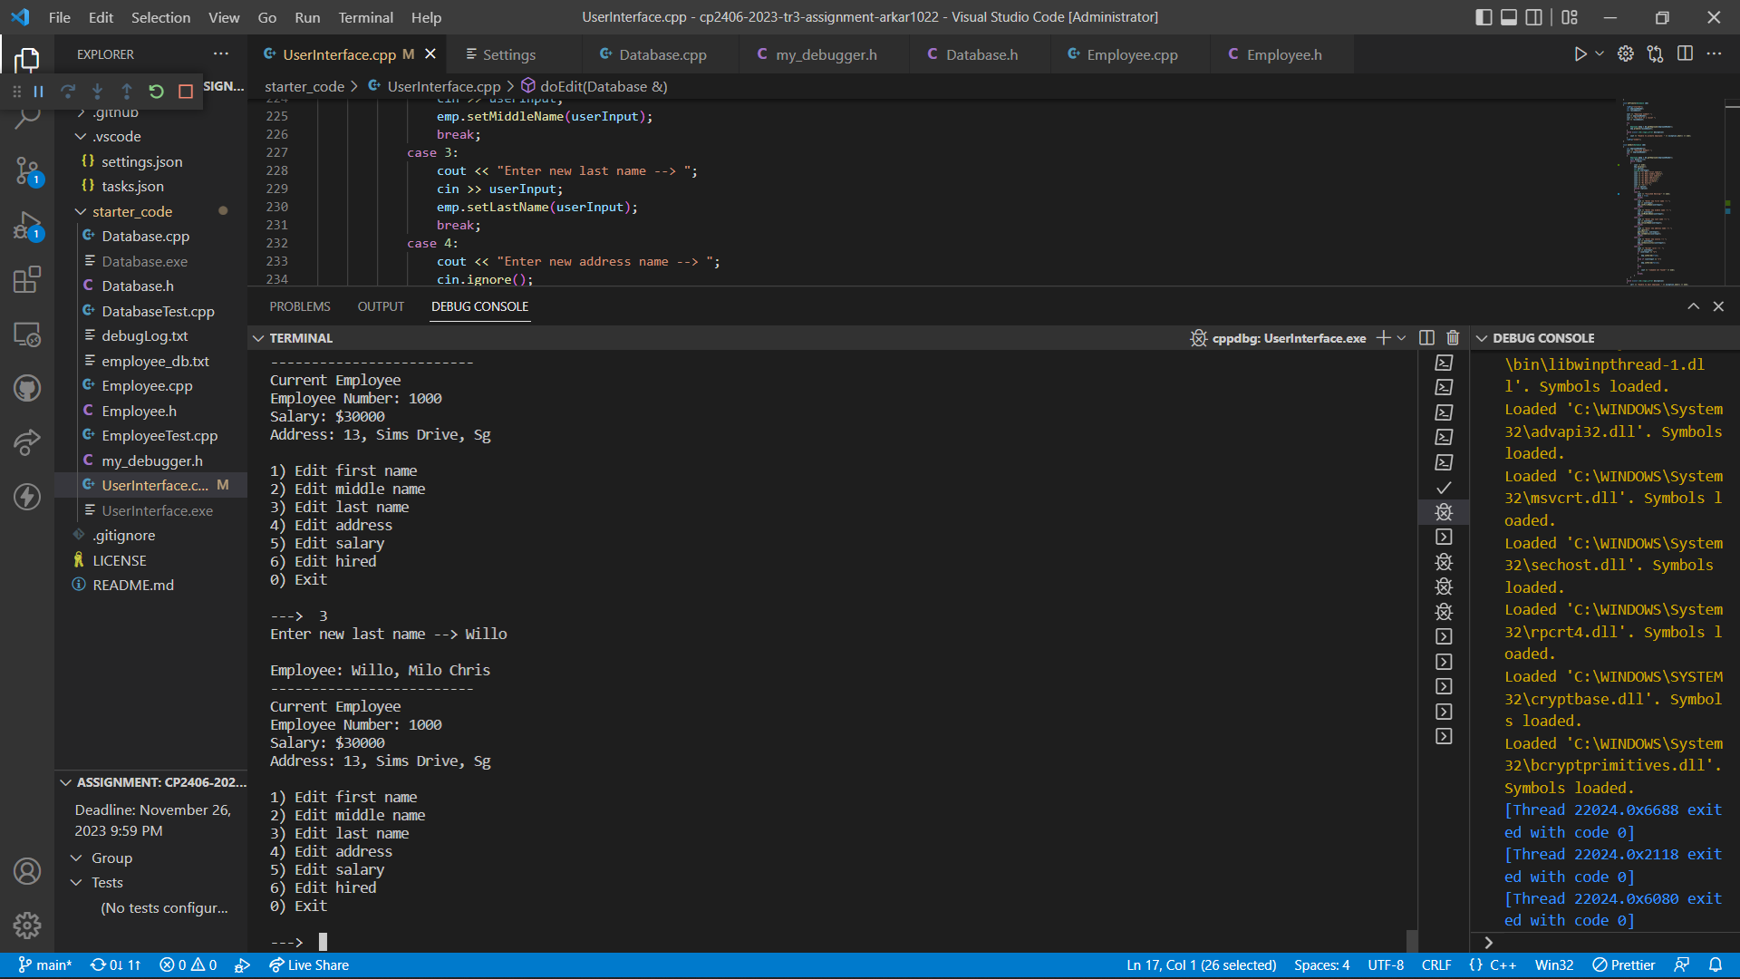

Editing address:

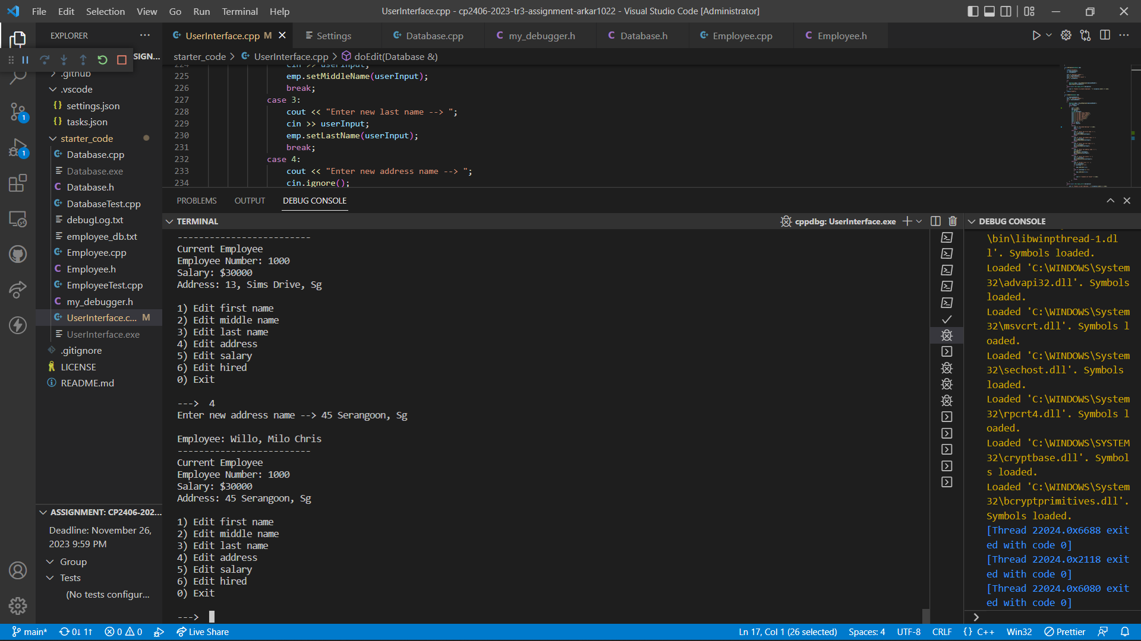

Editing salary:

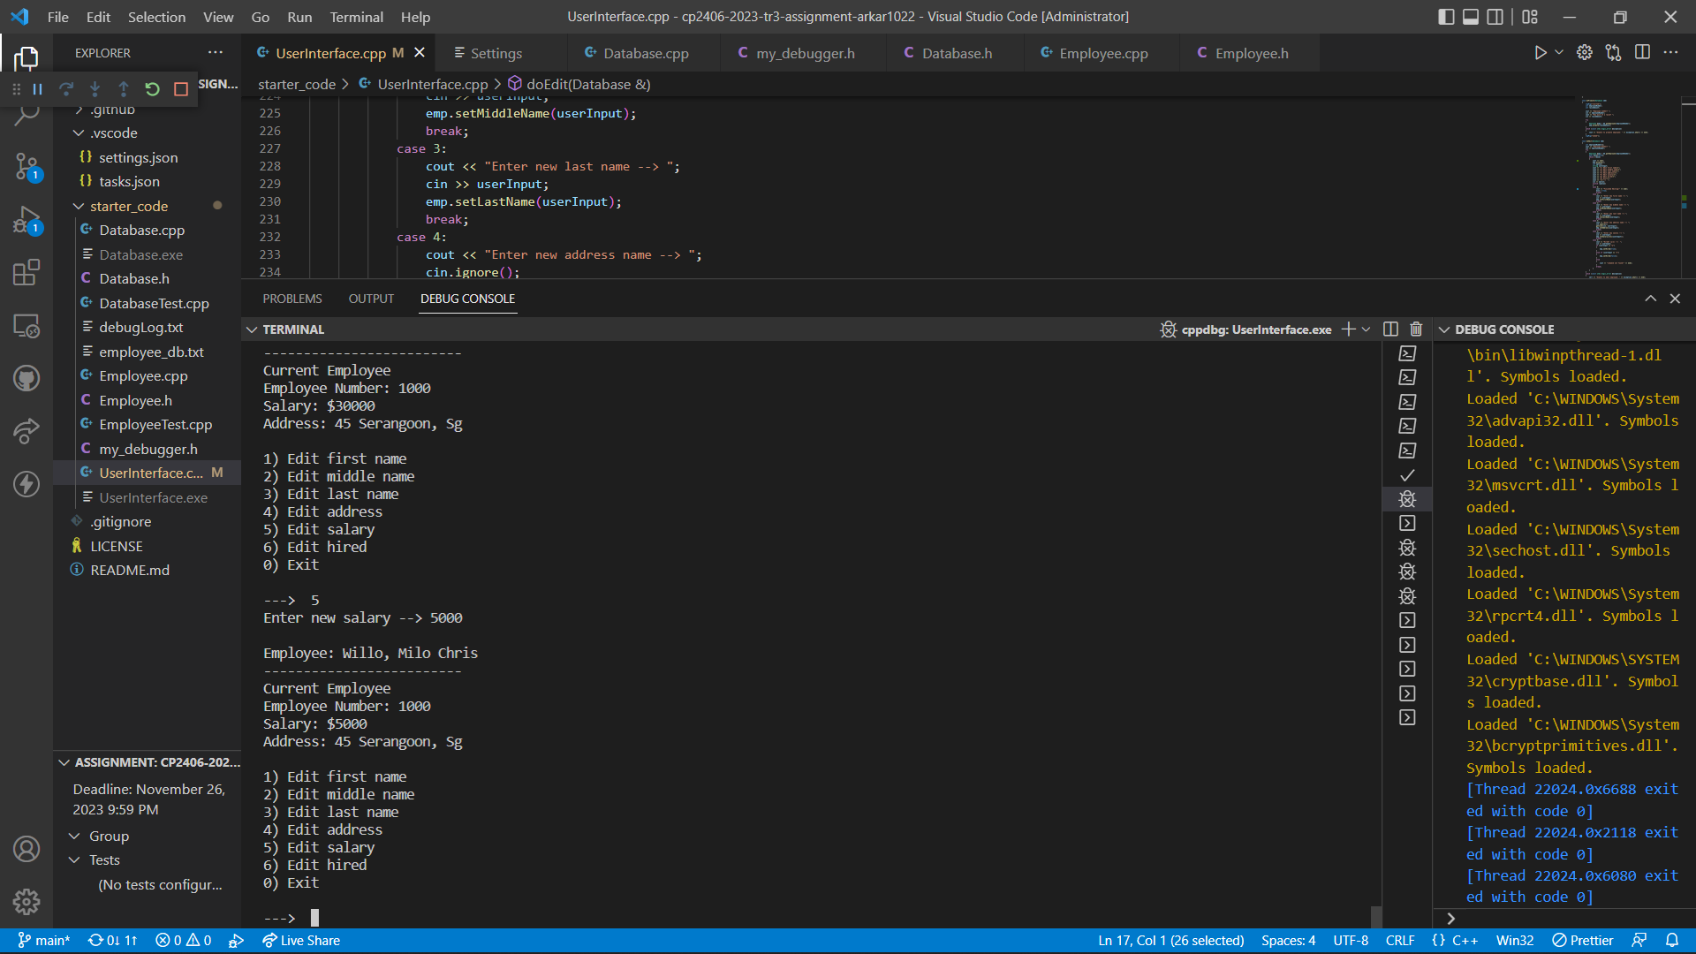

Editing employee status, hire or not:

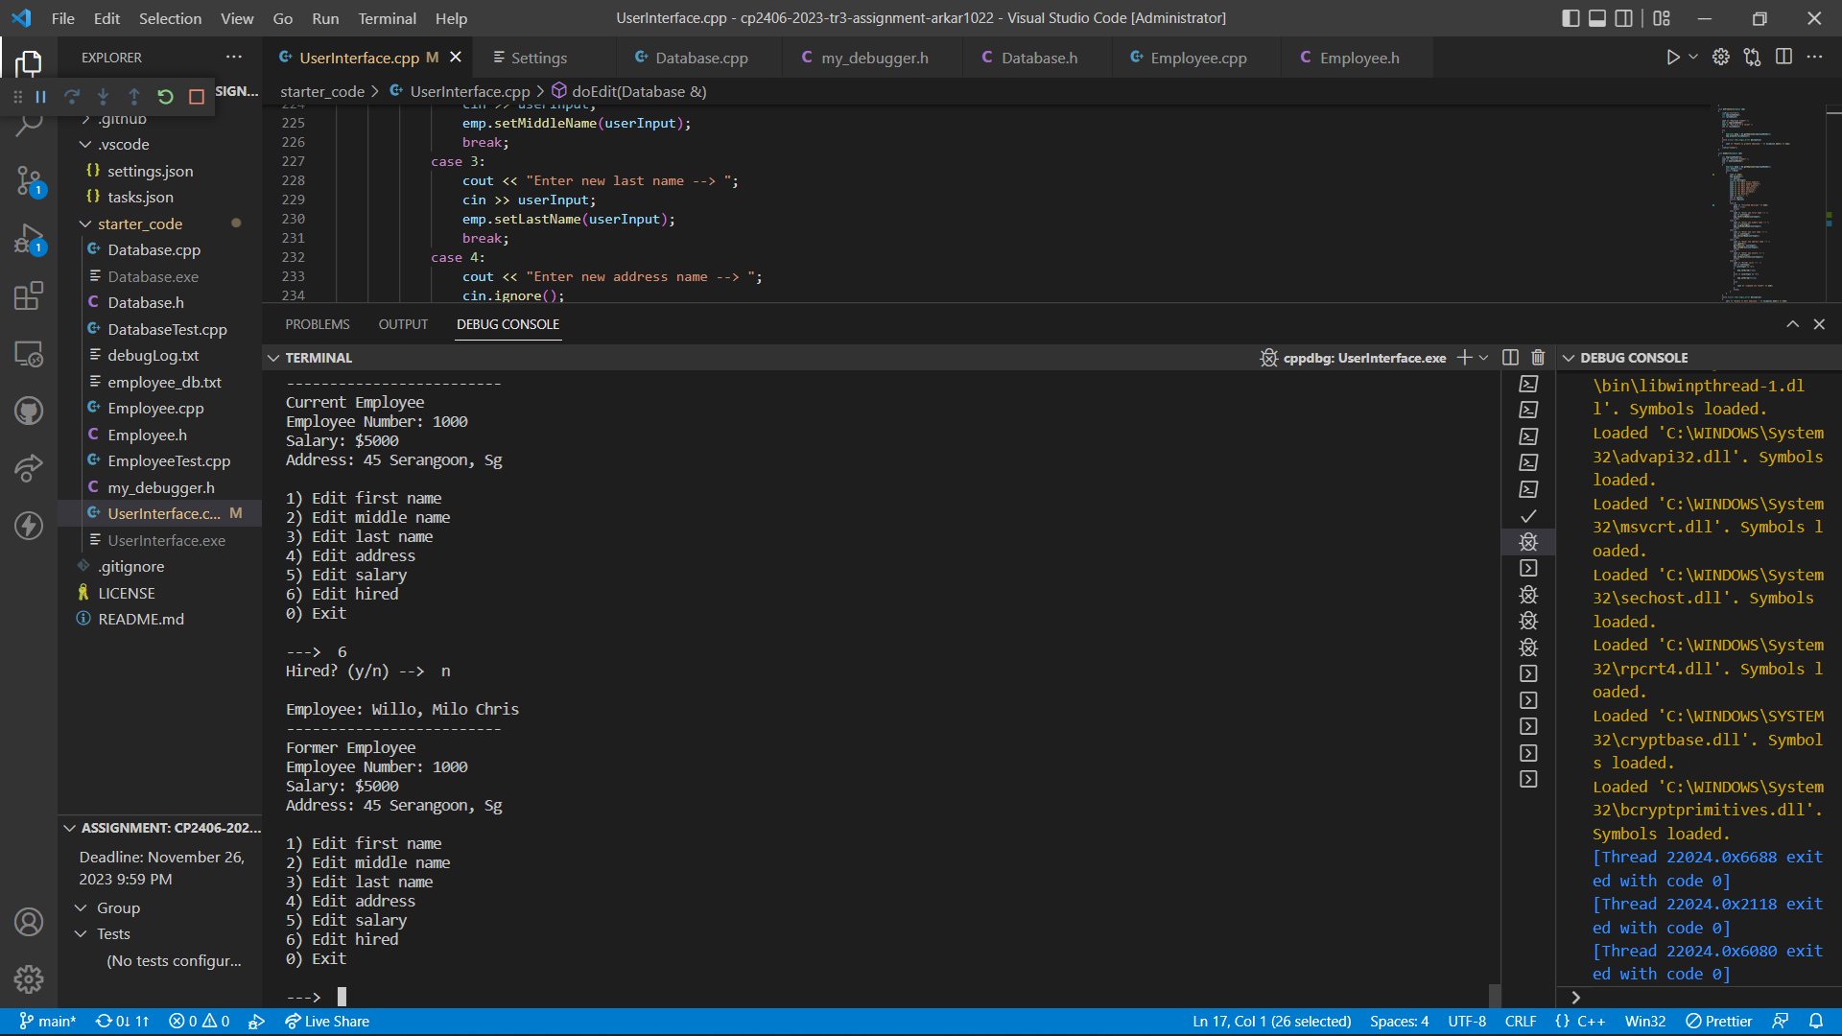

# Task 7 Add Option “11) Search Employee”

Declare “searchMenu()” and “displaySearchMenu()” functions in “Database.h”. Moreover, we also imply “size()” function which will be used to detect whether is there any employee data or not when performing search function. “SearchOption” enumerates class and “searchBy” functions are also declared to define which search type, we are going to perform i.e. by first name, middle name, last name or address. In addition, “stringToLower()” function which will convert string to lowercase is also declared.

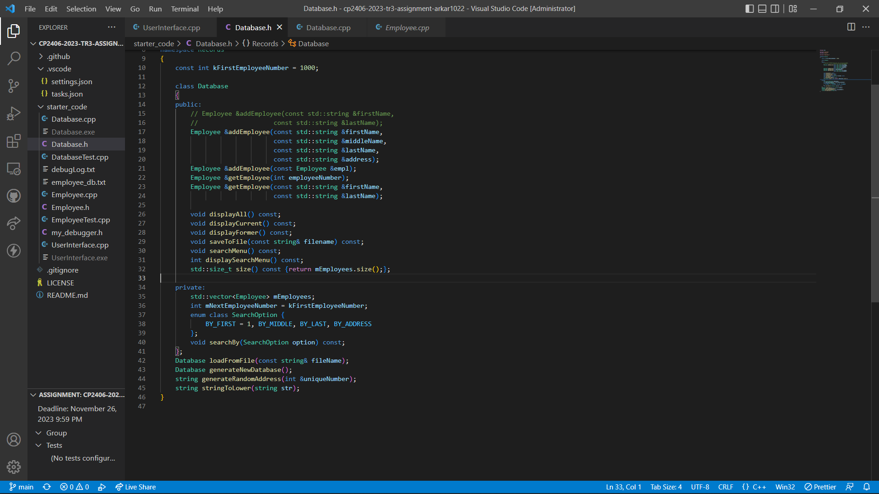

Define “displaySearchMenu()” function and “searchMenu()” function in “Database.cpp”.

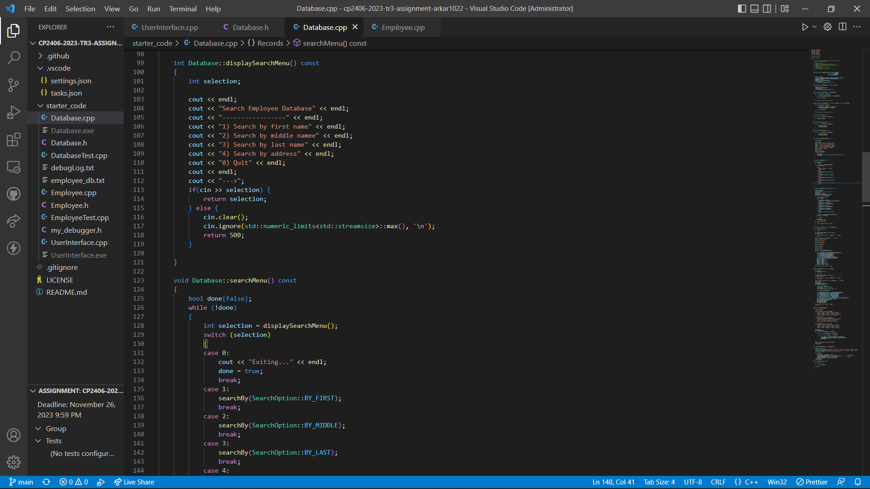

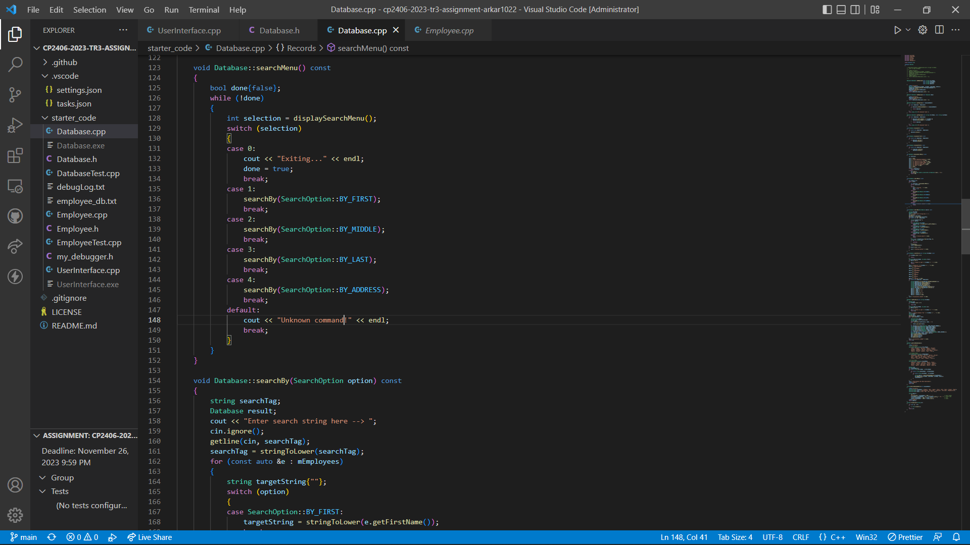

Define “SearchBy()” function to perform searching. In this function, we change all the input string and original string data from employee database to lowercase. So, that searching will not be case sensitive. For example, whether user search first name “John” by “jo” or “JO”, all employees with first name “John” will be displayed.

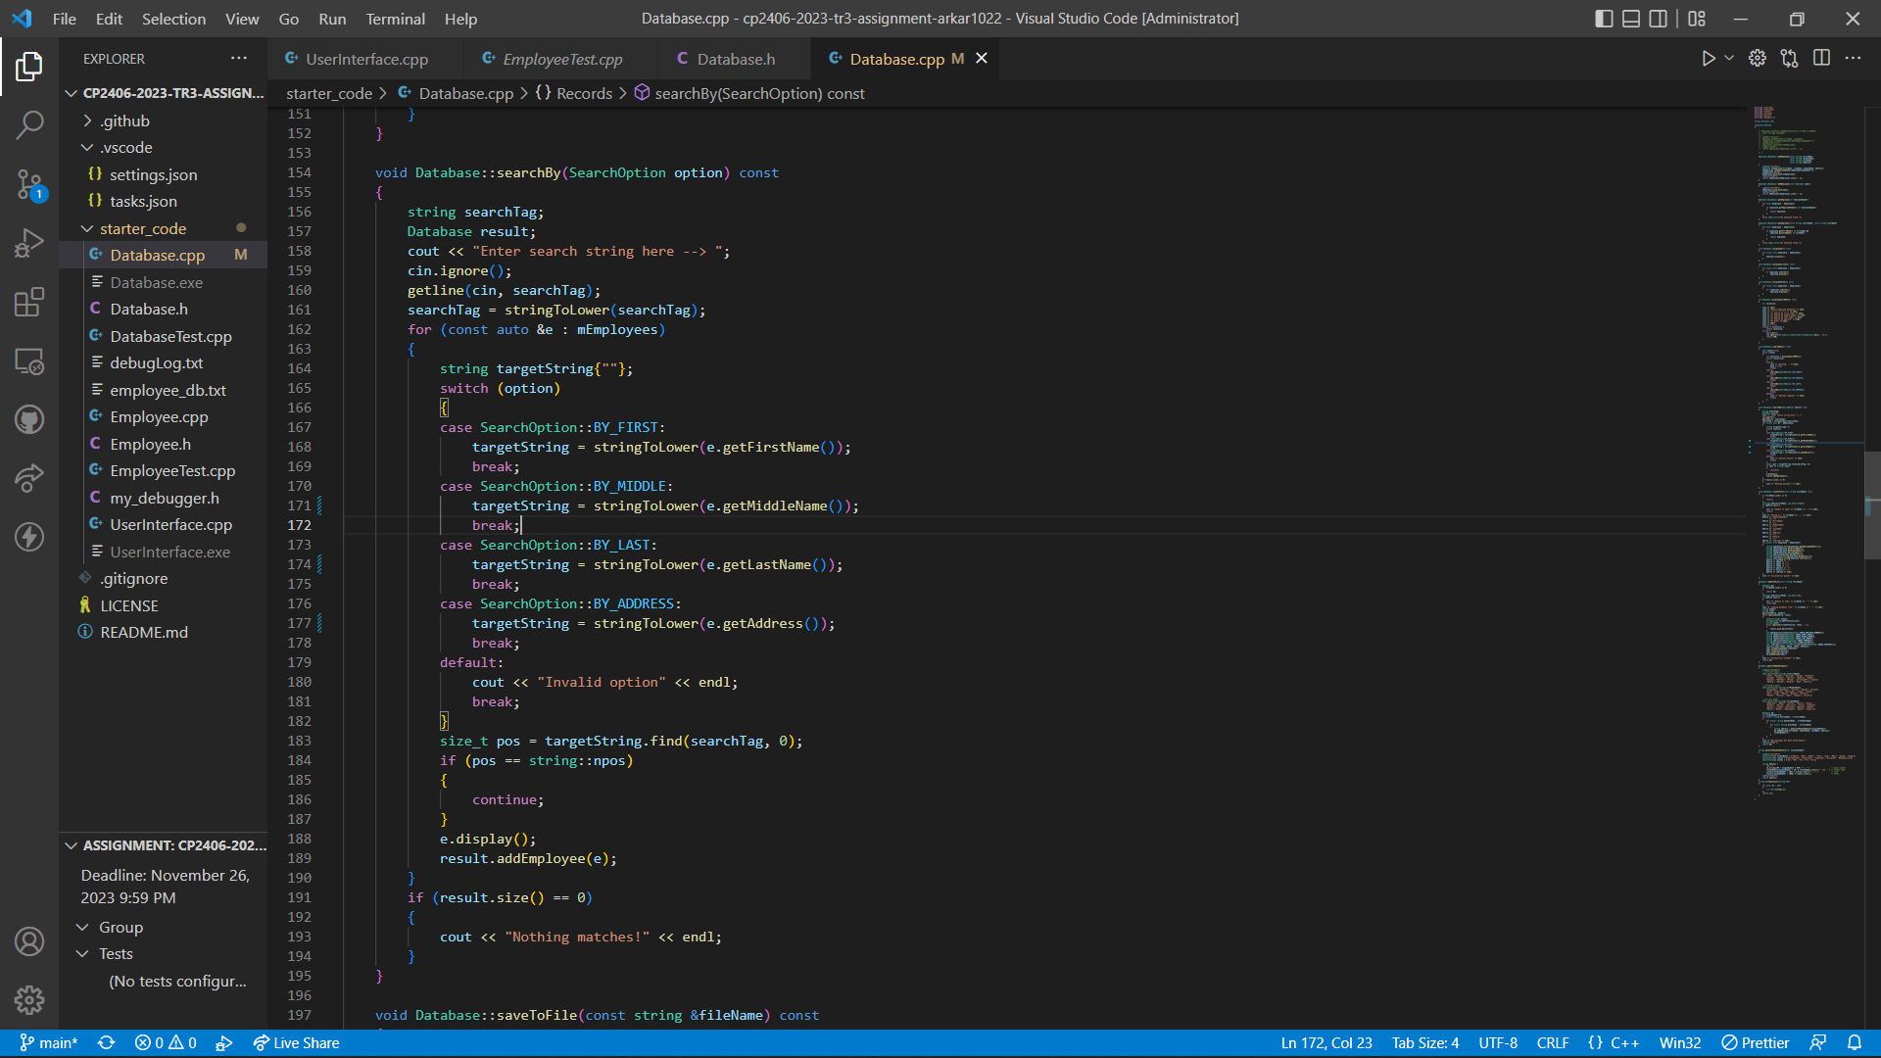

Define “stringToLower()” which will perform converting to string to lowercase.

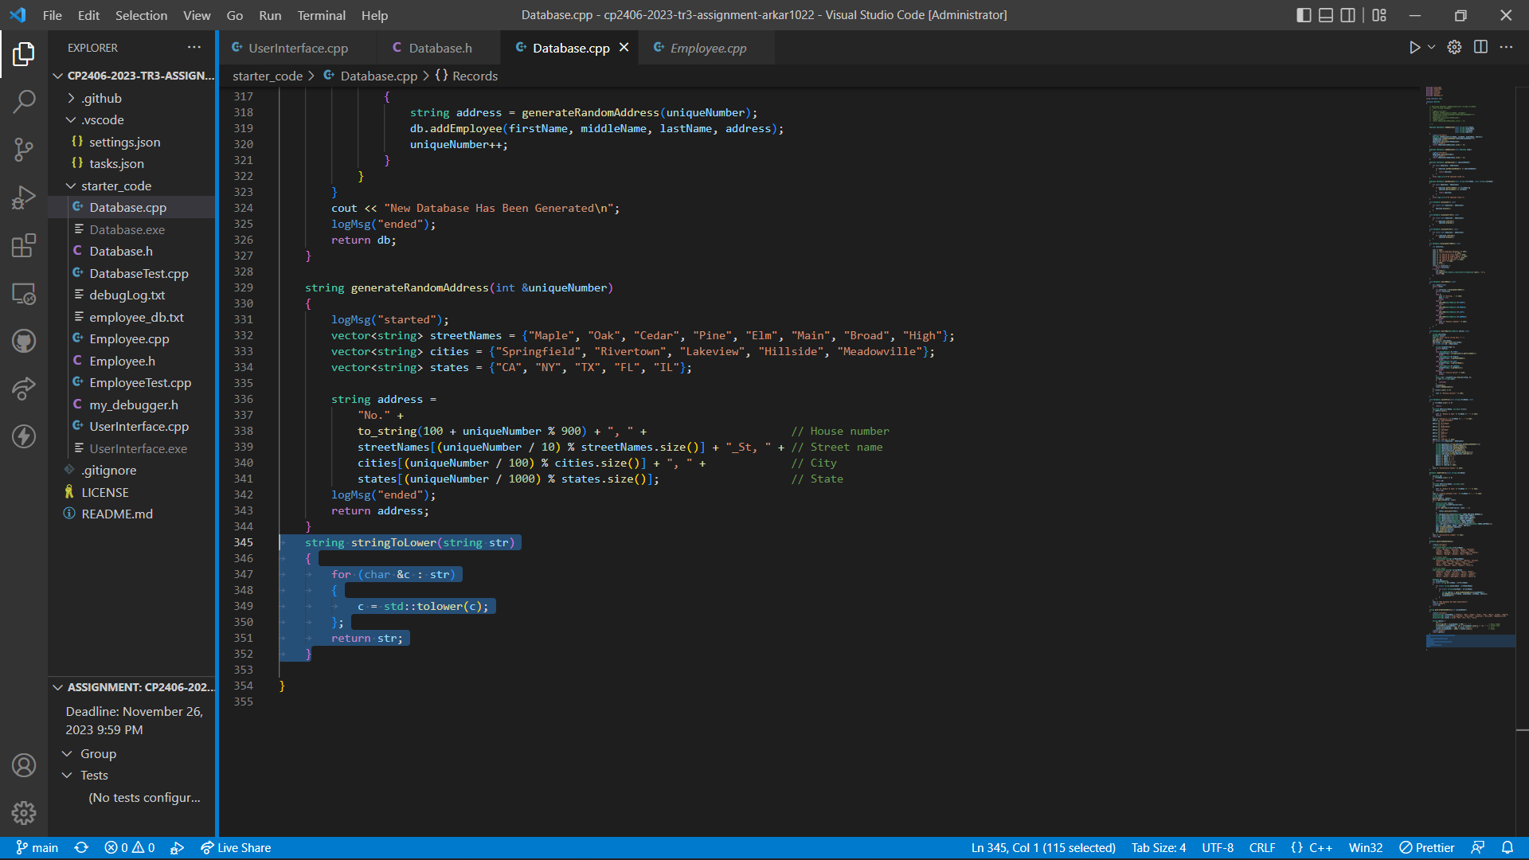

Output Result:  
Search by first name:

Input -> “jo”

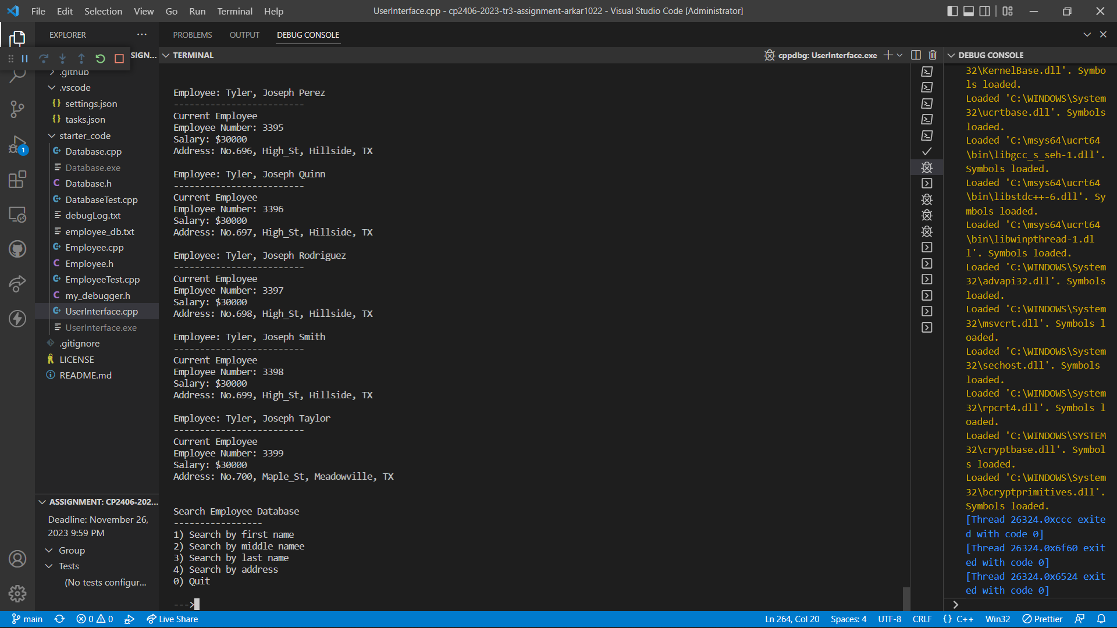

Search by middle name:

Input -> “PER”

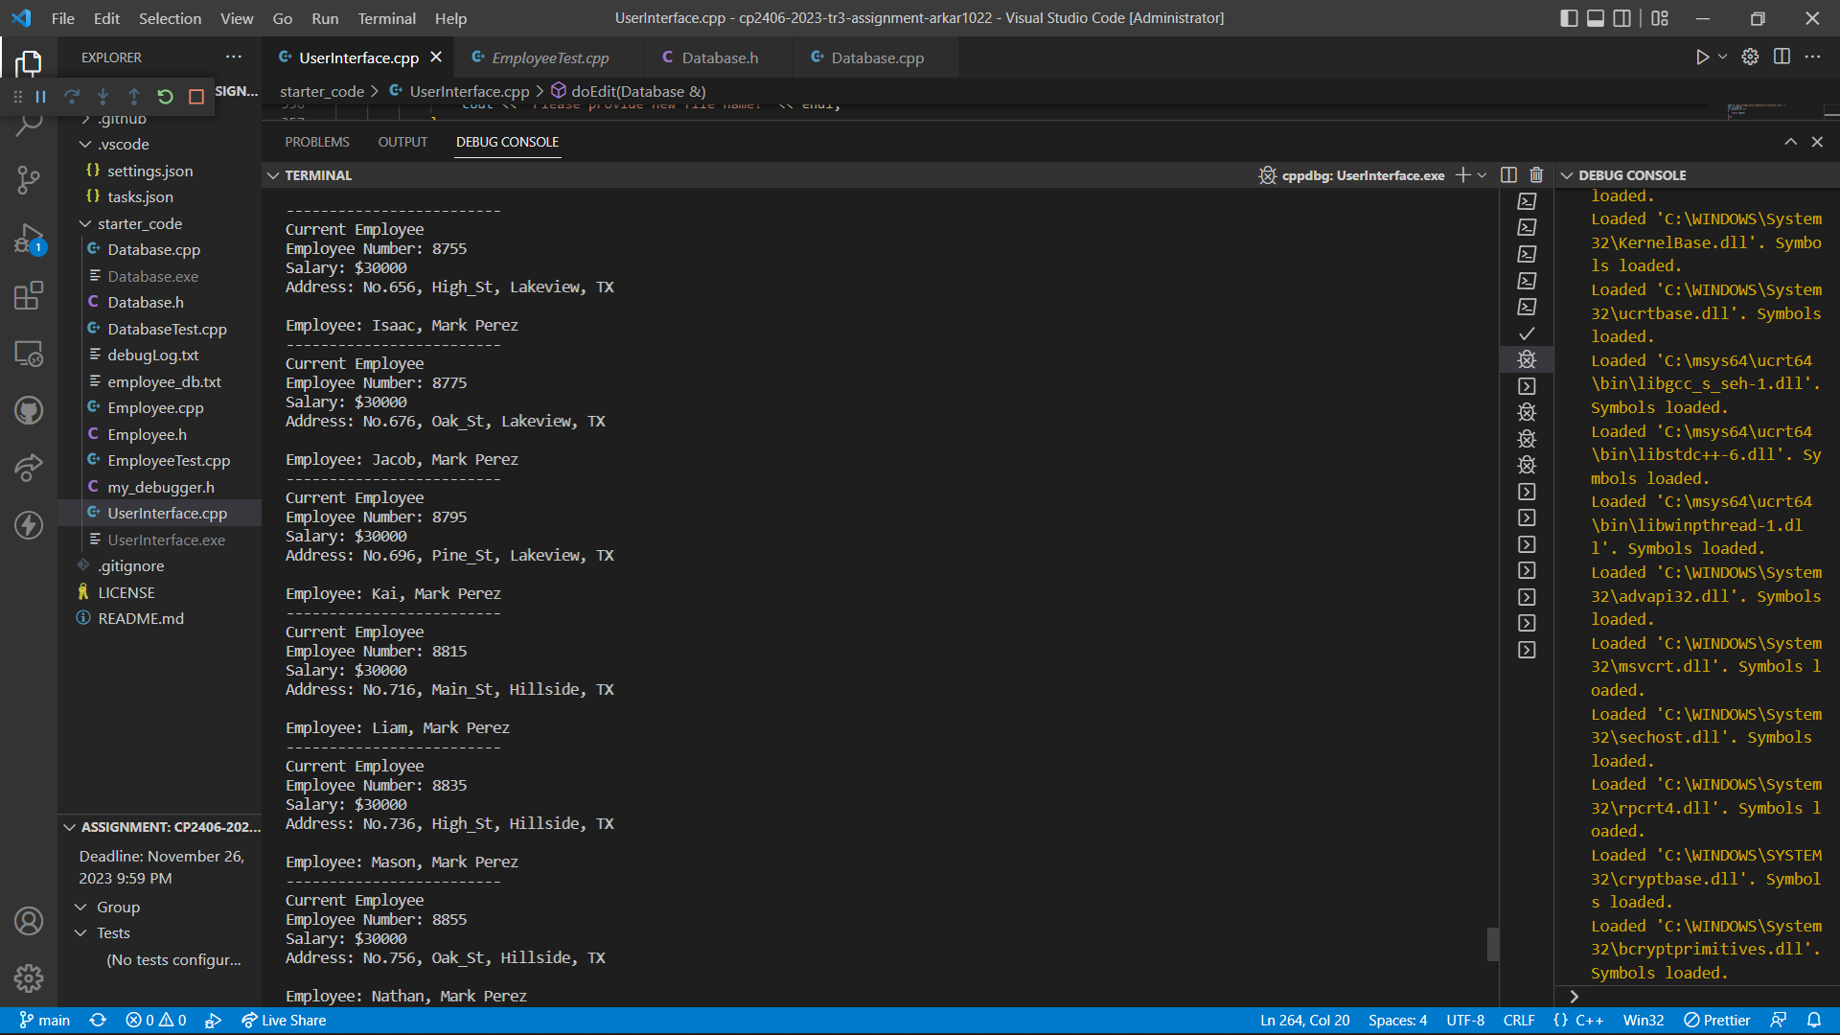

Search by last name:

Input -> “LiA”

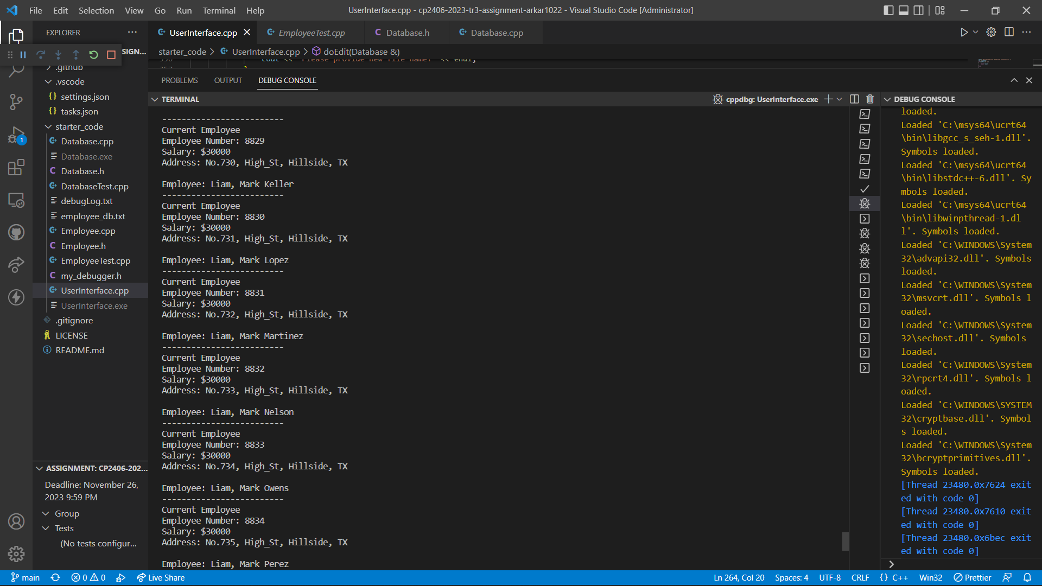

Search by address:

Input -> “No.731”

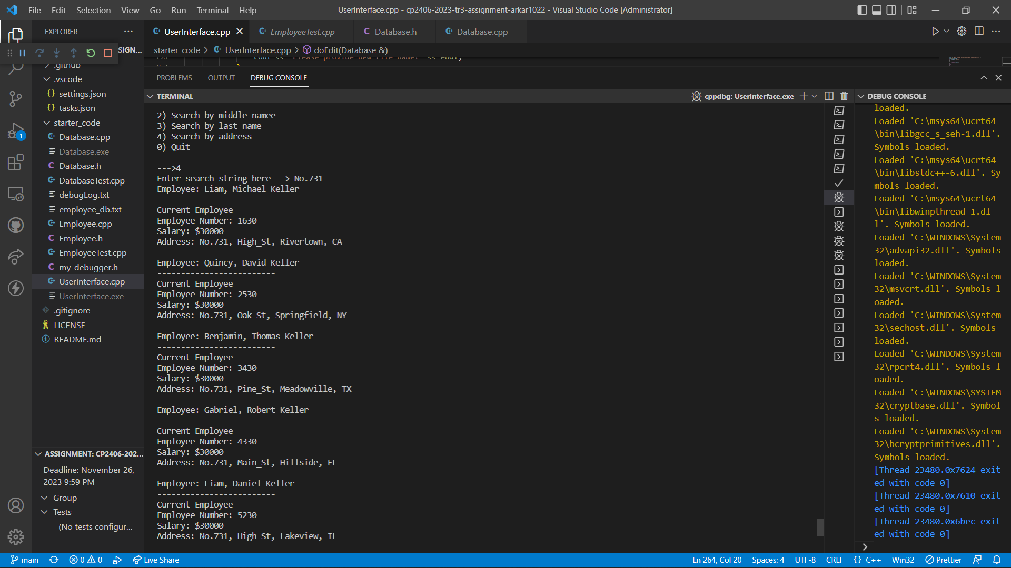

# Task 8 HD-level

Implement conditional switch in “main()” function to allow user to choose login as ‘Manager’ or ‘Employee’

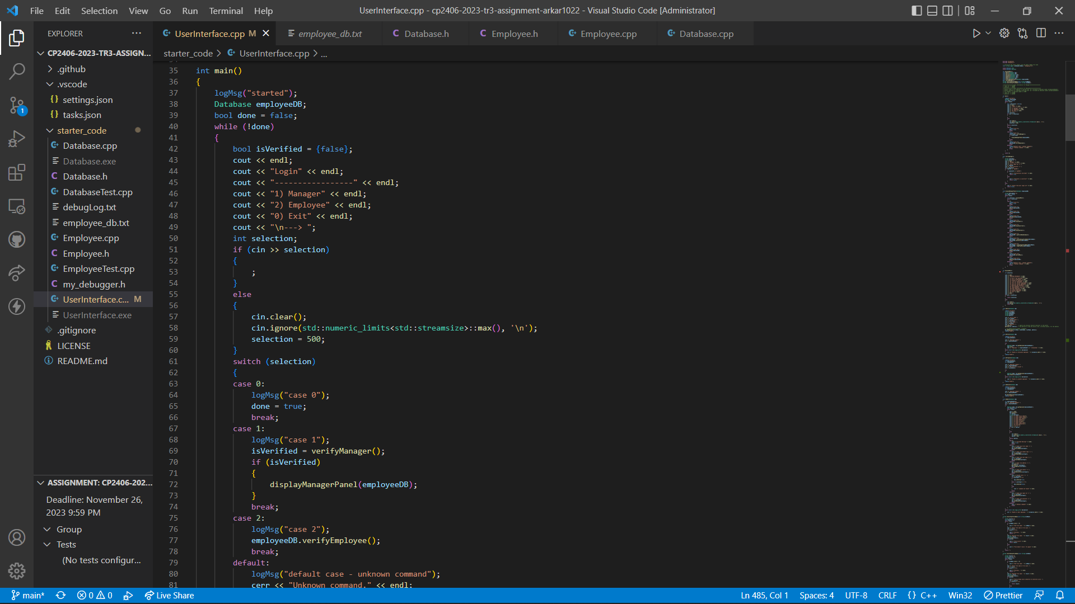

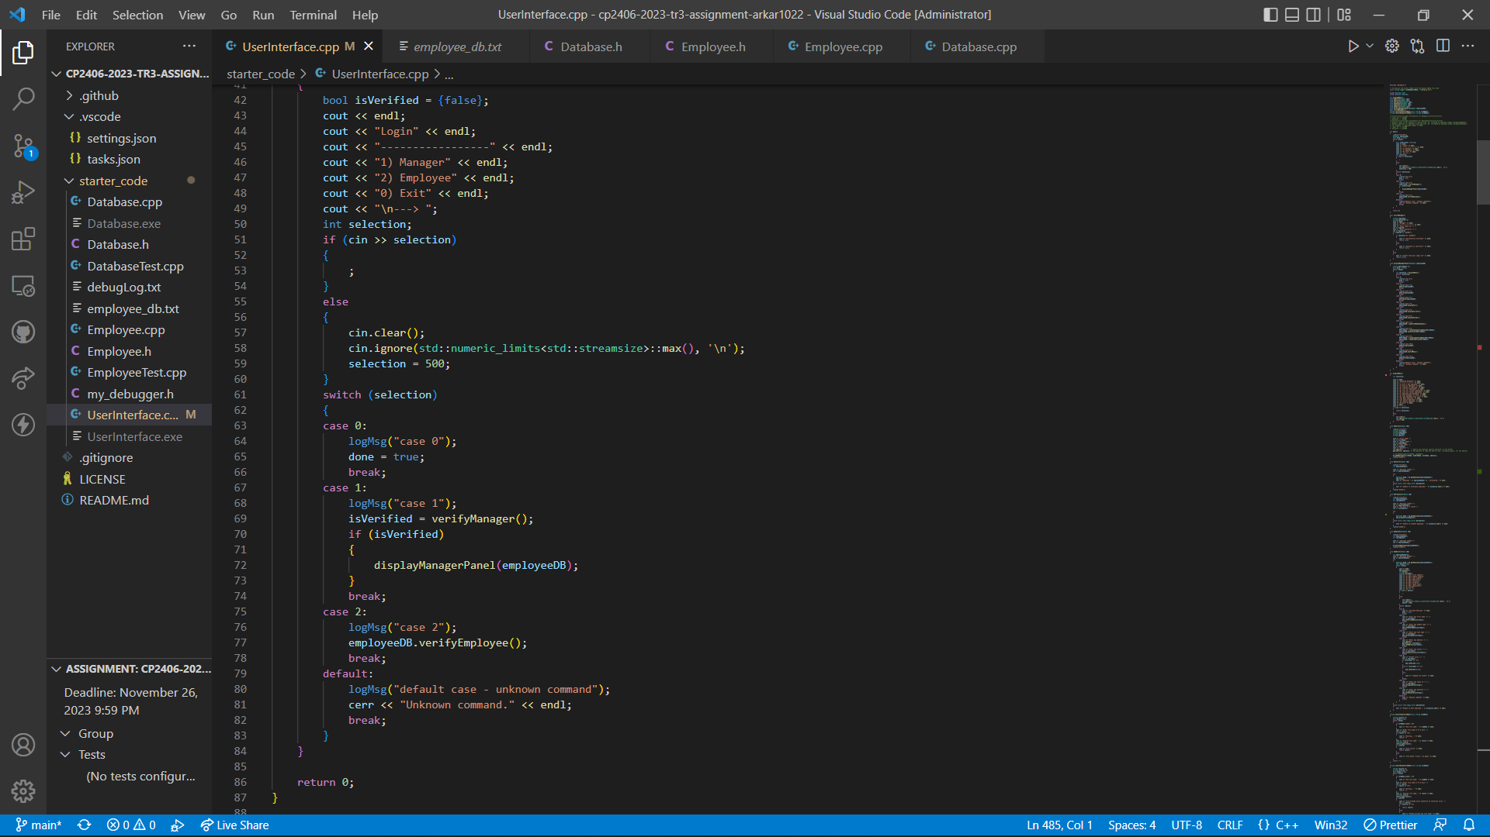

Declare and define “verifyManager” to perform the verification by processing on login id and password inputted by user. If the verification success, “displayManagerPanel()”function which will allow manager-level user to perform all user-interface options.

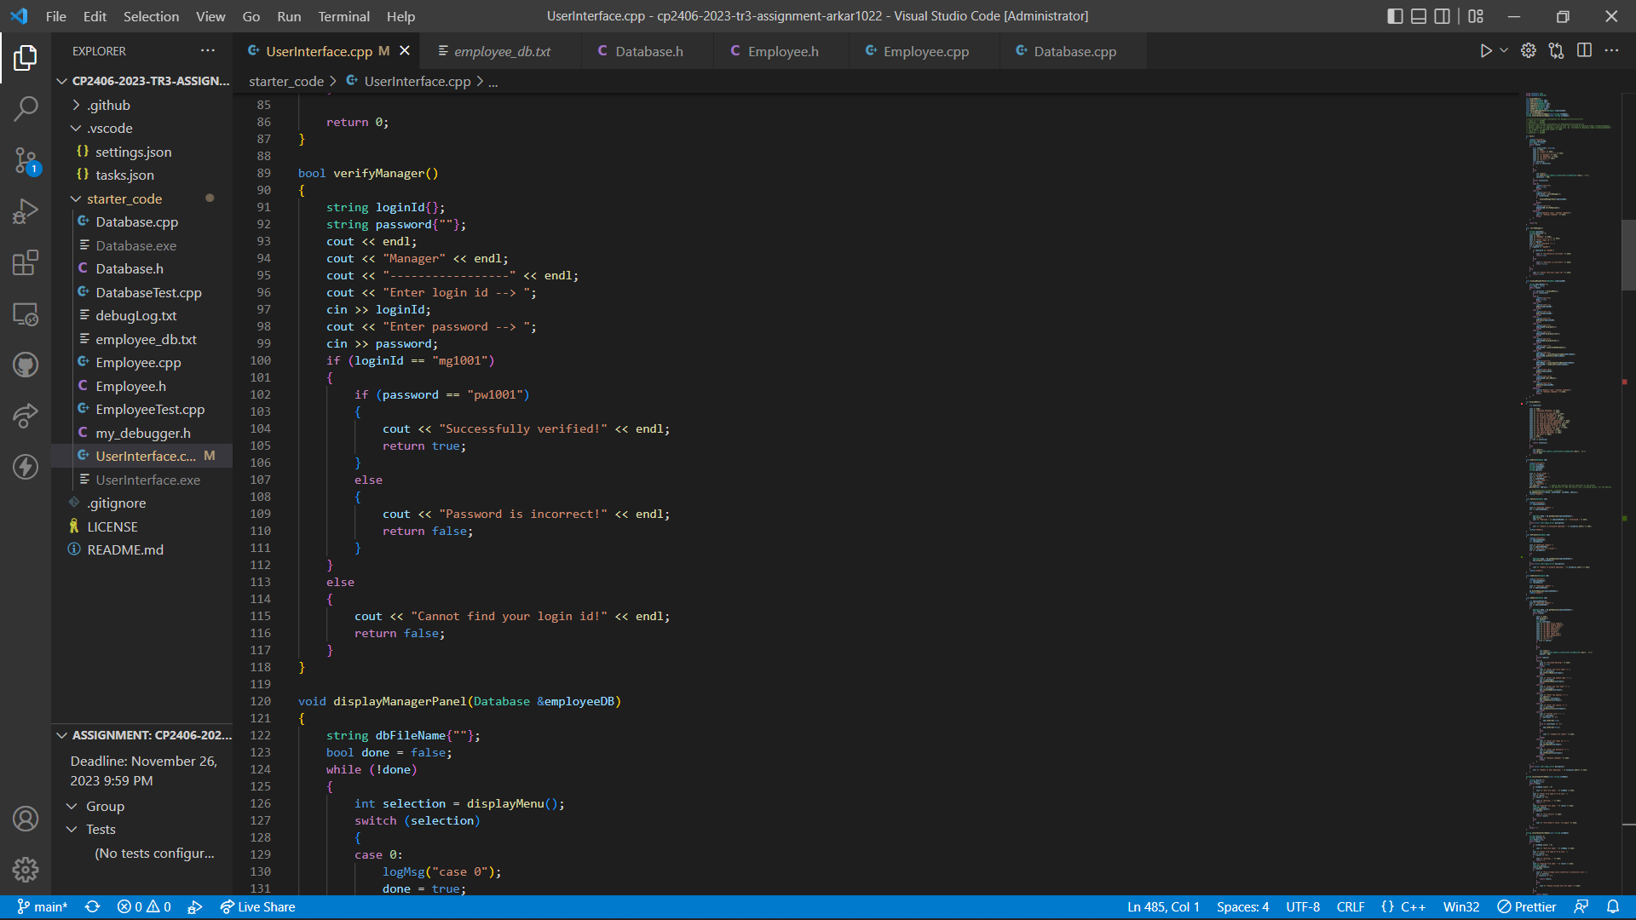

Declare and define new variables: “mLoginId” and “mPassword” as well as getters and setters in “Employee.h” and “Employee.cpp”.

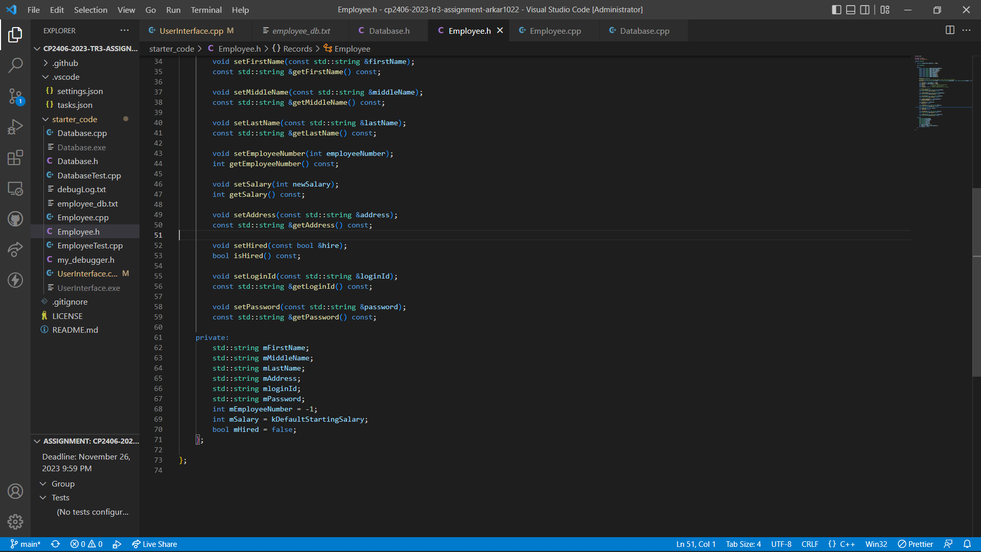

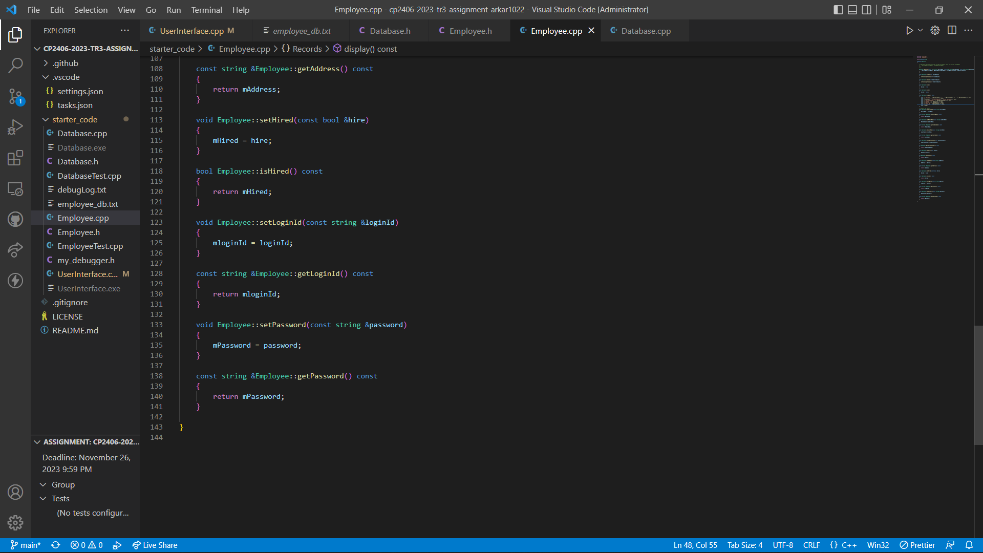

Updated “addEmployee()” function in “Database.cpp” to set default **login id** which will be a string value starting with “em” (representing employee) followed by the employee number and default **password** which will be a string value starting with "pw” (representing password) followed by employee number. For example, if an employee number is “1000”, login id would be “em1000” and password would be “pw1000”.

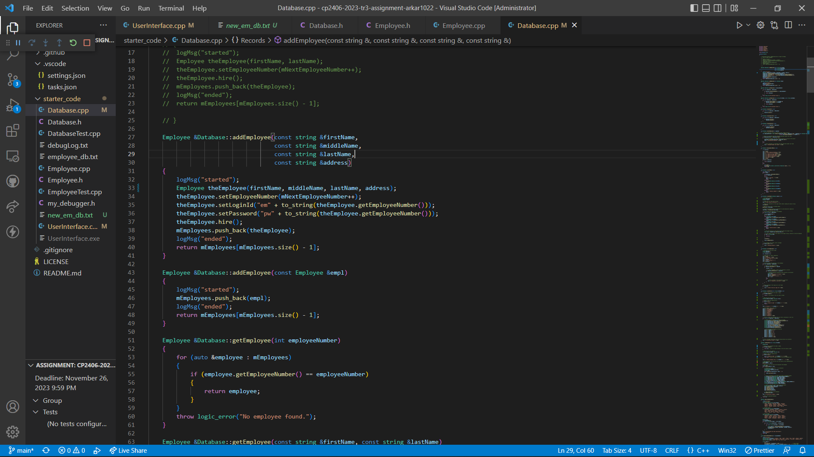

Updated “saveToFile()” function and “loadFromFile()” function in “Database.cpp” as well as “doEdit()” function in “UserInterface.cpp” to ensure login id and password are also included in processing.

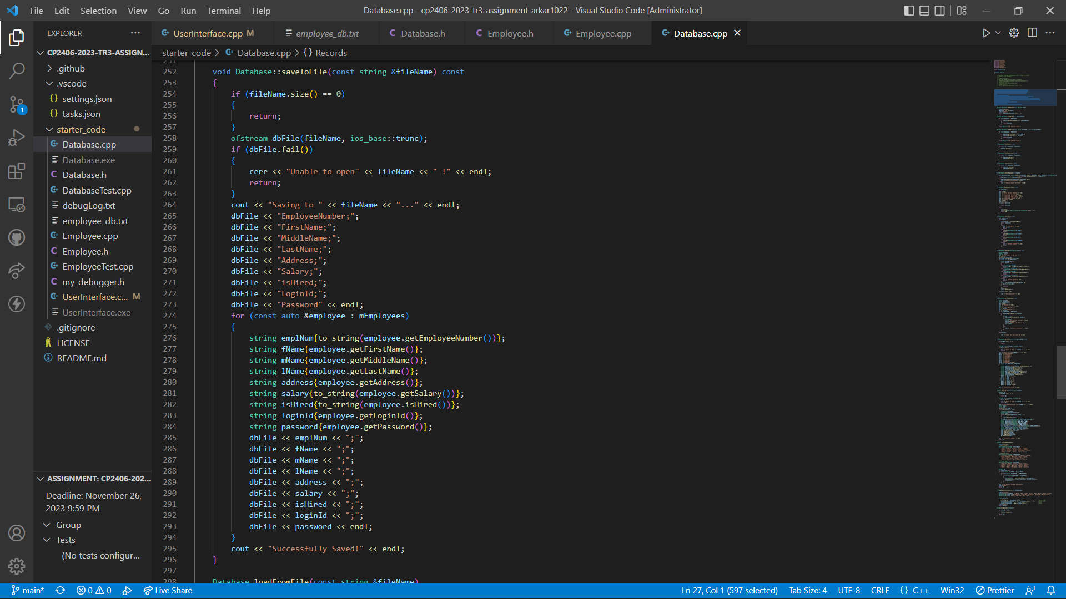

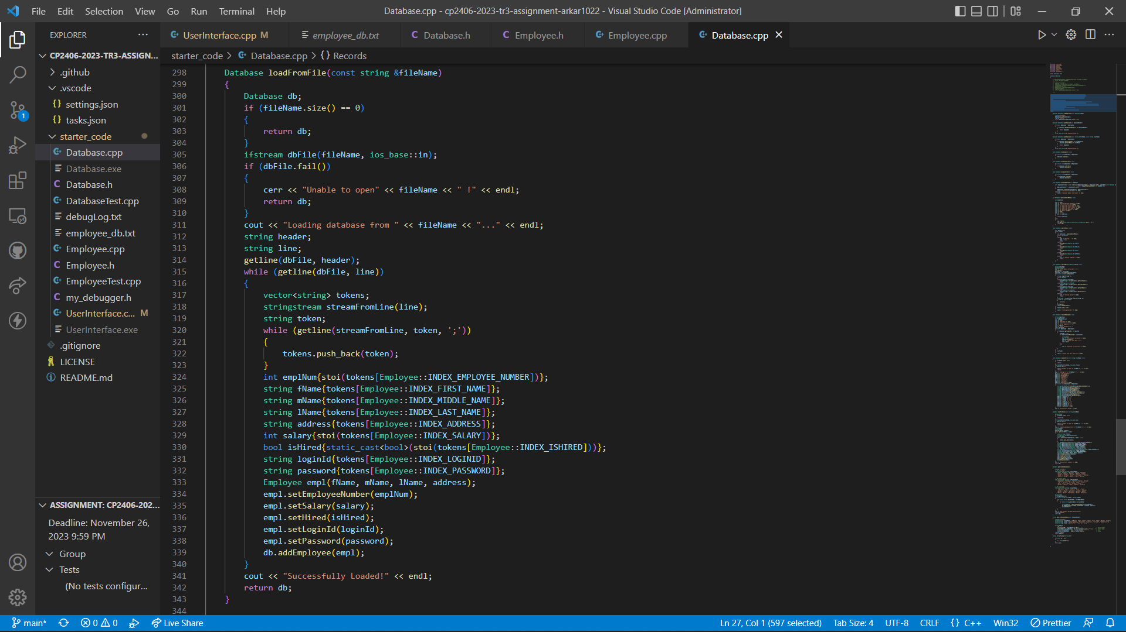

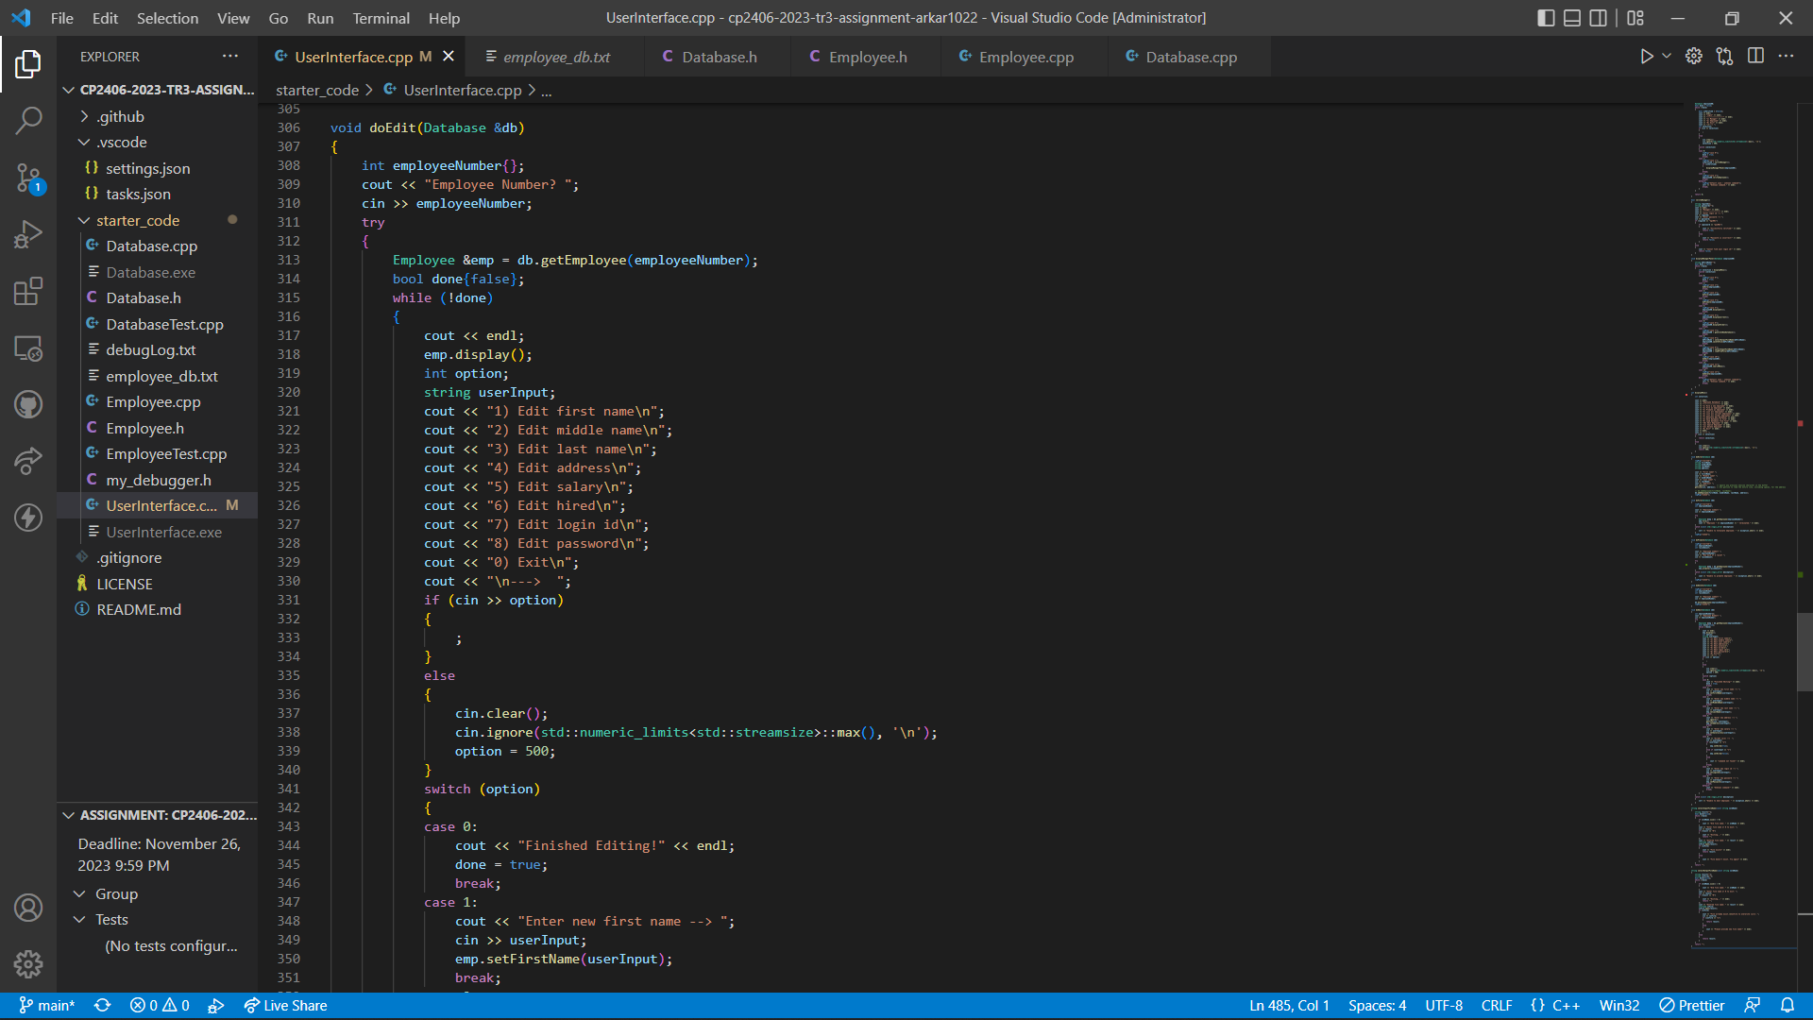

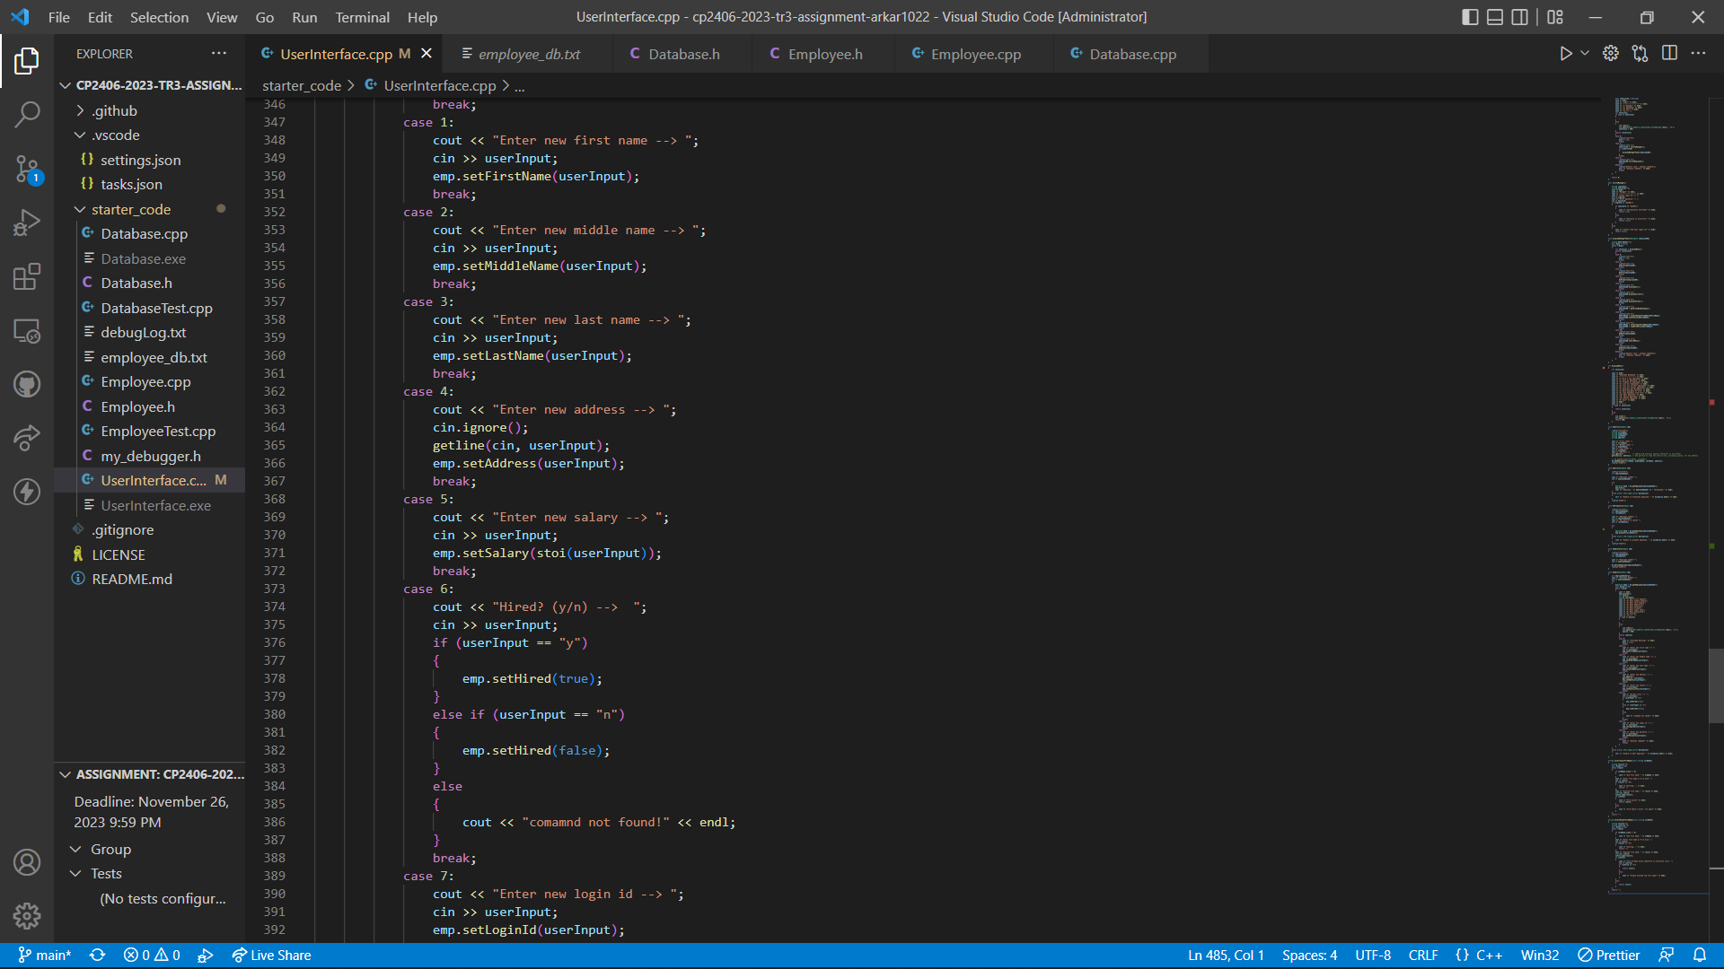

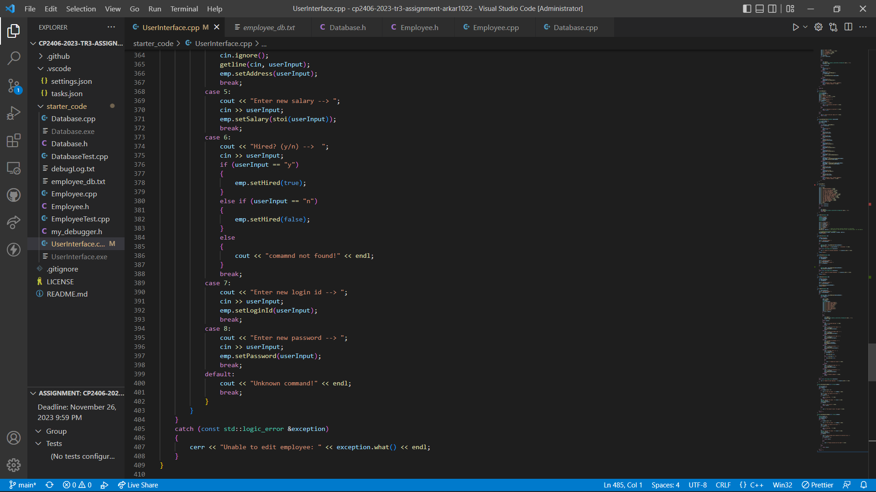

Add Delete Option to allow manger-level use to delete the employee data using employee number.

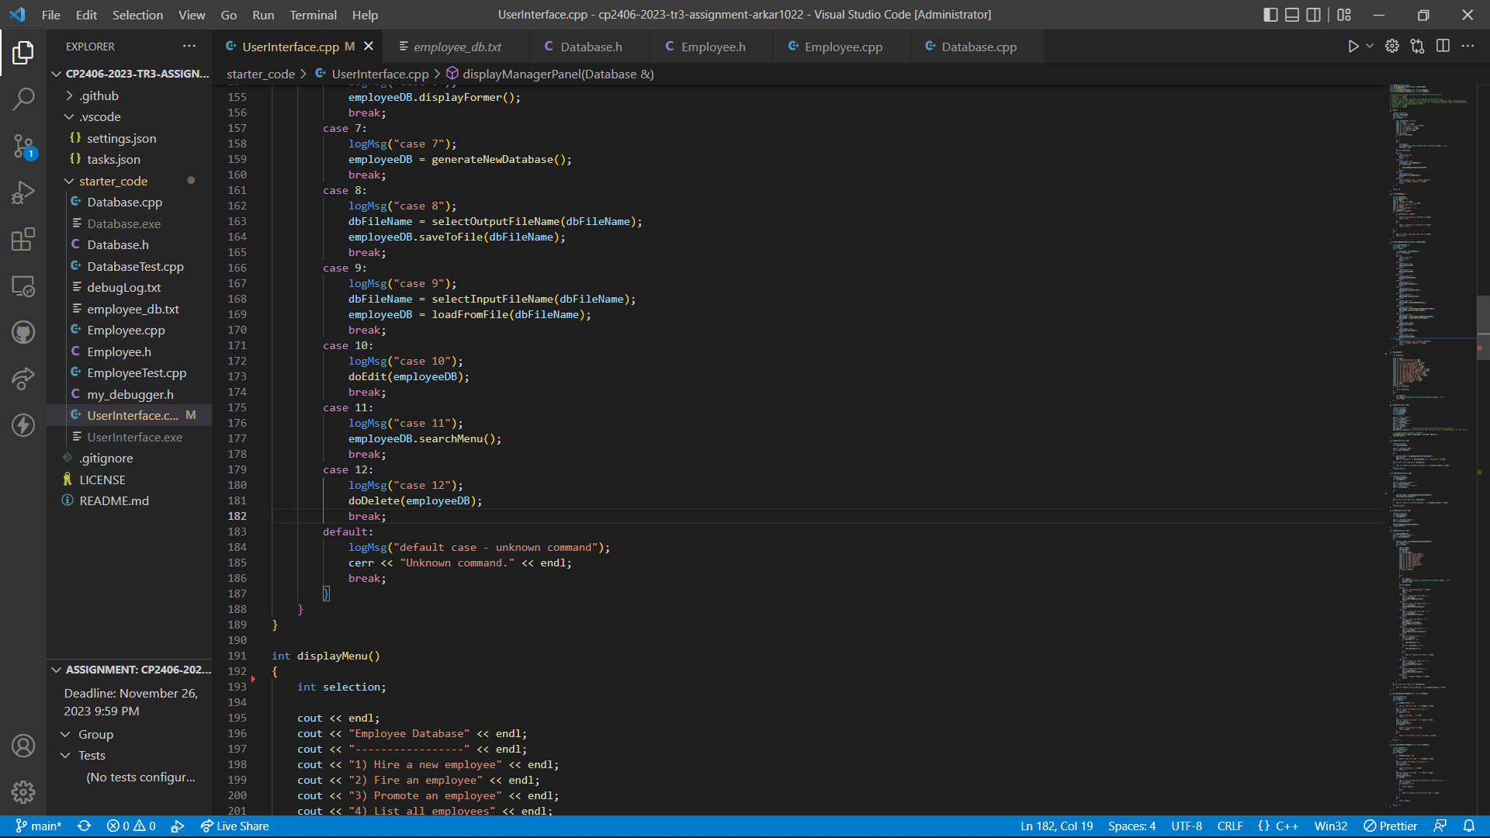

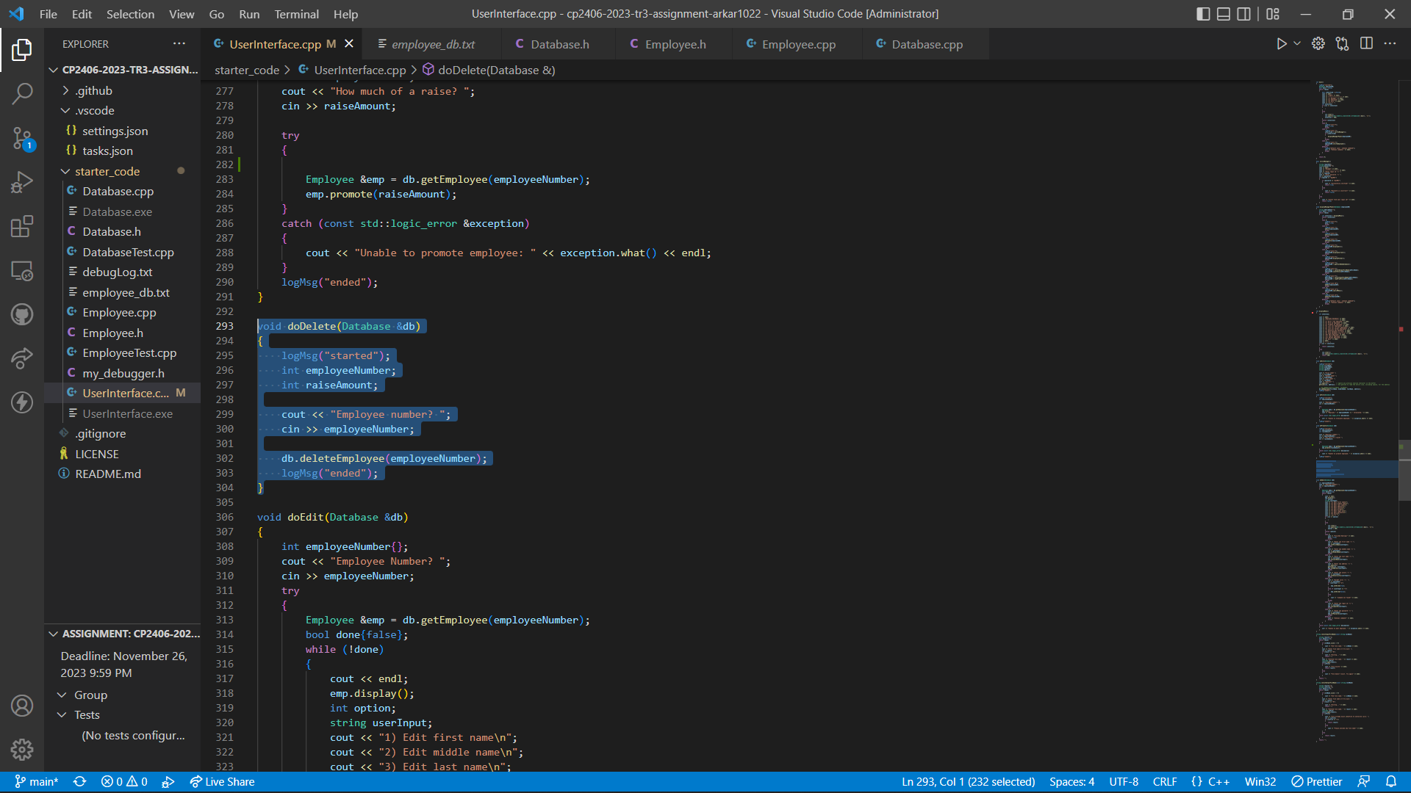

Declare and define “verifyEmployee()” function in “Database.h” and “Database.cpp” to verify the employee using the login in and password. If verification is successful, his/her record will be displayed. Incorrect login id and password will result specific alert messages.

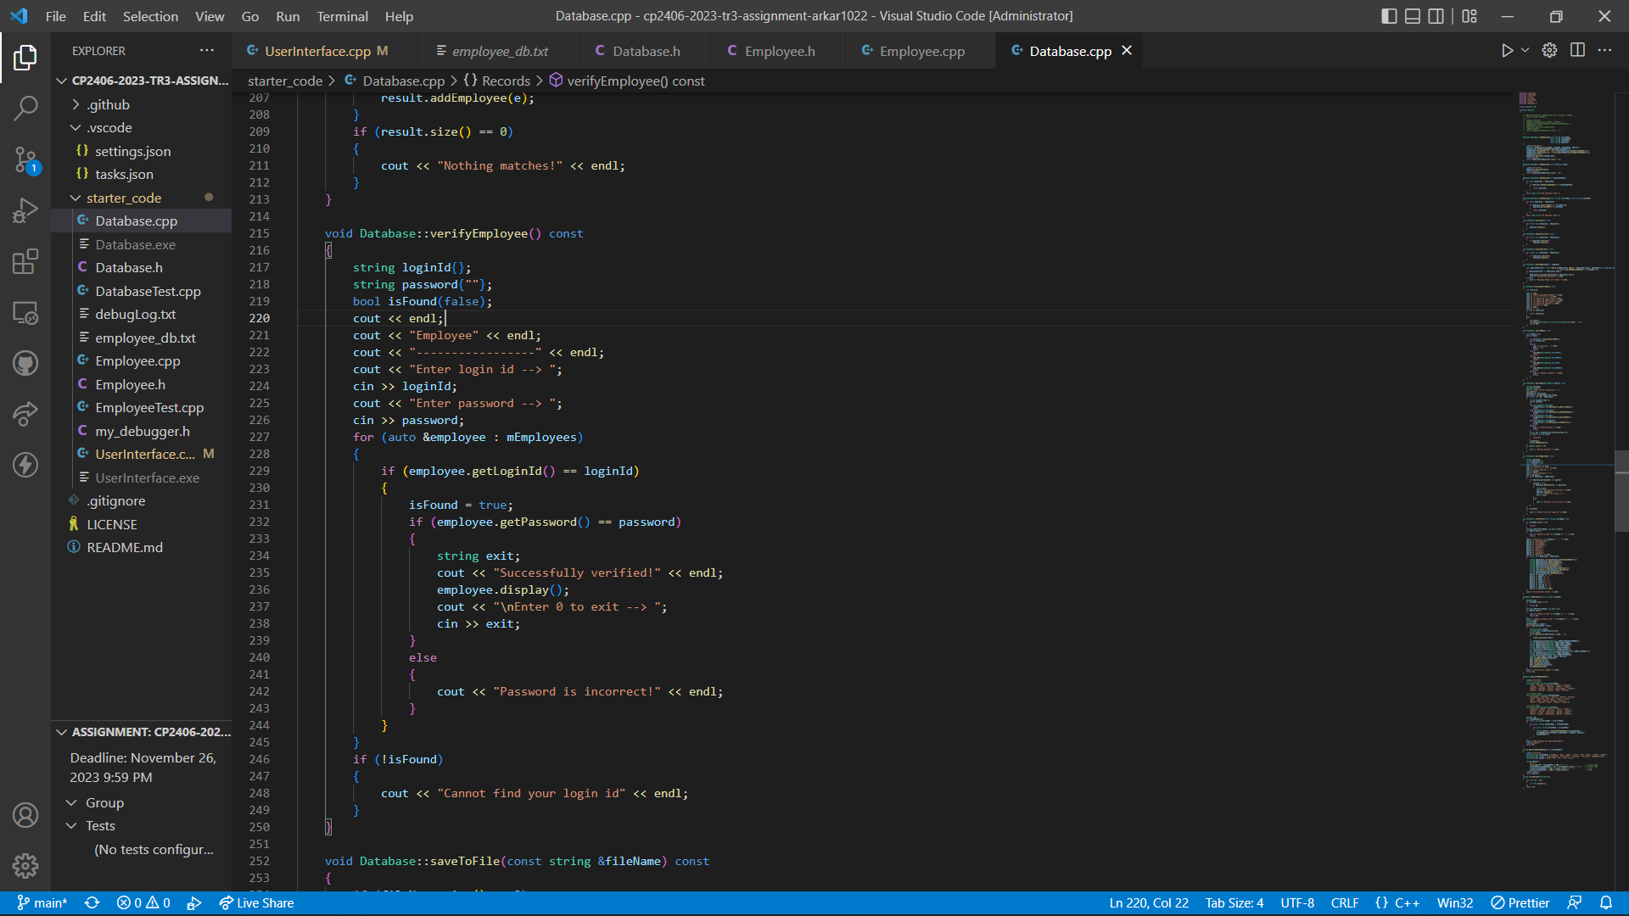

Output Result:

Login as Manager using default login id -> “mg1001” and password -> “pw1001”.

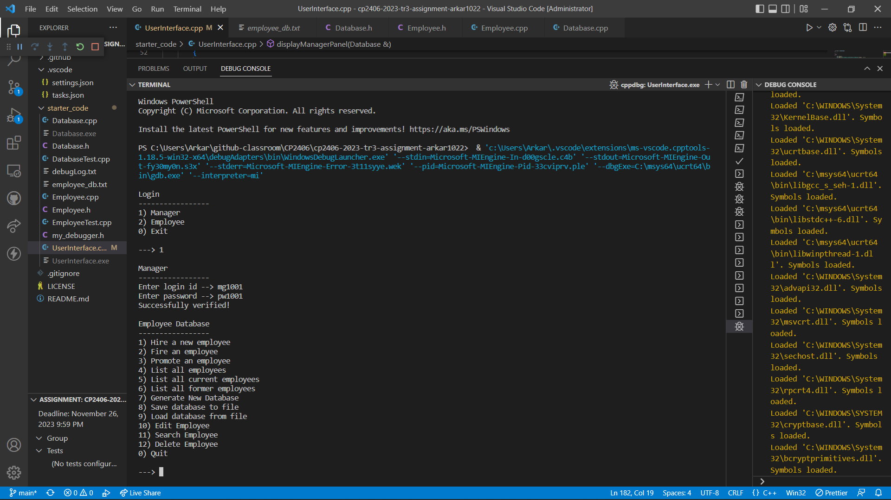

Generate a new database and display.

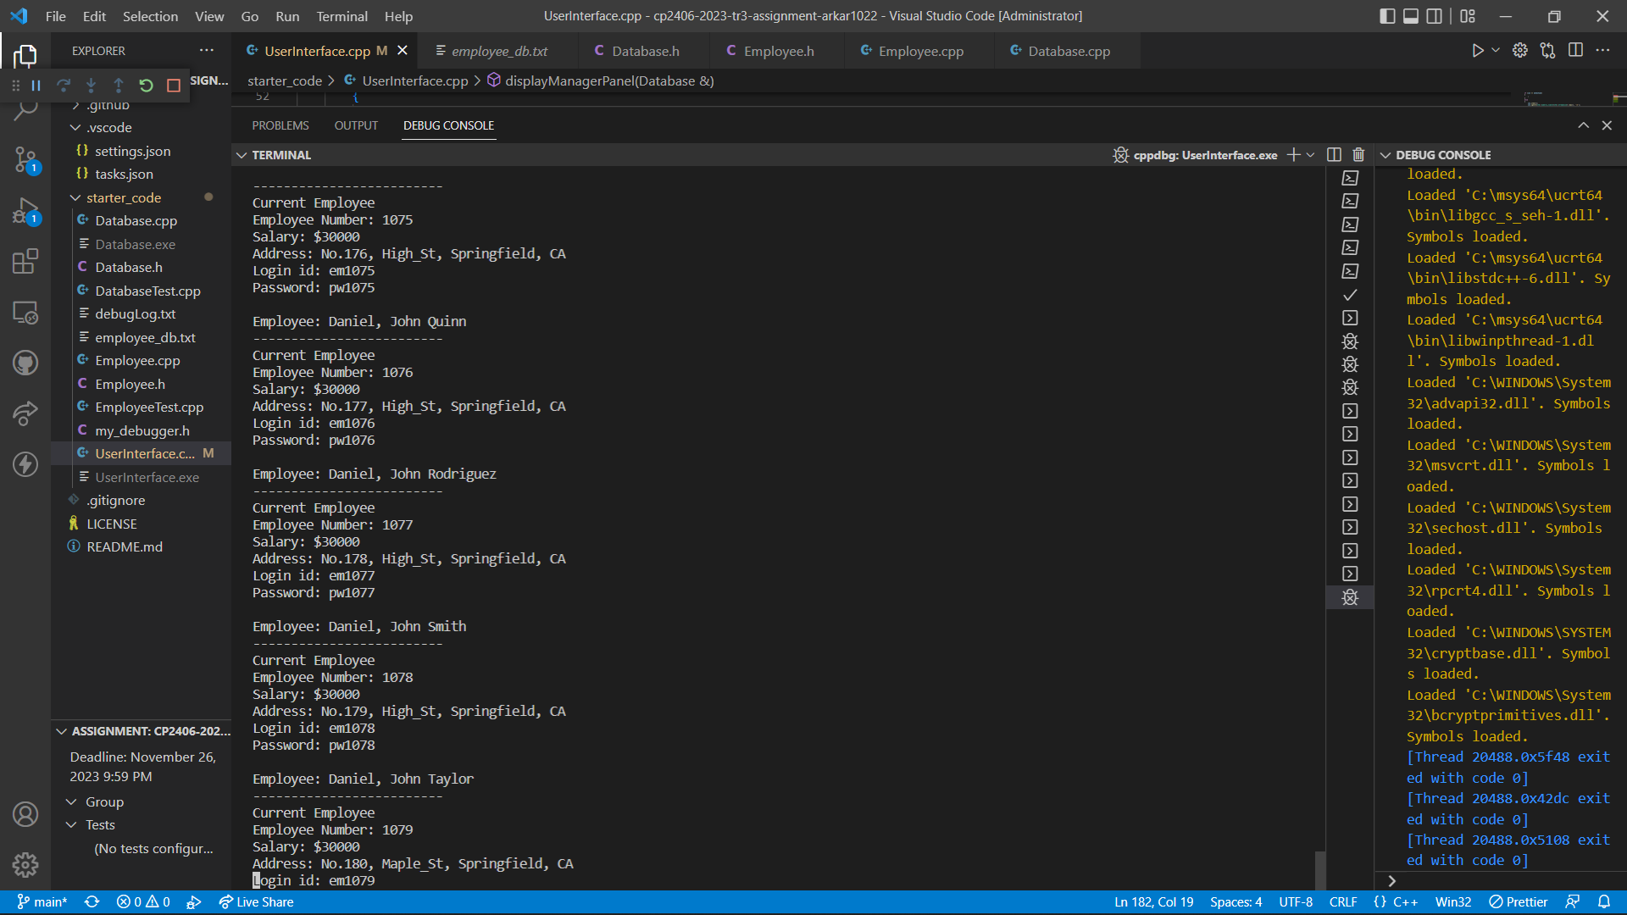

Save the database to the file “employee_db.txt”.

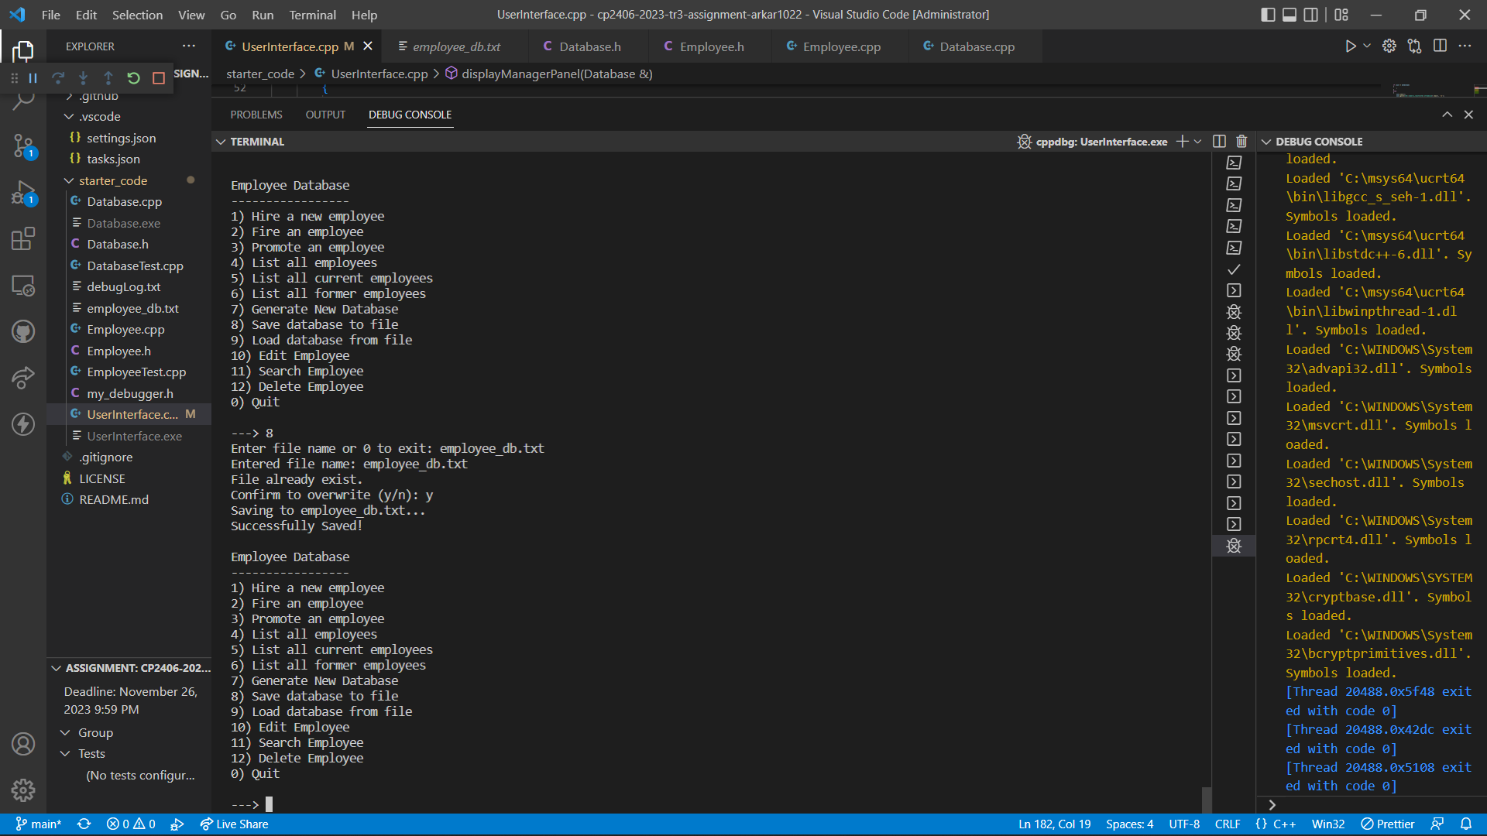

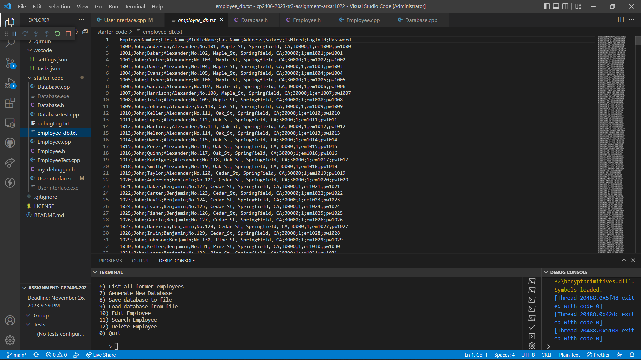

Load Database from the file “employee_db.txt” and display.

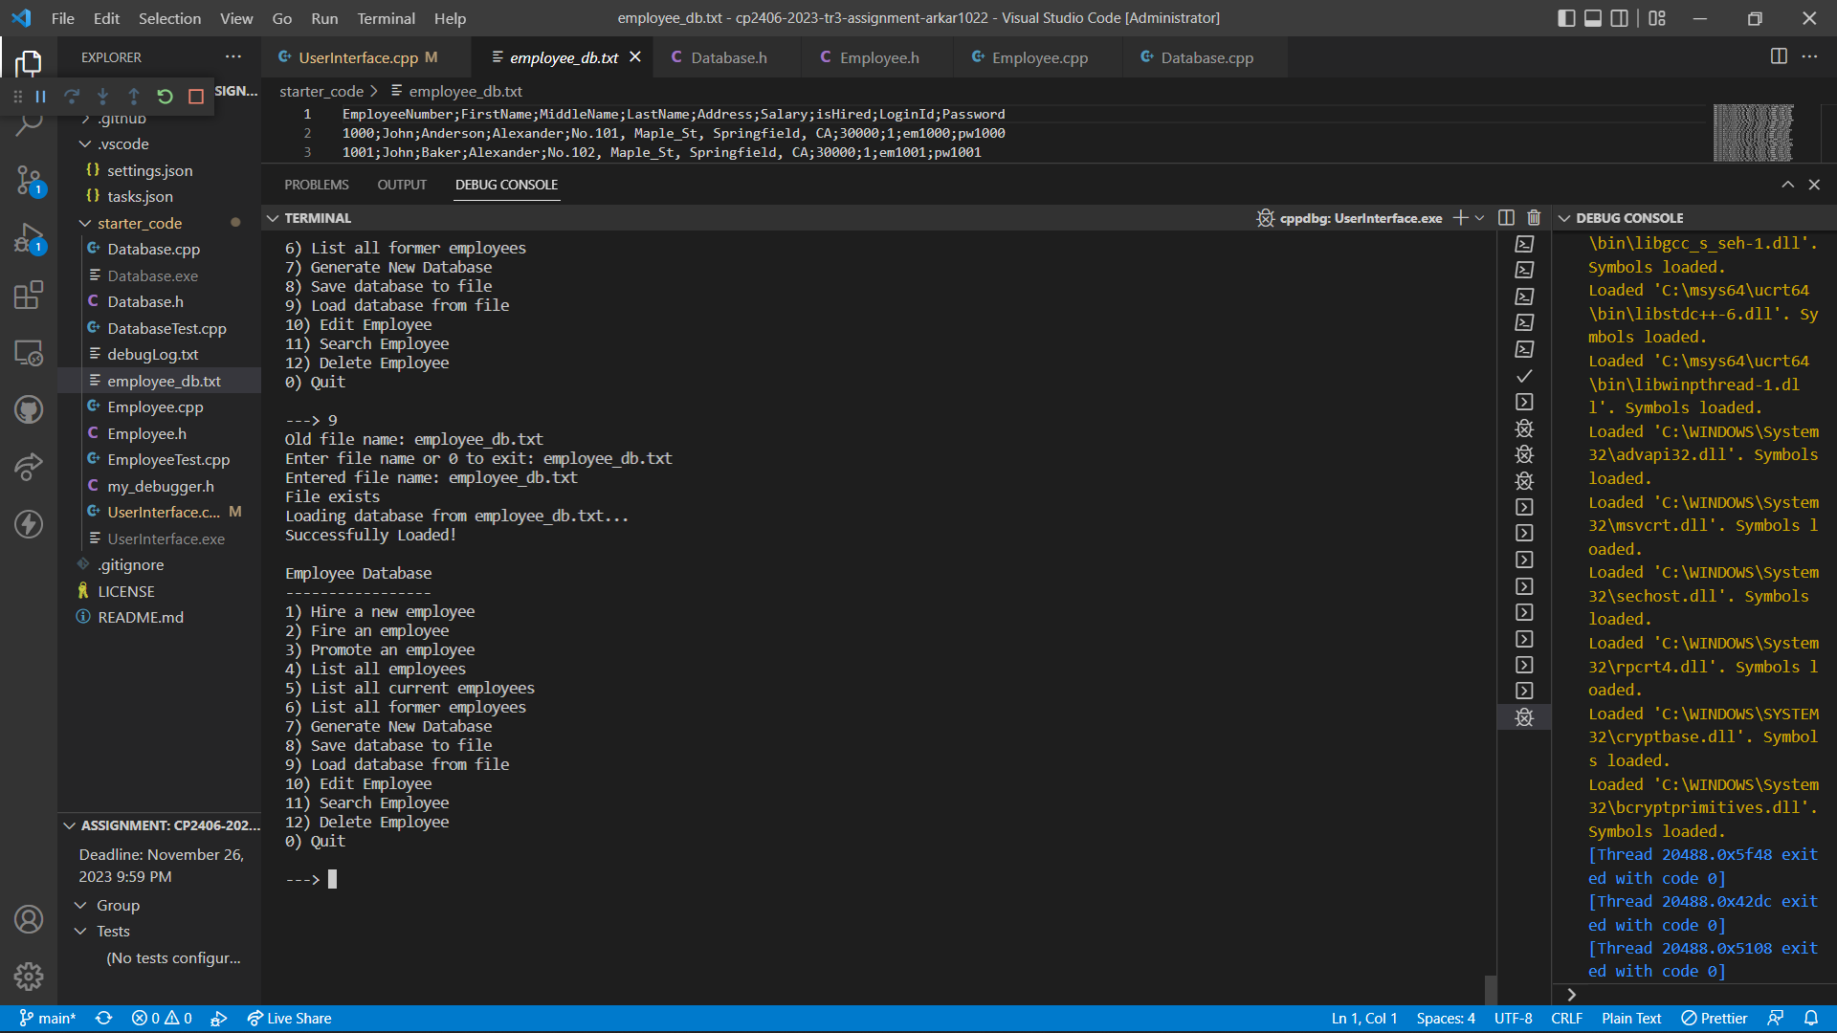

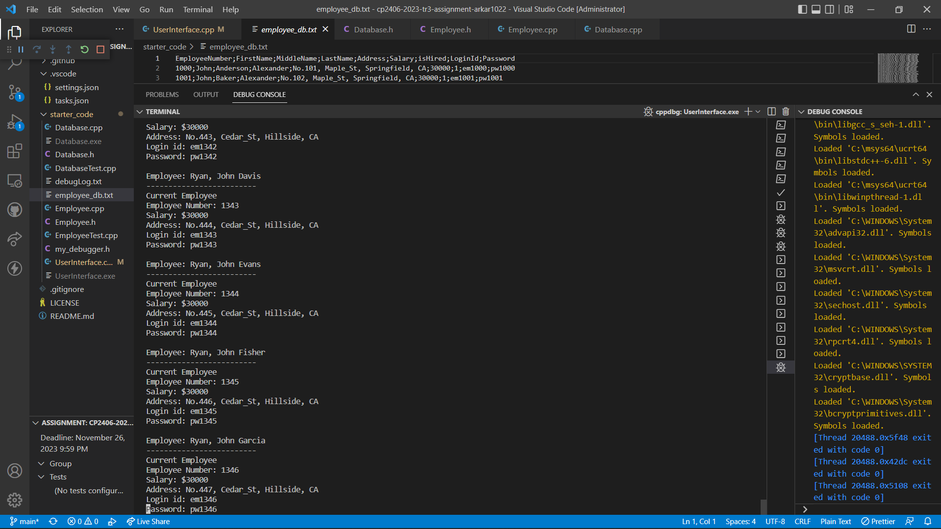

Edit login id and password of employe number “1000” to “em9999” and “pw9999”.

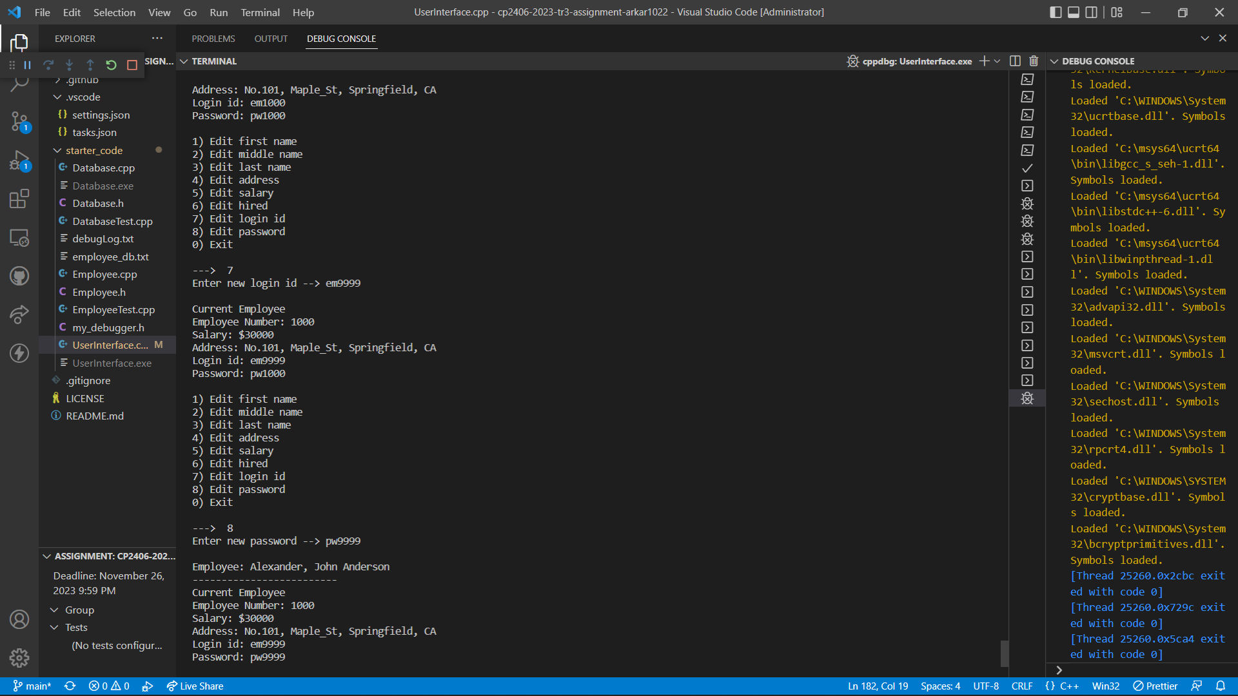

Login as employee using new login id: “em9999” and password: “pw9999”.

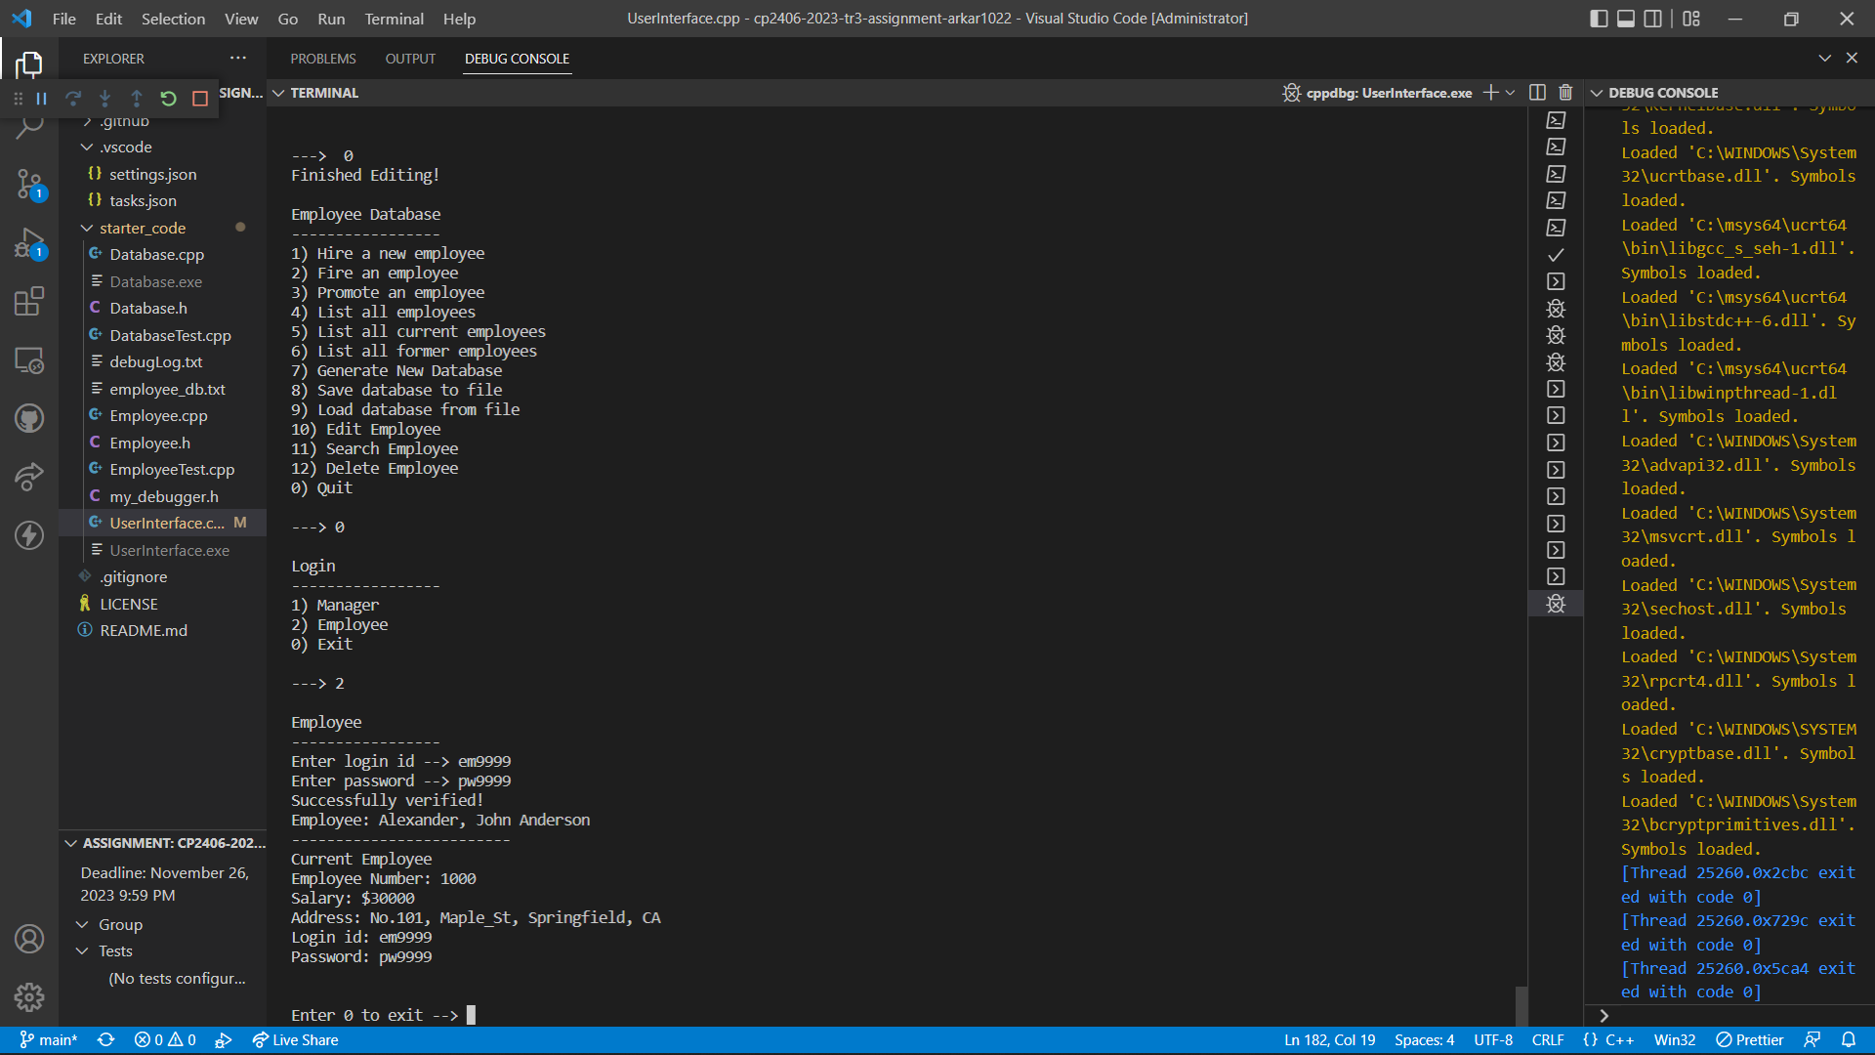

Delete the employee with employee number “1000” from manager panel and try to login again using its login id and password. We will see, we cannot login anymore as the record has been deleted.

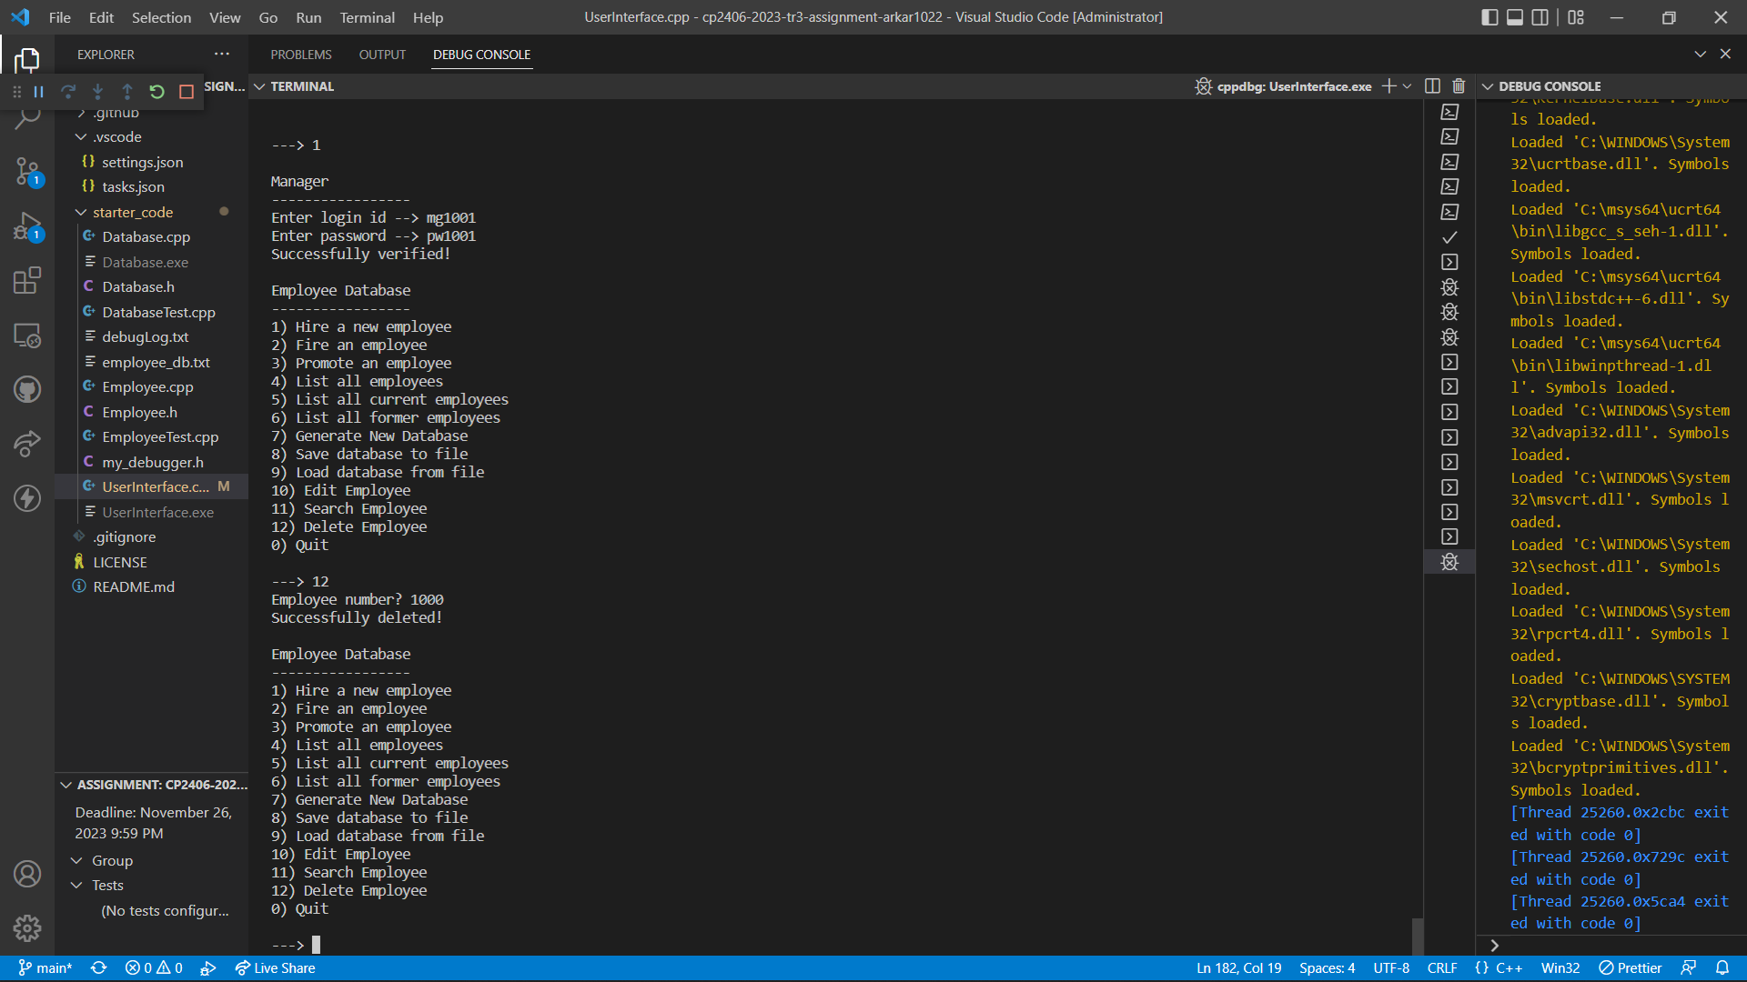

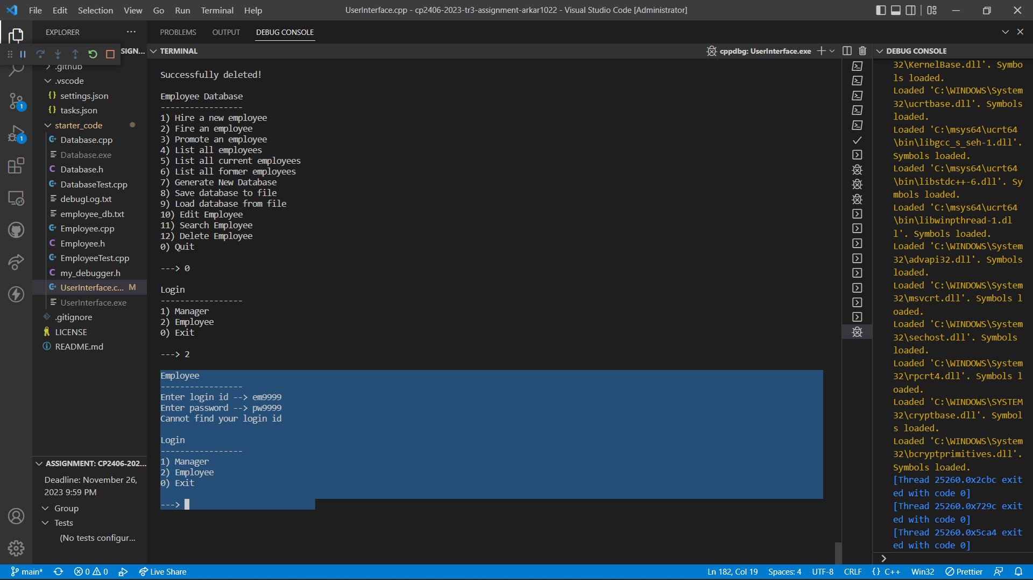

# Commit Record

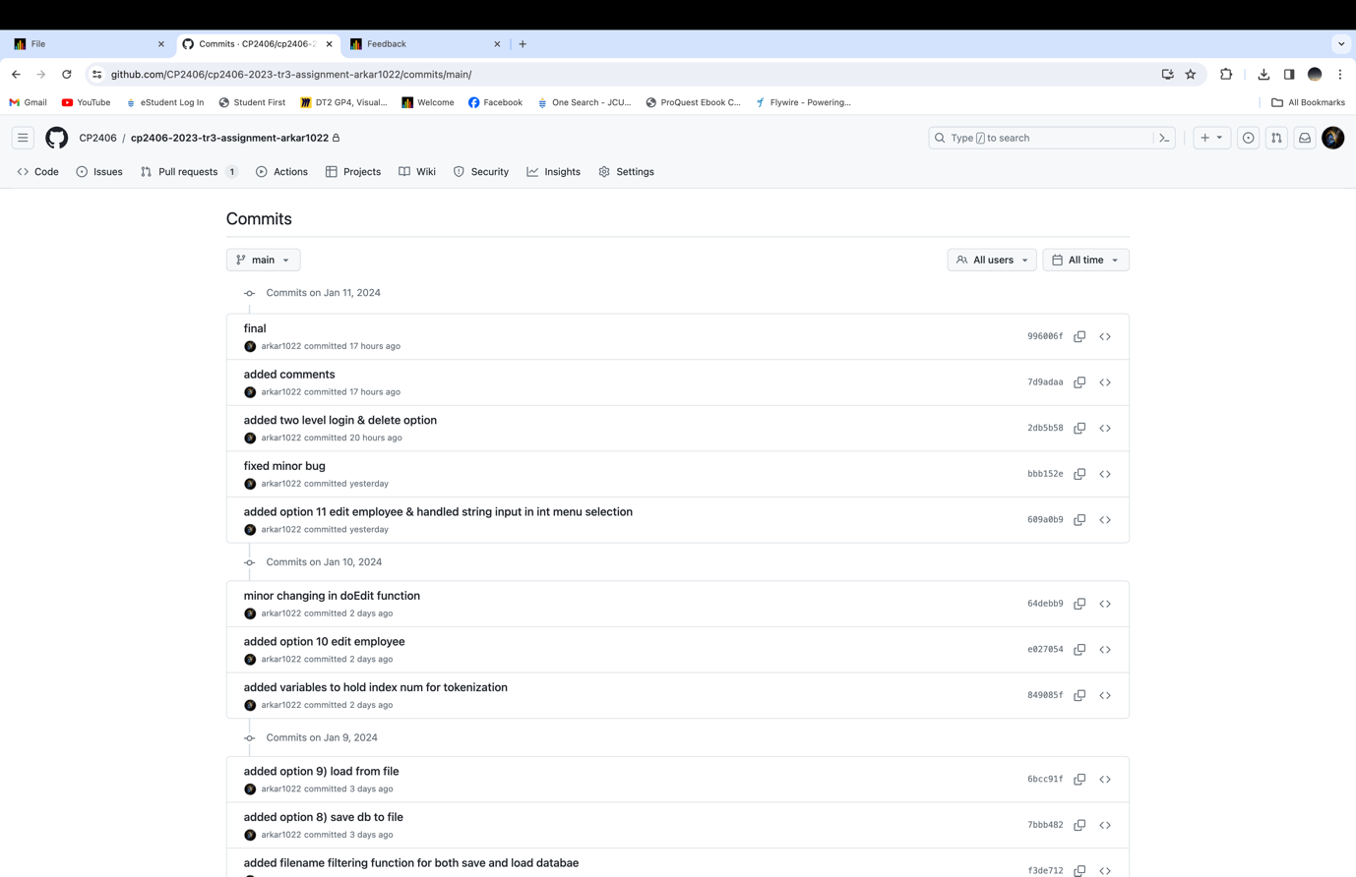

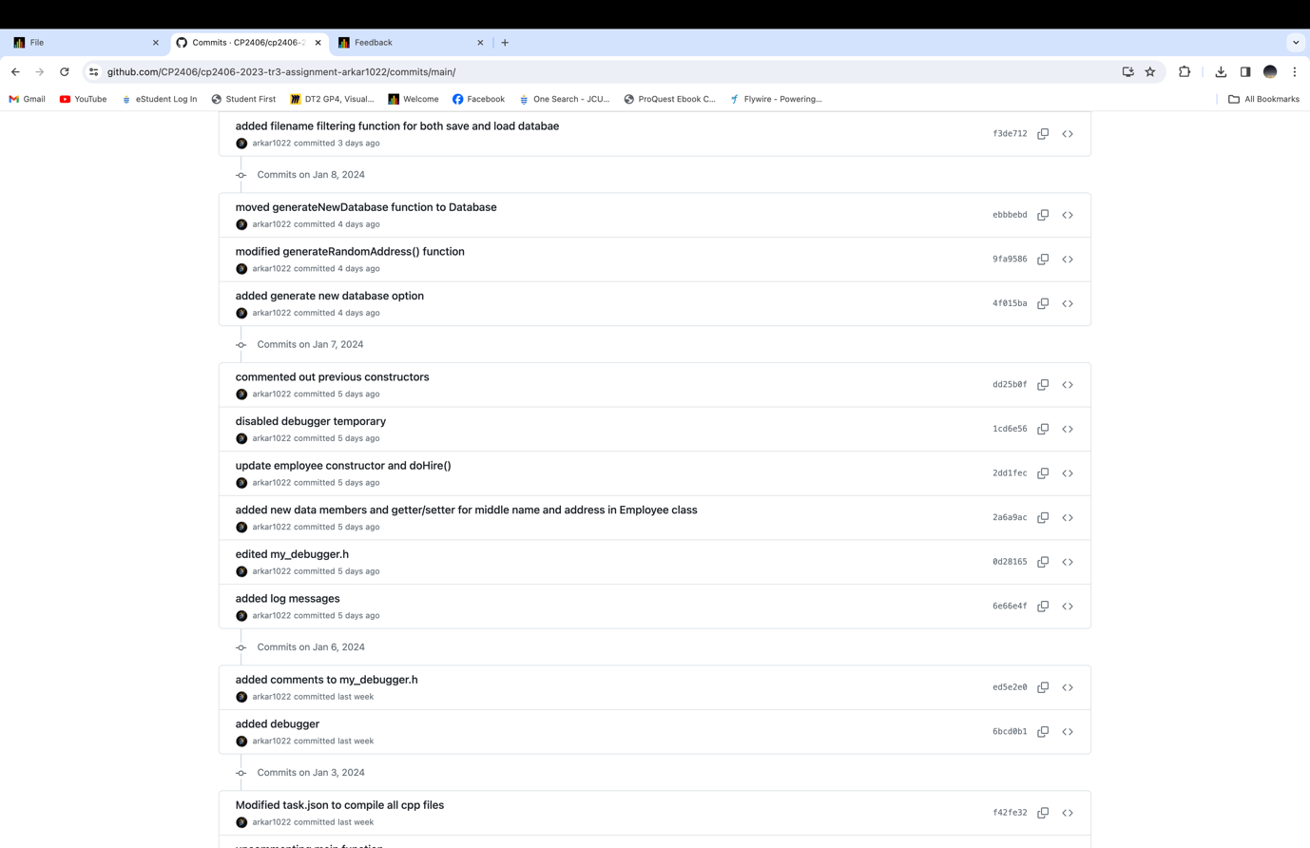

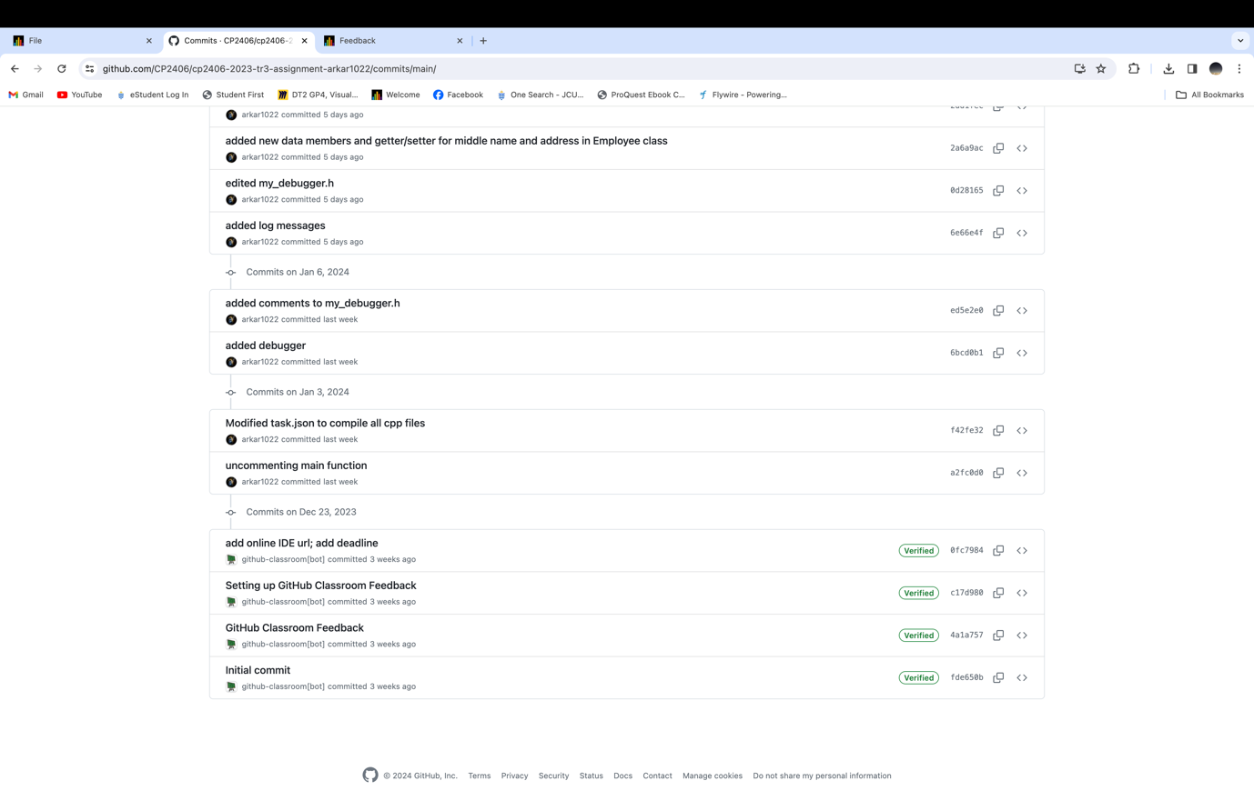

# GitHub Repo Link

<https://github.com/CP2406/cp2406-2023-tr3-assignment-arkar1022.git>